Setting up before you start receiving emails
Setting up your email inbox before you receive your SafetyCulture notification emails notifications@safetyculture.io
Manage email messages by using rules in Outlook
Use rules to automatically perform specific actions on email that arrives in your inbox. For example, you can create rules that will change the importance level of messages as they come in, automatically move them to other folders, or delete them based on certain criteria.
Create a folder in Outlook
- Right-click your name in the Folder Pane and select New Folder.
Or right-click Inbox to add a folder inside the Inbox and select New Folder.
- Type a name for the folder and press Enter. Suggestion: Corrective Actions
- Select the new folder to open it.

Create a rule from a template in classic Outlook for Windows
- Select File > Manage Rules & Alerts > New Rule.
- Select a template.
For example, to move a message based on the email address it is sent from :
  - Select Move messages from someone to a folder.
- Edit the rule description.
  - Select an underlined value (people or public group), choose the options you want
  - In the rule address pop up box type notifications@safetyculture.io in the space at the bottom of the box next to “From”, and then select OK
- Select the conditions, select the underlined value “specified” and select the folder you created in earlier steps Corrective Actions.
- Select Next.
- Select Next.
- Finish the rule setup.
  - Name the rule, setup rule options, and review the rule description. Click an underlined value to edit.
- Select Finish.
Certain rules will only run when Outlook is on. If you get this warning, select OK.
- Select OK.

Setting Up After you have received notifications
To be used once you have started to receive SafetyCulture notification emails via notifications@safetyculture.io

Organise your inbox in Outlook for Windows
Organising your inbox is paramount to keep you productive. Making the switch from Gmail to Outlook, here are a few differences in terminology and functionality between the two apps:
- Outlook uses Folders, while Gmail uses labels, to organise messages.
- Outlook uses Rules to sort your emails into folders and categories as they are delivered. Gmail uses filters. Outlook also has Filters, but in Outlook it is a way to sort the inbox or a folder.
- Flagging an email in Outlook is a lot like starring an email in Gmail.

Create a folder
- Right-click your name in the Folder Pane and select New Folder.
Or right-click Inbox to add a folder inside the Inbox and select New Folder.
- Type a name for the folder and press Enter. Suggestion: Corrective Actions
- Select the new folder to open it.

Use Folders to organise your email
- Select a message.
- Select Move.
- Choose a folder.
Or, drag and drop an email into a folder.
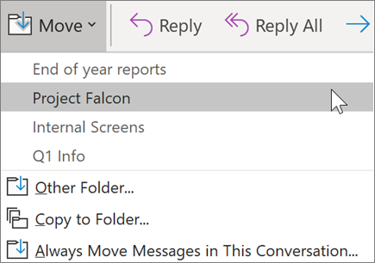
Create Rules to sort your email automatically
You can make your Rules as complicated or as simple as you want. Here's how you quickly send all messages from a single sender to a specific folder:
- Right-click a message.
- Select Rules.
- Choose Always move messages from [name of sender].
- Choose a folder or select New to create a new one.
- Select OK.
Note: To make your rule more complicated, right-click a message and select Rules > Create Rule. Read Manage email messages by using rules to learn more.
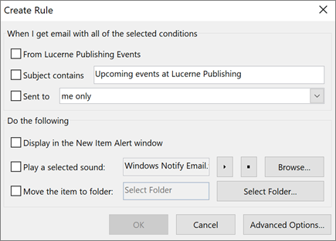

Notes:
You can manually run one or more rules.
- On the File tab, choose Manage Rules & Alerts, and on the E-mail Rules tab, choose Run Rules Now.
- In the Run Rules Now box, under Select rules to run, select the check box for each rule that you want to run.
- In the Run in Folder box, to select a different folder, choose Browse, choose the folder, and then choose OK.
Select the Include subfolders check box to include all folders under the folder you chose in step 3.
- In the Apply rules to list, accept the default setting of all messages, or change to read or unread messages.
- Choose Run Now.

