Emergency Management Plan

Plan No: PLN 4200.01

Version No: 09
Version Date: 30/10/2023
Table of Contents
Prevention, Preparedness, Response, and Recovery 4
Scope and Application 5
Endeavour Foundation Group 5
Community Solution Group and Brace 5
Emergency 5
Building Information 6
Allowable Number of Workers / Occupants 7
Evacuation Diagrams 8
Emergency Control Organisation (ECO) 9
ECO Membership 9
Indemnity of the ECO 9
ECO contact details 9
Emergency Contact Details 10
First Aid Safety Officer 11
Roles and Responsibilities 12
Fire Safety Adviser 12
Emergency Planning Committee 12
Site Manager 13
Worker 13
Evacuation Drill Schedule 14
Proposed Maintenance Schedule for Prescribed Fire Safety Installations 15
Defect classification and non-conformance 16
Occupier Statement, Fire Safety, Essential Safety Measures 17
Queensland 17
New South Wales 17
Fire safety certificates 17
Fire safety statements 17
Victoria 18
Individual Emergency Plans, including PEEP 19
Proposed Training Plan 19
Instruction Guidelines 20
General evacuation instructions 20
First response evacuation instructions 20
Evacuation coordination 20
Scheduled evacuation drills 20
In the Event of a Fire 21
Operating a Fire Extinguisher 22
Types of fire extinguisher 22
Fire Blankets 23
Tips 24
Outside Normal Working Hours 24
Medical Emergency 25
Bushfire, Flooding, Store, Heatwave, and Cyclone Plan 26
Emergency Numbers 26
Endeavour Foundation Group Emergency Phone Numbers 27
Utility connections and deactivation in the event of severe weather 28
Emergency preparation 28
Evacuation plan 28
Emergency Kits 29
Residential & 24/7 Shared Disability Accommodation 29
During a wet weather alert 30
Stay informed 30
Know the signs before disaster strikes! 31
Advice (Yellow) 31
Watch and Act (Orange) 31
Emergency Warning (Red) 31
Cyclone Management 31
The Home portfolio 31
Bushfires 32
Floods 34
Riverine flooding 34
Flash flooding 34
Storm surge and storm tide. 34
Storms 35
Alert warnings for extreme weather 35
Heatwave 36
Pandemic 37
Earthquake 38
Handling or Addressing Threatening Phone Calls 38
Bomb Threats 39
Evacuation 40
Locating a Bomb 40
Lockdown / Shelter in place 41
Hazardous Chemical Spills 42
Major spills 42
Minor spills 42
Assess the risk 42
Decontaminate 43
Dispose 43
Record 43
Spill Response Kits 44
Debriefing 44
Emergency evacuation debrief: 44
Critical incident: 44
Critical Incident Debriefing (CID): 44
Hot debrief: 44
Formal debriefing: 44
Employee Assistance Program (EAP) 45
Resources 46
Appendix 1 47
Fire Installation descriptions 47
Building classifications 51
Related Documents and References 53
Document Information 53
Document Amendment History 54

Prevention, Preparedness, Response, and Recovery
Enter site name:
Address line 1:
Address Line 2:
State: |  |  | Postcode:
This Emergency Management Plan must be reviewed annually

Scope and Application
The Emergency Management Plan has been written to support Endeavour Foundation Group (Endeavour Foundation) and its group entities Community Solutions Group and Brace in the event of an emergency. All state legislation has been considered when preparing this document.
This Emergency Management Plan has taken into consideration the NDIS standard practices to ensures that the risks to the health, safety and wellbeing of participants that may arise in an emergency or disaster are considered and mitigated and ensures the continuity of supports critical to the health, safety, and wellbeing of participants in an emergency or disaster.

Endeavour Foundation Group
Endeavour Foundation Group (Endeavour Foundation) is a disability service provider currently operating out of Queensland, New South Wales, Victoria, and South Australia. Endeavour Foundation core business is providing supported independent living, learning and lifestyle, supported employment through business services including packaging solutions, recycling solutions, document destruction, mailing and collating, timber products and industrial cleaning cloths.
Endeavour Foundation includes subsidiary group entities:

Community Solution Group and Brace
Community Solutions Group (CSG) and Brace provides a diverse range of services including Employment Services, family support, NDIS Specialist Services (including Behaviour Support and Support Coordination), BRACE Education and Training (RTO) and Apprenticeships and Traineeships. Community Solutions Group operates both in Queensland and Victoria.

Emergency
An Emergency is any situation or event that poses an immediate or imminent risk to human life and/or property and it requires an immediate response.
Emergency events or occurrences that Endeavour Foundation Group including entities Community Solution Groups and Brace are most likely to experience are:
- fire – home, office, factory
- natural disasters – cyclone, storm and floods, bushfires, heatwave
- electrical outages
- security breaches – intruder
- significant injuries – physical and psychological
- medical events
- pandemics/outbreaks – COVID.
For this document, an Endeavour Foundation property will be either an administration building (Endeavour Foundation and Community Solutions Group), Business Solutions worksite, Learning and Lifestyle centre, disability accommodation, Resource Recycling Centre, and retail store.

Building Information
Building location:
Building classification: | Refer to Appendix Building Classifications
Building owner: | Need to include contact details.
Building occupier: | Need to include contact details.
Building Site Manager:
Building Site Manager phone number:
Building construction:
Floor area:

Allowable Number of Workers / Occupants
Building section name | Room size | Maximum number of workers / occupants
Total number of occupants:

Evacuation Diagrams
Every workplace or home must display evacuation diagrams in clear locations where occupants and visitors are able to view them. They should be installed in a way that the occupants can determine the direction of the evacuation route from the point at which they are viewing them.
Insert evacuation diagram here

Emergency Control Organisation (ECO)
Emergency control organisation (ECO) is a person or persons appointed by the emergency planning committee to direct and control the implementation of the site’s emergency response procedures.

ECO Membership
Where numbers permit, a formal ECO will be established and will contain the following Key positions:
- Chief Warden
- Deputy Chief Warden
- Area / Floor Warden/s
- Warden/s
- First Aid Officer
There are many Endeavour Foundation, Community Solution and Brace sites that will not have adequate numbers to establish a full ECO. In these sites all workers will be trained as wardens.
The ECO will be trained and where possible attend the Emergency Planning Committee (EPC) annual meeting.

Indemnity of the ECO
Indemnity is in place that covers Endeavour Foundation, Community Solutions and Brace workers. Indemnity insurance protects against civil liability resulting from their participation in EPC and ECO activities and is where the workers act in good faith and during their emergency control duties.

ECO contact details
Position | Name | Contact number
Chief Warden | <insert name> | <insert no.>
Deputy Chief Warden | <insert name> | <insert no.>
Area / Floor Warden/s | <insert name> | <insert no.>
Warden/s | <insert name> | <insert no.>
First Aid Officer | <insert name> | <insert no.>

Emergency Contact Details
(Delete if not applicable)
Emergency contact | Number
Fire, Police, Ambulance | 000 (106 for people with a hearing or speech impairment)
State Emergency Services (SES) for Flood and Storm Emergencies | 132 500
Poison Helpline | 131 126
Ergon - Life-threatening emergencies only (south-east Queensland) | 131 670
Energex – Life-threatening emergencies only (regional QLD) | 131962
Essential Energy – Life threatening emergencies only (areas around Goondiwindi, close to QLD/NSW border). | 132 080
Endeavour Energy – Life threatening emergencies only (Southern & western metropolitan Sydney and surrounds including the Blue Mountains and the Illawarra) | 131 003
Essential Energy – Life threatening emergencies only (Country & regional NSW, southern regional QLD) | 132 080
Ausgrid – Life threatening emergencies only (Inner, northern & eastern metropolitan Sydney and surrounds) | 1313 88
CitiPower - Life threatening emergencies only (Melbourne City and inner suburbs) | 131 280
Jemena - Life threatening emergencies only (Northern and South-Western suburbs) | 131 871
Powercor Australia - Life threatening emergencies only (Western suburbs and western Victoria) | 132 412
AusNet Services - Life threatening emergencies only (Outer Northern and Eastern suburbs and Eastern Victoria) | 131 799
United Energy Australia - Life threatening emergencies only (Southern suburbs and Mornington Peninsula) | 132 009
Insert Local Hospital | <Insert phone number>
CBC for non-life-threatening property emergencies (Select option 4) | (07) 3900 5460
Asset Management Manager (Simon Northey) | 0428 116 170
On call number (Applicable to Service Delivery) | <Insert phone number>
Operations Manager (insert name here) | <Insert phone number>

Fire Safety Adviser
(this is your Safety and Wellbeing Advisor)
Name:
Phone number:
Email:
Description of qualification held:
Registration training organisation that issued the above qualification:

Roles and Responsibilities
Role | Responsibilities
Fire Safety Adviser | - Liaising with the Emergency Planning Committee (EPC) in developing the Emergency Management Plan  - Liaising with the Emergency Planning Committee (EPC) in reviewing the Emergency Management Plan and Evacuation Sign and Diagram (annually).  - Liaising with the Emergency Planning Committee to ensure the development of the Evacuation Sign and Diagram.  - Monitoring the building’s prescribed fire safety installation maintenance schedule and maintenance records and advise the Site Manager of discrepancies.  - Ensure where possible a functional ECO has been established.
Emergency Planning Committee | - Develop and implement an Emergency Management Plan and Emergency Management Procedures.  - Ensure that personnel are appointed to all positions on the Emergency Control Organisation (ECO).  - Arrange for training of ECO personnel.  - Arrange for the conduct of evacuation exercises.  - Review the effectiveness of evacuation exercises and arrange for procedure improvements.  - Determine who will conduct firefighting, first aid, environmental safety actions and shutdown procedures.
Site Manager | - Ensuring all workers are trained in general evacuation procedures and first response.  - Ensure all First Responders are trained using Fire Evacuation Instruction Record (QF 4200.09).  - Ensuring Emergency Management Plan is displayed.  - Ensuring Emergency Management Plan is current and reviewed annually.  - Ensure Personal Emergency Evacuation Plan (PEEPs) are completed for anyone who does not have the capacity to evacuate the building unassisted.  - Completing the Occupier Statements (QLD), Annual Essential Safety Measures Report (Vic) and NSW Fires Safety Certificates (NSW), verifying fire installations are compliant with legislation annually.
Worker | - Complete the general evacuation and first response training.  - Familiarise themselves with the Emergency Management Plan.  - Execute the Emergency Evacuation procedure to the best of their abilities.  - Follow any directions given to them by the wardens.
Roles and Responsibilities are covered in further detail in the Emergency Response Manual (QD 4200).

Evacuation Drill Schedule
Endeavour Foundation | Emergency Control Organisation (ECO) | Evacuation Drills
Administration buildings, for example, Support Centre | Functional ECO | Annually
Work | Functional ECO | Monthly
Learning and Lifestyle | Functional ECO or All workers trained as Evacuation Coordinators | Monthly
Home | All workers trained as Evacuation Coordinators | Monthly
Community Solutions Group | Emergency Control Organisation (ECO) | Evacuation Drills
Large sites | Functional ECO | Annually
Small Sites | All workers trained as Evacuation Coordinators | Annually

Proposed Maintenance Schedule for Prescribed Fire Safety Installations
(Delete what is not applicable)
All testing is completed in accordance with AS 1851-2012 Routine Servicing.
Installation | Start Date | Test | Frequency | Competent Person
Emergency lifts |  | AS1735. Sections 2 & 10 | yearly | <insert Service Provider>
Emergency Warning and intercom system |  | AS 1851 | monthly, 6 monthly, yearly and 5 yearly | <insert Service Provider>
Emergency Lighting |  | AS2293.1 | 6 monthly yearly | <insert Service Provider>
Emergency Power Supply |  | BCA | yearly | <insert Service Provider>
Exit signs |  | AS2293.1 | 6 monthly and yearly | <insert Service Provider>
Fire Blankets |  | AS2444 | 6 monthly | <insert Service Provider>
Fire detection and alarm systems (Fire Panel) |  | AS 1851 – Section 6 | monthly, 6 monthly, and yearly | <insert Service Provider>
Fire door sets |  | AS 1851 – Section 17 | 3 monthly, 6 monthly and yearly | <insert Service Provider>
Fire extinguishers |  | AS 1851 – Section 12 | 6 monthly and yearly | <insert Service Provider>
Fire hose reel |  | AS 1851 – Section 14 - 6 | 6 monthly and yearly | <insert Service Provider>
Fire Hydrants (including booster) |  | AS 1851 – Section 4 - 6 | 6 monthly, yearly and 5 yearly | <insert Service Provider>
Fire mains |  | AS 1851 – Sections 2 & 4 | 6 monthly, yearly and 3 Yearly | <insert Service Provider>
Smoke and heat Alarms 240 V |  | AS3786 | 6 monthly | <insert Service Provider>
Smoke door sets |  | AS 1851 – Section 17 | 6 monthly | <insert Service Provider>
Solid core door |  | AS 1851 – Section 17 | 6 monthly | <insert Service Provider>
Sprinklers |  | AS 1851 Section 2 – | monthly, 6 monthly, yearly, 5 yearly, 10 yearly, 25 yearly and 30 yearly. | <insert Service Provider>
Water storage tanks for fire protection systems |  | AS 1851 Section 5 | monthly, 6 monthly, yearly and 10 yearly | <insert Service Provider>
It is important to note that each Australian State has its own legislation regarding the rules of AS 1851. While you may find minor differences in how the local fire equipment safety reports are compiled, the AS 1851 is the primary source of information.

Defect classification and non-conformance

Critical Defect
A defect that renders a system inoperative.

Non-critical Defect
A system impairment or faulty component not likely to critically affect the operation of the system.

Non-conformance
A missing or incorrect feature that does not affect the system operation but is required to facilitate ongoing routine maintenance.

Occupier Statement, Fire Safety, Essential Safety Measures

Queensland
(delete what is not applicable)
An Occupiers' Statement is a declaration from the Building Owner and Occupier to the Commissioner QLD Fire and Emergency Services (QFES) that all fire installations at the building are being maintained and that all critical defects notices have been rectified.
Occupiers Statement (QF 4200.11) shall be completed annually by April 1st and emailed to occupier.statements@qfes.qld.gov.au once completed.
A copy must be retained with the evacuation plan and can be kept electronically.
A copy of the email sent to QFES must be kept as proof.

New South Wales
(delete what is not applicable)
A building owner must ensure that an annual fire safety statement for the building is issued each year and that a copy of the statement is provided to the local council and Commissioner of Fire and Rescue NSW.
Completed fire safety certificates must be lodged with Fire and Rescue NSW by email at firesafety@fire.nsw.gov.au.
A copy must be retained with the evacuation plan and can be kept electronically.
A copy of the email sent to fire safety must be kept as proof.

Fire safety certificates
A fire safety certificate is issued by or on behalf of a building owner when new building work is complete. The certificate confirms that a properly qualified person has installed and checked the measures listed in the fire safety schedule. This helps verify that the measures can perform to the minimum standard.
Certificates must use the Fire safety certificate template

Fire safety statements
A fire safety statement is a document issued by or on behalf of the owner(s) of an existing building.
The statement confirms that an accredited practitioner (fire safety) has assessed, inspected and verified the performance of each fire safety measure that applies to the building.
There are two types of fire safety statements:
Annual fire safety statements - An annual fire safety statement must be issued each year and include all the essential fire safety measures that apply to a building. The statement also verifies that an accredited practitioner (fire safety) has inspected and confirmed that the exit systems in the building are in compliance with the Regulation.
Supplementary fire safety statements A supplementary fire safety statement is issued at more regular intervals (as specified in the fire safety schedule) for any critical fire safety measures that apply to a building.
For further information:
https://www.planning.nsw.gov.au/policy-and-legislation/buildings/fire-safety-in-buildings/fire-safety-certification

Victoria
(delete what is not applicable)
As the building owner, you must prepare an annual essential safety measures report on the building’s essential safety measures. You may authorise an agent, such as a specialist maintenance contractor, to complete the report. The annual essential safety measures report needs to be in accordance with the approved form.
Keep all annual essential safety measures reports and records of maintenance checks, service, and repair work on the premises for inspection by the municipal building surveyor or chief officer at any time on request.

Yearly condition report
A report prepared annually by the Asset Management Team for the responsible entity, which summarises the routine service activities, records operational status, notes defects and non-conformances and confirms that the installed fire protection systems and equipment accord with the approved design. This can assist with completing the Occupiers Statement, Fire Safety Statements or Essential Safety Measure reports.

Individual Emergency Plans, including PEEP
Individual Emergency Plans including PEEPs are customised documents that provide the framework for the planning and provision of emergency evacuation of people with a disability.
The most vital component to emergency evacuation is – to get everyone out safely.
Individual Emergency Plan including PEEP (QF 4200.06) is to be completed annually. This is usually completed the same time as the Emergency Management Plan.
Note: If a person is physically disabled, the procedure is to leave them in a safe place on the floor with another worker staying with them. If they then need to be physically evacuated from the building, the person is removed from the workplace by the firefighter attending the premises. If it is decided by the Fireman that a disabled person was required to be moved from a particular level, they as part of their training, would move the disabled person to a safe level below the level the fire is on. There would not be a need to completely move the person out of the building entirely.

Proposed Training Plan
All workers must complete the Emergency Management and Fire Extinguisher training module in Engage.
All wardens/evacuation coordinators must complete the Warden training module in Engage.
The Site Manager is responsible for ensuring all workers are provided with general evacuation instructions within two (2) days of commencing work and then completing annually.
The Site Manager is responsible for ensuring all people we support are provided with general evacuation instructions on day one of taking up residence and then completing annually.
A record of instructions (General Evacuation, First Response and Evacuation Coordinator) provided is to be recorded on the – Fire Evacuation Instruction Record (QF 4200.09) and is to be retained with the original Fire Safety Management Plan folder.
- Identify the location of the buildings’ escape routes (fire exits and pathways to an exit).
- A procedure for conducting members of the public to an exit and then to the designated assembly area (safe place).
- Checking of all rooms (including toilets) for people (after assessing the risk from smoke or fire).
- The location of fire-fighting equipment (fire extinguishers, fire blankets and fire hose reels).
- The location of fire alarms or equipment for warning of fire (if applicable).
- The method of operation of fire-fighting equipment (fire extinguishers, blankets & hose reels).
- The method used to activate fire alarms or equipment for warning of fire (if applicable).
- Making the announcement for occupants of the building to evacuate. This can be delivered via messengers or a public-address system (if applicable).
- Contacting the Fire Service using ‘000’ telephone number passing on details of the emergency.
- Assessing the effectiveness of the building evacuation, with consideration as to who may be missing and where they may still be within the building.
- Meeting the attending Fire Service Officer to pass on updated details of the emergency.

Instruction Guidelines

General evacuation instructions
Must be given to workers within two (2) days of a person commencing work in the building (Points 1-5) and repeated annually.

First response evacuation instructions
Must be given to workers within one (1) month of a person commencing work in the building (Points 1-7) and repeated two (2)-yearly.

Evacuation coordination
Procedures must be given to nominated responsible worker within the month prior to that person taking on those responsibilities (All Points) and repeated annually.
Instructions on any change to the Fire Evacuation Plan must be given to all persons within one month of the change taking effect.

Scheduled evacuation drills
An evacuation practice will be carried out on a regular basis to practice the fire and evacuation plan for the building. This is to be recorded on Fire and Evacuation Practice Record (QF 4200.10) and is to be retained with the original Fire Safety Management Plan folder.

In the Event of a Fire
ECO in place – delete if not applicable
- Upon hearing the Evacuation Alert, move calmly to the designated Emergency Assembly Area – Do not wait to be told.
- The ECO will deploy and enact the Emergency Management Plan.
- Wardens will ensure everybody is clear of the building and assist anyone who may need assistance.
- When safe to do so, the Chief Warden will call 000.
- On arrival of the Emergency Services – Chief Warden will notify the building was clear upon exit or if someone is still in the building.
- Do not re-enter the building until authorised by the Emergency Services that it is safe to return.
No ECO in place – delete if not applicable
- Remain calm.
- Evacuate the building - Alert all occupants without placing yourself in danger or further compromising life.
- Move calmly to the designated Emergency Assembly Area
- Account for all occupants at the assembly area.
- When safe to do so, notify emergency services. (Call 000)
- On arrival of the Emergency Services – notify the building was clear upon exit or if someone is still in the building.
- Do not re-enter the building until authorised by the Emergency Services that it is safe to return.
If safe to do so
Attempt to extinguish the fire if trained and if it is safe to do so.
If the first attempts to put out the fire are not successful, evacuate the building immediately.
On evacuation of the building (except in the case of a bomb threat) personal items are to be left behind. Everyone should exit the building empty - handed. This helps reduce the risk of any falls or accidents whilst evacuating through stairwells and doorways.

Operating a Fire Extinguisher
P | Pull the pin (and give it a “squirt” to make sure it is going to work) | 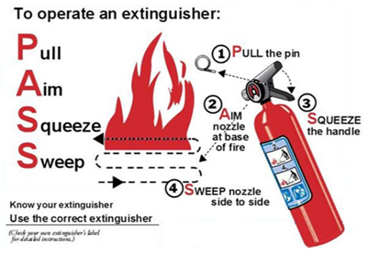
A | Aim the extinguisher at the base of the fire
S | Squeeze the handle
S | Sweep back and forth, extinguishing as you go

Types of fire extinguisher
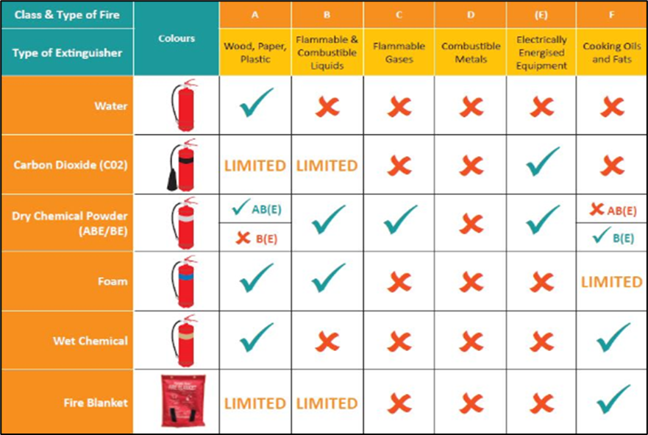

Fire Blankets
Pull down sharply on the tabs hanging from the bottom of the package to release the fire blanket. | 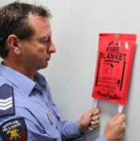
Hold it in front of you, with the fabric rolled back at the edges to protect your hands. | 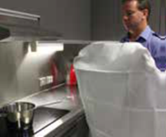
Place (not throw) fire blankets over cooking fat fires, keeping hands and face protected behind it. | 
Lay the blanket gently over the fire. Do not throw the bottom of the blanket onto the far side of the fire as flames can then run up the blanket to your hands. | 
Turn off the heat source and leave the blanket over the burnt area for at least 15 minutes or until the heat has dissipated. | 
Dial 000 to call the fire service. | 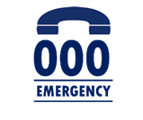
To put out a clothing fire, wrap the blanket around the flames and person. Get them to drop to the ground and roll until the fire is out. Seek medical assistance. | 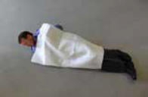

Tips
- Always place a fire blanket carefully over a cooking fire (do no throw).  - Ensure the heat source is turned off once the blanket is over the flames.  - Do not remove or touch the fire blanket until completely cool.  - Never reuse a fire blanket. They are for single use only.  - In case of a clothing fire, wrap the fire blanket around the person and roll them onto the ground.  - Do not use a fire blanket on electrical fires. | 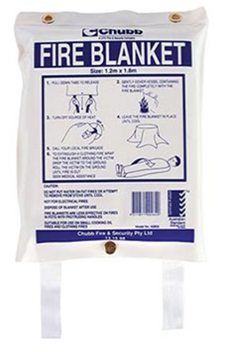

Outside Normal Working Hours
If an emergency occurs in the immediate area that could impact on occupant safety, or if the emergency warning system sounds outside normal working hours, persons working in the building should alert others in their area (if it is safe to do so). The person must then activate the emergency warning system by any available means, notify the relevant Emergency Service on “000” and leave their area via the emergency exits.
If the primary assembly area is in a remote location where an individual’s personal safety may be placed at risk it is advisable, and if it is safe to do so, for the evacuee/s to remain in a well-lit area near the entrance where they can also pass on any relevant information to the responding Emergency Service.
Do not re-enter the site or building until directed that it is safe to do so by Emergency Services.

Medical Emergency
In the event of a medical emergency, a qualified first aider will remain calm and follow the instructions below.
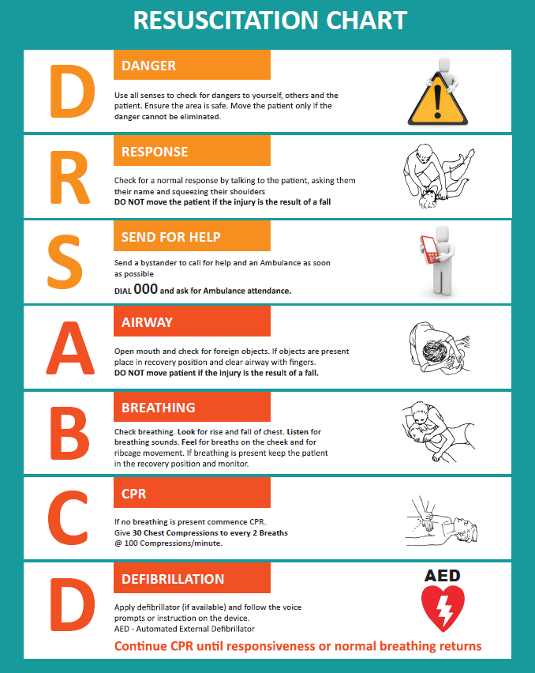

Bushfire, Flooding, Store, Heatwave, and Cyclone Plan
Select which dangerous weather events could impact your worksite/home.
 |  | 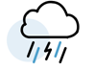 | 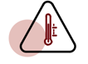 | 
☐  Bush Fire | ☐  Flooding | ☐  Storms | ☐  Heatwave | ☐  Cyclone
Fire season is July – February. Check your council’s website for fire areas. | Rain or ocean tides cause flooding. Check council’s website for flood areas. | Storms can happen anywhere, any time | Heatwaves are deadly. Drink water, stay in shade, wear light clothes, a hat and sunscreen. | Cyclone season is November – April and can impact community close to the ocean.

Emergency Numbers
During an event, safety should always be your priority. Add the below numbers into your mobile phone so that you can access them promptly.
Police – Fire – Ambulance | 000 - (106 for people with hearing or speech impairment)
SES (State Emergency Services) | 132 500
Poison and Information Line | 13 11 26
Local Council Name and Number | <Insert here>
NDIS | 1800 800 110
Note: All worksites have a business continuity plan on how to manage and recover from disruptions to the business. These continuity plans are located on Resolver and is managed by the Legal and Governance Team.

Endeavour Foundation Group Emergency Phone Numbers
Name | Title | Phone Number
Eric Teed – Work  Leanne Rutherford – Home & Community | Executive General Manager | 0448 926 224  0447 137 078
Simon Cook - Work  Andrew Jeffery – Home North  Simon Wright – Home South | General Manager | 0434 079 916  0417 632 058  0434 687 350
<Insert here> | Operations Manager | <Insert here>
<Insert here> | Site Manager / Team Leader | <Insert here>
<Insert here> | On call | <Insert here>
<Insert here> | WHS Head of Safety | <Insert here>
<Insert here> | WHS Specialist | <Insert here>
<Insert here> | WHS Operation Lead | <Insert here>
<Insert here> | People and Wellbeing Business Partner | <Insert here>
<Insert here> | Customer Safeguarding | <Insert here>
Miranda Willis | SD Transport team | 0400 212 408  1800 112 112
Simon Northey | Asset Manager | 0428 116 170
North – Sharyn Bentley  South - Glenn Tadman  CSG - Peter Robison | Regional Asset Manager (RAM) | 0497 328 758  0429 968 851  0497 942 610
CBC | For non-life-threatening property emergencies, call | (07) 3900 5460 and select option 4.

Utility connections and deactivation in the event of severe weather
Utility | Where is it located | How and where to turn off
Electricity
Water
Gas

Emergency preparation
☐ | Trim trees to remove leaves and branches that are close to buildings
☐ | Check the roof and gutters are not blocked with leaf litter
☐ | Clear drains
☐ | Keep vegetation controlled
☐ | Clear rubbish from around your worksite
☐ | Make sure windows can be sealed to stop water coming inside.
☐ | Store chemicals and poisons up high
☐ | Check your insurance for correct dangerous weather coverage

Evacuation plan
Prioritise the relocation of workers, clients (people we support) workers who receive support and clients we have in a community setting to a safe place ensuring their safety.
Refer to the Individual Emergency Plan including PEEP (QF 4200.06) for workers, people we support, employees who receive support, or people with a disability (Community).

Emergency Kits

Residential & 24/7 Shared Disability Accommodation
Ensure you have adequate supplies for three (3) days, even without power. In the event of a pandemic, you will need to increase supplies for 14 days.
 | Item | Details
☐ | Drink water | For three (3) days or 10 litres for each person in shared disability accommodation.
☐ | Food and can opener | Enough packet food, canned food, and dried food for three (3) days. Think about everyone’s needs.
☐ | Medications and Prescriptions | Enough medication for three (3) days for those who require it.
☐ | First Aid Box | Items to help if someone gets hurt.
☐ | Bathroom and Health | Toilet paper, toothpaste, soap, shampoo, sunscreen, sanitary products, insect spray, wipes, and facemasks.
☐ | Mobile phone chargers | A mobile phone and a charger and solar powered battery pack.
☐ | Torch (Flashlight) | A torch for everyone or head lamps, glow sticks or battery powered lanterns.
☐ | Radio | A radio that uses batteries to listen to safety alerts.
☐ | Batteries | Spare batteries for radio and torches. Solar charged batteries are a good idea.
☐ | Important documents on USB or online | Scan and save digital copies of papers like driver’s licenses, passports, birth certificates, ID cards, Medicare cards, insurance policies. Save contacts, photos, and a copy of your Dangerous Weather Emergency Plan.
☐ | Cooking items | A small gas stove and items like plastic plates and cutlery.
☐ | Small tool kit | Tools like safety knife, pliers, screwdriver, gardening gloves and wrench for small repairs.
☐ | Spare cash | In case ATMs or the internet are not working.
☐ | Extra clothes and blankets | Warm and dry clothing, sunglasses, and hats.
☐ | Entertainment | Cards, books, colouring/drawing, board games.

During a wet weather alert
☐ | Trim trees to remove leaves and branches that are close to buildings
☐ | Put fuel in the car and park it undercover or up a hill if in a flood area
☐ | Put away or secure outdoor items so they do not blow around or catch fire
☐ | Sandbag doors and drains, if needed
☐ | Close windows and curtains or blinds
☐ | Fill buckets or bathtub with water in case water supply stops
☐ | Stay home unless you need to leave
☐ | If you need to leave, turn off electricity (power), gas and water and lock doors and remember, do not drive into flood waters

Stay informed
In the event of a cyclone, severe storm, or flooding is forecasted by authorities, a sever weather warning will be issued to affected residents via free to air TV stations, local radio, apps, and website notifications that you have subscribed to on your mobile phone.
Where to get weather and safety updates:
Local council disaster dashboard website: | <Insert here>
Weather warnings: BOM mobile app | BOM mobile app www.bom.gov.au/app
Local ABC Radio station to tune radio to: | <Insert here>

Know the signs before disaster strikes!
Australia has a national warning system to help you understand the risk and impact of dangerous weather.
  Advice | Advice (Yellow)  An incident has started. There is no immediate danger. Stay up to date in case the situation changes.
  Watch and Act | Watch and Act (Orange)  There is a heightened level of threat. Conditions are changing and you need to start taking action now to protect you and your family.
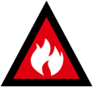  Emergency Warning | Emergency Warning (Red)  An Emergency Warning is the highest level of warning. You may be in danger and need to take action immediately. Any delay now puts your life at risk.  By understanding your weather risks, you can have a plan to stay safe at work/home or leave quickly in an emergency.

Cyclone Management
(delete if not applicable)
- Cyclones are generally well predicted and appropriate warnings provided. Most Endeavour Foundation, Community Solution Group and Brace workers will not be at work during the event of a cyclone.
- Site Mangers for our Business Solution, Learning and Lifestyle and Community Solution Group sites will ensure no workers attempt to come to work during a cyclone and the site has been secured.
- All sites impacted by a cyclone, will need to be inspected by the Asset Management Team to ensure the sites are safe to return.
- No workers shall return to work until notified by their site manger that it is safe to do so.

The Home portfolio
Management and support workers may be susceptible to work during a cyclone, either in an Endeavour Residential Houses or providing In Home Support for people we support with a disability.
It is vitally important that we have planned and prepared for the impacts of a cyclone.

Bushfires
(delete if not applicable)
Bushfires can lead to loss of life and cause severe damage to property and infrastructure, but the fire itself is only one part of the danger.
- Fire embers (small pieces of burning bark, leaves and twigs) can be caught in the wind and travel many kilometres from where the bushfire is burning and cause spot fires to start.
- The radiant heat from a large bushfire can be felt more than 100 metres away and can melt or crack objects such as glass windows, allowing embers into buildings and vehicles.
- Radiant heat can also be deadly to people and animals, causing dehydration and even heatstroke.
- Toxic fumes and heavy smoke from bushfires can make seeing and breathing difficult.
If you are in proximity to an area that could be at risk of a dangerous fire, you will need to know what you will do to protect the property and life when the fire arrives.
If there is a Bushfire threat to Endeavour Foundation Group property, ensure the site evacuates early enough to get to safety.
Under no circumstances should we defend our property against bushfires.
Do not rely on an official warning to leave. Bushfires can start quickly and threaten lives, homes, and workplaces within minutes.
If you are forced to stay at the property, it is essential you are prepared for the oncoming bushfire.
- Ensure vehicles have sufficient fuel and move them to a safe location.
- Relocate furniture, door mats and other outdoor items indoors.
- Block downpipes at the top and fill gutters with water if possible.
- Wet down the sides of buildings, decks and plants close to the worksite in the likely path of the bushfire.
- Turn on taps and hoses to soak the ground.
- Close windows, doors, and vents. Shut blinds.
- Take down curtains and move furniture away from windows.
- Seal gaps under doors and windows with wet towels.
- Fill containers with water, for example, sinks, bathtub, buckets, bins.
- Tune in to warnings to monitor local radio, websites, or social media for updates.
- Put on protective clothing.
- Drink lots of water to stay hydrated.

As the fire front arrives
- Disconnect hose and fittings and bring inside.
- Go inside for shelter.
- Drink lots of water.
- Shelter in the designated building on the opposite side from the approaching fire, in a room with multiple escape points.
- Patrol and check for embers inside, particularly in the roof space.
- Check on workers.
- Maintain a means of escape.
- Continually monitor conditions.
- Stay tuned to information channels.

As the fire front passes
- Stay tuned to information channels.
- Contact your manager and family to tell them you are safe.
- Continue to check for small spot fires and burning embers.
When there is a bushfire in your area, take notice, stay informed, make decisions, and act early.

Floods
We cannot prevent floods from happening, but we can take steps to be prepared by understanding our flood risk, where and how we get our flood warnings, and what steps we can take to reduce the impact of flooding on our lives.
There are three (3) main types of flooding:
Riverine flooding | Riverine flooding happens when there has been a lot of rain over several days or weeks. When there is too much water, creeks and rivers can burst their banks and that’s when flooding happens
Flash flooding | Flash flooding happens where there is a lot of rain in a brief period of time. It can happen anywhere, at any time, and often without a lot of warning. Flash flooding is dangerous.  Expect to see powerful, water moving fast.
Storm surge and storm tide. | Storm surge is sea water pushed onto land, often during a cyclone. Storm surges happen with the sea levels rise higher than normal tide levels. Storm tides are when the when storm surges happen alongside a high tide.
Understanding the type of flooding you are likely to experience will help you to prepare for how quickly the flooding is likely to occur, the duration of heightened flood water levels, where flooding is likely to occur, and the potential impact it could have on your home, workplace, and transport networks.
Ask council the following questions to understand your flood risk:
Question | Response
What is the flood risk to the property where I work? Where can I find this information?
Could my property be flooded? (Ask about ground level versus flood levels)
Could my building be flooded? (Ask about floor level versus flood level)
Could my access be cut off by flood waters?
Where would I go if I needed to evacuate?
Which flood warning gauge is most relevant for me?
Site Managers should be familiar with official flood warnings to be able to seek information, make decisions and act.
- Register with your council for flood warnings and alerts or visit your local council website or disaster dashboard for the latest emergency information.
- Get flood warning notifications direct to your device with the BOM Weather App.
- Check the Bureau of Meteorology website - Warnings Summaries.
- Tune into local radio stations and social media and stay informed for situational awareness.
- Source additional information about how rain and river gauges work. Additional information on how forecasts warn our communities about the approximate size of a flood and when it is likely to reach various locations so that people know how to respond.

Storms
Storms and thunderstorms can manifest unpredictably and strike within minimal advance notice. Therefore, it is crucial to assess your vulnerability and establish a preparedness strategy to mitigate their impact on yourself, your family, as well as your residence and business.
Storms can comprise of heavy rainfall and flash flooding, damaging winds, lightning strikes, and hail. Storms can last many hours and travel long distances, potentially causing considerable damage to homes and vehicles, and causing loss of power, isolation, and flash flooding.
Severe storms or thunderstorms, as classified by the Bureau of Meteorology, are storms that are likely to produce:
- Large hail measuring more than 2cm in diameter.
- Wind speeds of more than 90km per hour.
- Heavy rainfall conductive to flash flooding.
A severe storm warning will only be issued by the Bureau for storms that are likely to produce all three (3) elements.

Alert warnings for extreme weather
- Continue to monitor the Bureau of Meteorology website and get updates.
- Stop any outside work and get workers to safe location.
- Do not allow workers to go outside in extreme weather.
- Keep away from windows and doors.
- Where possible put cars under cover, away from trees, powerlines, and waterways.
- Do not allow workers to drive in extreme weather.

Heatwave
Heatwaves are known as a silent killer – they cause more deaths than any other extreme weather event in Australia combined, including bushfires, floods, and cyclones.
A heatwave is any extended period of very hot weather. In Australia, heatwaves usually range from 37°C to 42°C.
The Bureau of Meteorology now forecasts heatwaves between the start of November and the end of March using maps showing colour-coded heatwave severity for the previous two three-day periods and the next five three-day periods.
Endeavour Foundation Group will provide communication in relation to when a Heatwave occurs that may impact our workers, people we support and people with a disability (community)
Note: Have air conditioners serviced before the beginning of summer.
Heat wave checklist - Complete the following checklist if a heatwave occurs.
☐ | Identify workers who are susceptible to heat related illness. If a worker is on certain medications, has a pre-existing medical condition or has had heat-related illness before, they are more susceptible to a heat-related illness.
☐ | Ensure as reasonably as practicable that identified workers are monitored and are not allowed to work alone.
☐ | Ensure there are adequate workers first aid trained in managing heat related illness.
☐ | Check fridges, freezers, fans, and air-conditioners work well.
☐ | Ensure there is adequate cool drinking water and or electrolyte drinks.
☐ | Ensure there is a cool room, workers can access during their breaks.
☐ | Is it humid? High humidity makes it harder for the body to cool itself.
☐ | Ensure there are adequate breaks to manage heat.
☐ | Review workstations to ensure workers are not being exposed to heat sources, such as hot machinery and confined spaces with minimal air flow.
☐ | Ensure where possible, there is adequate cross flow throughout the workplace.
☐ | Remind workers to avoid caffeinated, carbonated and alcoholic drinks, and salt tablets.
☐ | Remind workers to eat as they normally would but try to eat cold foods, particularly salads and fruit. Avoid heavy protein foods which raise body heat and increase fluid loss.
☐ | If say to do so, encourage workers to wear lightweight, light-coloured, loose, porous clothes. If required to go out into the sun, wear a wide-brimmed hat and sunscreen.
☐ | Monitor workers during heat waves due to:  - warmer nights contributing to reduced sleep quality  - elevated temperatures being reached earlier in the day and lasting longer  - fatigue affecting workers’ ability to perform work safely and effectively.

Pandemic
Pandemics are highly contagious viruses that are easily spread and can cause severe illness and even loss of life. The most common form of pandemic in Australia is influenza, otherwise known as the flu. Every year, a substantial number of individuals succumb to flu-related complications.
In the event of a pandemic, follow Endeavour Foundations Group Pandemic Management Plan and government guidelines.
Potential action
- Instigate remote working/work from home.
- Provide personal protective equipment (PPE), training and equipment.
- Communicate to your workers and test where relevant.

Earthquake
Australia does not typically experience large earthquakes and on average only experiences a single magnitude five (5) (or greater) event each year.
Earthquakes with magnitudes of less than 3.5 seldom cause damage.
Understanding whether you are in an earthquake prone area is important so that you can take measures to reduce the potential impacts and know what to do during a disaster.
In the event of an earthquake:
- DROP to the ground; take COVER by getting under a sturdy table; and HOLD ON until the shaking stops.
- Do not use a doorway except if you know it is a strongly supported, load-bearing doorway and it is close to you.
- Do not use the elevators. Do not take shelter near any glass, windows, outside doors and walls, and anything that could fall.
- Stay inside until the shaking stops and it is safe to go outside.
- If outdoors, stay there. Move away from buildings, streetlights, and utility wires.
- Earthquakes can trigger secondary events such as landslides, tsunamis and fires caused by downed power lines and ruptured gas mains.

Handling or Addressing Threatening Phone Calls
Threatening phone calls are made by a variety of persons for several reasons. The most common calls of this type usually include the following:
- Threats of violence etc.
- Extortion demands.
- Allegations that a bomb has been placed on the premises.
If a threatening phone call is received, the following procedures should be followed as closely as practicable. The person receiving the call should, primarily, attempt to remain calm.
The caller may ask to be connected to a Senior Manager or may simply make demands to the worker answering the call.
Wherever possible the worker receiving such a call should transfer the call to an appropriate Line Manager.
If there is no opportunity to transfer the call, or if the caller declines to have the call transferred, the worker should obtain as much information from the caller as possible.
Once the call has terminated, contact your Line Manager, and inform them of the information received.
If the information given by the caller indicates a potential emergency, it may be necessary to evacuate either the whole or certain parts of the building. Should this situation arise, the “Evacuation” procedure should be followed.
See section below on bomb threats if the caller indicates a bomb threat situation.

Bomb Threats
As with any security threat, there is no rigid pattern of circumstances or behaviour for a bomb threat to the organisation. The following information and instructions are given as a general guide for dealing with the situation.
Upon receiving a call:
- The person receiving the call should remain calm, and if practical, engage the caller in conversation.
- Discreetly notify other workers in the area and have them notify the Police if possible and monitor the threat call.
- Ensure that the Line Manager is notified, where possible.
- Make a written record of the caller’s statements.
- If possible, try to ascertain the location of the bomb.
- Listen for any background noises which may identify the location of the caller and any accent or other information which may identify the caller.
- Use the Bomb and Chemical Checklist (QF 4200.25) to record all information.
- Do not hang up the telephone even if the caller does.
Prior to any evacuation:
- Worker to complete a quick search of the building to attempt to identify the alleged bomb.
- Particular attention needs to be given to all emergency exits to see that they are clear of danger before any evacuation is contemplated.
- Worker must then decide whether to evacuate the entire building or a portion of the building. This will depend on knowledge of the location of any bomb.
Note – To evacuate past a known location of a bomb may cause greater injuries in the event of an explosion.

Evacuation
Upon evacuation of the site, all workers will take with them all personal belongings, parcels, lunch bags, thermos flasks etc. so that the search team is not confused or delayed unnecessarily in their search.
In cases where workers are away from their workstation or office at the time of an evacuation, workers must not attempt retrieval of personal belongings. Any person/s having evacuated the building should move to nominated assembly areas or to an area well removed from the building to avoid flying glass and debris.

Locating a Bomb
The procedure here is clear and explicit – DO NOT TOUCH, DO NOT HANDLE – the Police BOMB SQUAD will remove or defuse any bomb or suspicious articles.

Lockdown / Shelter in place
Lock down / Shelter in place means finding a safe location indoors and staying there until you are given an “all clear” or told to evacuate. You may be asked to lock down / shelter in place due to aggressive member of the public / worker, severe weather event or other hazard.
Where is my Lock down / shelter in place? | Photo
<Insert location> | <insert image>
 | 
Procedure for Lock down / Shelter in place
- Alert all occupants without placing yourself in danger or further compromising life.
- Everyone in hallways or open areas is to seek shelter in the nearest room.
- Lock and barricade doors.
- Close windows and window blinds etc.
- Turn off lights.
- Everyone is to remain quiet: and not enter hallways or open areas.
- If possible, quietly contact (0) 000 from an internal extension or 000 from a mobile, if safe to do so also advise your manager.
- Crouch down in areas that are out of sight from doors and windows.
- Should the evacuation alarm sound, do not evacuate the building unless:
- You have firsthand knowledge that there is a fire in the building, or
- You have been advised by Police to evacuate the building, or
- There is imminent danger in the immediate area.

Hazardous Chemical Spills
Hazardous chemical spills in the workplace have the potential to harm people, property, and the environment.
A chemical spill is either classified as a minor or major spill, depending on several factors such as the volume spilt, the location of the spill, and how hazardous the substance is.

Major spills
Involve immediate risk to human health or the environment or uncontrolled fire and explosion and as such requires:
- Evacuation.
- Calling emergency services on ‘000’.
- Attend to anyone affected, move them upwind of the site, decontaminate, administer first aid and seek medical attention.

Minor spills
There is no immediate risk to human health or the environment, i.e., a Minor spill of pesticides which are non - flammable.
Respond to spills when they occur, including risk assessment, isolating the area, spill containment, clean-up of spilled chemical, disposal of contaminated waste and reporting of the spill incident.
Only workers that have been provided Information, training, and Instruction in the safe use of a spill kit should respond.

Assess the risk
- Assess the risk the spill poses to people, the environment and property.
- Determine the type of liquid material, the quantity spilt (and whether the spill is ongoing) and if there are any human casualties.
- Ensure you and any other responders are wearing appropriate PPE so you can safely respond the spill.
- Refer to the relevant Safety Data Sheet (SDS) to quickly identify any hazards associated with the liquid spilt.

Isolate
- Isolate the spill area from other workers, contractors, and members of the public.
- Contain.
- Confine the spill to reduce the area being contaminated and lessen the spill’s impact.
- Use the appropriate spill containment kit, including any additional PPE, neutralising agents, absorbent material, containers, brooms, physical barriers, and other tools as required.
- To contain the spill, distribute the spill control and absorbent materials around and over the entire spill area, working from the outside and circling towards the inside most effectively.
- Once the spill has been contained, stop the leak. If safe to do so, stop the spill at its source.
- If appropriate, decant any remaining liquid into a secondary container.

Decontaminate
- Ensure all the personnel involved with the spill clean-up are fully decontaminated.
- Make sure all PPE and equipment used to clean-up the spill is also fully decontaminated.
- Ensure the affected site itself is also clean, safe, and fully decontaminated.
- Check PPE, equipment, drain covers and spill kit items for damage and permanent contamination and dispose of accordingly.
- Replenish stocks of PPE, equipment and spill kits as required.

Dispose
- Ensure correct disposal of all contaminated waste. Make sure that any contaminated absorbent materials and other equipment used to clean-up the spill are disposed of appropriately to avoid further environmental damage.
- Identify used absorbent materials and other equipment used to clean-up spills that must be disposed of at a legal facility or collected by an authorised waste management provider.
- Used absorbent materials containing contaminated liquids hazardous chemicals cannot be disposed of in a general waste bin.

Record
- Record and log the spill incident into Riskman and ensure it is reported to management.
- Under the WHS Act, a major uncontrolled chemical spill or leakage is classed as a dangerous and notifiable incident. The regulator in your state or territory must be notified in writing as soon as possible following a chemical spill.

Spill Response Kits
- Spill response equipment, including spill kits, spill control materials (booms, pads, or other chemical spill barriers) and absorbent material (wipes, pillows, and floor sweep) must be suitable and compatible for the type of chemical spill that you are dealing with.
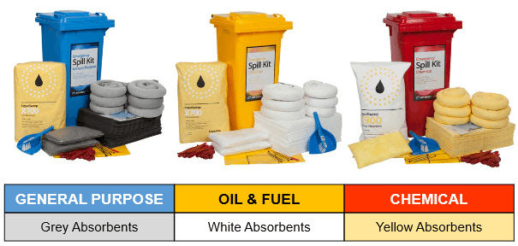

Debriefing
Emergency evacuation debrief: | Is used to assess the effectiveness of an emergency evacuation drill. The debrief should be recorded and include a description of the drill, the objectives, the participants, and the results. The report should also identify any areas that need improvement.
Critical incident: | Is defined as ‘a traumatic event, or the threat of an event which causes extreme stress, fear or injury’.
Critical Incident Debriefing (CID): | Is offered when a person or team has witnessed a traumatic event which is distressing or overwhelming.
Hot debrief: | Ideally occurs as soon as possible after the incident to ensure all information is obtained before anyone leaves the workplace (or within 24 hours of the incident).
Formal debriefing: | (powerful event group support) is usually carried out within one (1) to two (2) days of the critical incident, when workers have had enough time to take in the experience. Debriefing is not counselling. It is a structured voluntary discussion aimed at putting an abnormal event into perspective.
Debriefing can reduce the possibility of psychological harm by talking about what has happened; facts can be reviewed, misconceptions corrected, as well as valid and fair observations taken on board.
Some examples of critical incidents include assaults on workers, severe verbal or psychological aggression, the suicide or murder of a co- worker, incidents causing bodily harm or death, as well as car crashes or natural disasters including floods, bushfires, and cyclones.
A formal debrief should be facilitated by an EAP service provider or a line manager, who was not involved in the incident, or affected by it.
People and Wellbeing Business Partner, Safety and Wellbeing Specialist and the Injury Management Team should be consulted to assist with organising facilitation and any potential psychosocial risks.

Employee Assistance Program (EAP)
Who is our EAP provider? | Contact details
<insert details> | <insert phone number>
 | 
Psychological debriefing (including critical incident stress debriefing to reconstruct the traumatic event) is considered not the best clinical practice. Some people may not respond well to a psychological debriefing making the symptoms worse.

Resources
<delete what is not applicable>
All States | Bureau of Meteorology | http://www.bom.gov.au/
All States | ABC | https://www.abc.net.au/news/emergency/
All States | Emergency Alert | http://www.emergencyalert.gov.au/
Queensland | Get Ready Queensland | https://www.getready.qld.gov.au/
Queensland | Queensland Government Alerts | https://www.qld.gov.au/alerts
Queensland | Queensland Government Disaster Management | https://www.disaster.qld.gov.au/Warnings/Pages/default.aspx
Queensland | Queensland Rural Fire Service | https://www.ruralfire.qld.gov.au/Pages/Home.aspx
Queensland | Queensland State Emergency Services | https://www.ses.qld.gov.au/Pages/default.aspx
New South Wales | NSW Government Justice Office of Emergency Management | https://www.emergency.nsw.gov.au/
New South Wales | NSW Rural Fire Service | https://www.rfs.nsw.gov.au/
New South Wales | NSW State Emergency Services | https://www.ses.nsw.gov.au/
Victoria | Emergency Management Victoria | https://www.emv.vic.gov.au/index.php/
Victoria | Vic Country Fire Authority | https://www.cfa.vic.gov.au/home
Victoria | Victoria State Emergency Services | https://www.ses.vic.gov.au/home
South Australia | SA Government | https://www.sa.gov.au/topics/emergencies-and-safety
South Australia | SA Country Fire Authority | https://www.cfs.sa.gov.au/site/home.jsp
South Australia | SA State Emergency Services | https://www.ses.sa.gov.au/site/home.jsp

Appendix 1

Fire Installation descriptions
Installation | Picture | Description
Emergency lifts | 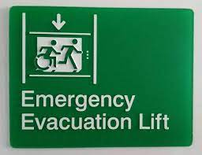 | At least one emergency lift must be provided in a building with an effective height of more than 25 m and in a Class 9a (Healthcare) building.  No lifts are to be used in the event of a fire.  However, Emergency Service personnel may use a lift to evacuate mobility-impaired persons.
Emergency Warning and intercom system | 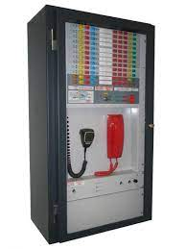 | Emergency warning & intercommunication system (EWIS), is a sound system and intercom system for emergency purposes”
Emergency Lighting | 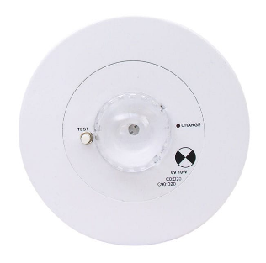 | Emergency lighting provides lighting for occupants to safely exit a building when the normal lighting has failed due to power loss.
Emergency Power Supply | 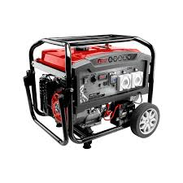 | An emergency power system is an independent source of electrical power that supports important electrical systems on loss of normal power supply.
Exit signs | 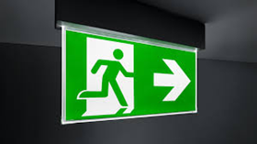 | Emergency exit lighting provides lighting for occupants to safely exit a building when the normal lighting has failed due to power loss.
Fire Blankets | 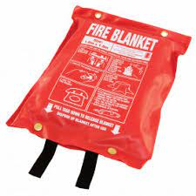 | A fire blanket consists of a piece of fire-resistant fabric (usually woven glass fibre) that can be used to smother a small fire or wrap around a person whose clothing is alight.
Fire detection and alarm systems (Fire Panel) | 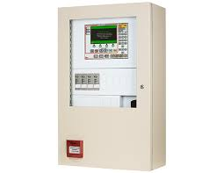 | A fire alarm (or fire indicator) panel is an early detection and warning system design to communicate warning and evacuation directions to occupants at the detection of a fire.  Fire alarm panels are activated in separate ways; they may consist of smoke detectors, heat detectors, flame detectors and manual break glass points.
Fire door sets | 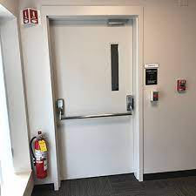 | Fire resistant door sets, commonly called fire doors, are an integral component of fire protection in buildings and classified as passive fire protection systems. They are installed in walls constructed as fire barriers. Each fire door and the wall housing it, have a fire rating known as a fire-resistant level.
Fire extinguishers | 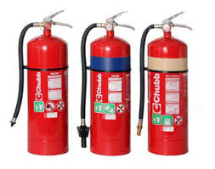 | A fire extinguisher is a handheld active fire protection device usually filled with a dry or wet chemical used to extinguish or control small fires, often in emergencies.  There are six main types of fire extinguisher available in Australia – water, foam, dry powder, carbon dioxide (CO2) or wet chemical and vaporising liquid.  Endeavour Foundation Group sites are mostly fitted with Dry Chemical powder fire extinguishers due to its effectiveness against most types of fires.
Fire hose reel | 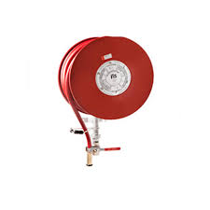 | The fire hose reel, in short, is a device used to extract substantial amounts of water out of a fire hose. This small, portable device is manually operated and can be used to extract a large amount of water, usually from a fire hydrant, or from a fire hose.
Fire Hydrants (including booster) | 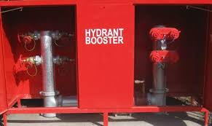 | Fire Hydrants are an assembly installed on a branch from a water pipeline, which provides a valved outlet to permit a supply of water to be taken from the pipeline for firefighting.  Hydrant boosters, also known as fire hydrant pump, fire pumps and fire water pumps, are specifically designed to increase the firefighting capacity.
Fire mains | 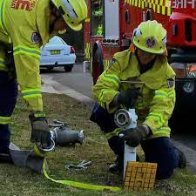 | A continuous pressurised water supply that firefighters can tap into to extinguish and control the spread of fire and protect neighbouring properties.
Smoke and heat Alarms 240 V | 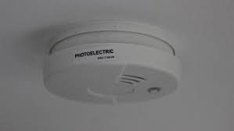 | There are two (2) main types of smoke detectors: ionisation detectors and photoelectric detectors. A smoke alarm uses one or both methods, sometimes plus a heat detector, to warn of a fire. The devices may be powered by a 9-volt battery, lithium battery, 230-volt house wiring or an alarm panel.
Smoke door sets | 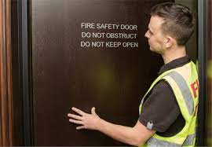 | A door set with close fitting single or multi-leaves which are impermeable to the passage of smoke, fitted with smoke seals and installed within a smoke separation. The door, in the event of smoke, if not already closed, will close automatically, and be held closed.
Solid core door | 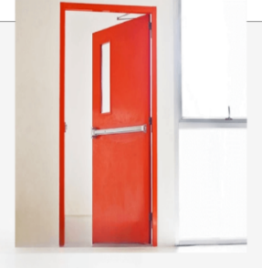 | Solid core doors can provide up to three (3) hours of protection and typically have higher ratings than wood or glass doors.  Solid core doors are constructed with higher quality materials and provide better insulation for sound and heat.
Automatic Fire Sprinkler system | 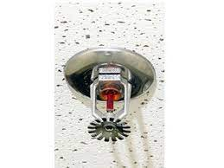 | A fire sprinkler system is a fire suppression system installed to suppress and combat fires with water.  Sprinkler systems can automatically detect a fire, alarm, and control the fire.
Water storage tanks for fire protection systems | 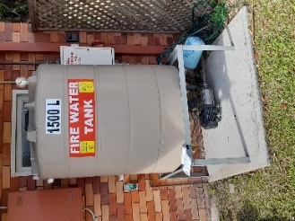 | Fire water storage tanks supply dedicated source of water set to support automatic sprinkler and fire suppression systems.

Building classifications
As per the National Construction Code.
Class 1 Buildings | Houses or dwellings of a domestic or residential nature—single or horizontally attached to other Class 1 buildings such as terrace houses, row houses, or townhouses.  In these situations, they must be separated by a wall that has fire‑resisting and sound insulation properties. 2 subclasses include:  class 1a - is a single dwelling being a detached house; or one of a group of attached dwellings being a town house, row house or the like.  class 1b - is a boarding house, guest house or hostel that has a floor area less than 300 m2 , and ordinarily has less than 12 people living in it. It can also be four or more single dwellings located on one allotment which are used for short-term holiday accommodation.
Class 2 Buildings | Apartment buildings—residential buildings containing two (2) or more sole-occupancy units where people live above, besides, or below each other.  Class 2 may also be single storey attached dwellings where there is a common space below such as a basement or carpark.
Class 3 Buildings | A residential building, other than a Class 1 or 2 building, which is a common place of long term or transient living for a few unrelated persons, such as:  - boarding-house  - hostel  - back packers’ accommodation  - residential part of a hotel, motel, school or detention centre.  Class 3 buildings could also include dormitory style accommodation, or workers’ quarters for shearers or fruit pickers.  Class 3 buildings may also be “care-type” facilities such as accommodation buildings for children, the elderly, or people with a disability, and which are not considered to be Class 9 buildings.
Class 4 Buildings | Part of a building that is a dwelling or residence within a non-residential building (Class 5 to 9), such as a caretaker’s residence in a hospital.
Class 5 Buildings | Office buildings for professional and/or commercial purposes (excluding Class 6 to 9), such as offices for government agencies, accountants, or lawyers.

Class 6 Buildings | Shops, restaurants, and cafés - places for the sale of retail goods or the supply of services direct to the public, such as:  - dining room, bar, shop or kiosk part of a hotel or motel  - hairdresser or barber shop  - public laundry  - market or showroom  - funeral parlour  - shopping centre.
Class 7 Buildings | Buildings including carparks, warehouses, or storage buildings. This class includes two sub-classifications:  - class 7a - carparks  - class 7b - warehouses, storage buildings or buildings for the display of goods (or produce) that is for wholesale.
Class 8 Buildings | Factories - buildings used for production, assembling, altering, repairing, finishing, packing, or cleaning of goods or produce.  It includes buildings such as a:  - mechanic’s workshop  - abattoir  - laboratory.
Class 9 Buildings | Public buildings - with three sub-classifications:  class 9a - healthcare buildings such as hospitals and day surgery clinics  class 9b - buildings where people assemble for social, political, theatrical, religious or civic purposes, for example, churches, schools, universities, sports facilities, night clubs.  class 9c - aged care facilities.
Class 10 Buildings | Non-habitable buildings or structures. This class includes three sub classifications:  class 10a - non-habitable buildings including sheds, carports, and private garages.  class 10b - structures such as fence, mast, antenna, retaining wall, swimming pool.  class 10c - private bushfire shelter associated with, but not attached to, a class 1a building.

Related Documents and References
Policy
QD 4001 | Work Health and Safety Policy

Framework

Procedure

Supporting documents
QF 4200.09 | Fire Evacuation Instruction Record
QF 4200.11 | Occupiers Statement
 | Fire safety certificate template
QF 4200.06 | Individual Emergency Plan including PEEP
QF 4200.10 | Fire and Evacuation Practice Record
QF 4200.25 | Bomb and Chemical Checklist

Legislations/Standards/Acts

Document Information
Department | People & Wellbeing
Portfolio | Safety & Wellbeing
Document EGM | Shannon Foley
Document owner | Jennifer Mathofer-Borsic, Head of Safety and Wellbeing
Review period (in months) | 60
Purpose (for new documents) | N/A
Rationale for change/s (legislative, review due etc) | Review due
Action/s required | N/A
Classification | In-confidence

Document Amendment History
Version | Date | Section(s) amended | Summary of amendment
09 | 30/10/2023 | All | Document prefix changed from ‘QF’ to ‘PLN’ to align with document hierarchy.  Transferred to new template.  Change of language as per Endeavour Foundation Group Communications guidelines.  Table of Contents added.  Referenced documents hyperlinked.  Formatting throughout.

