Edition 138 DATE: 16/10/2023

Ultraviolet (UV) radiation & Heat related illnesses.
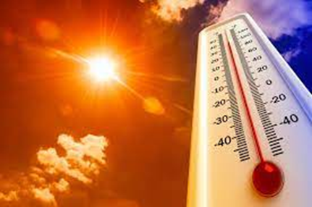
This year is increasingly likely to become the hottest year on record, due to a rapidly strengthening El Niño weather pattern and unprecedentedly hot summer. As El Niño exacerbates dry and hot conditions across the country, prompting further warnings that extreme heat could hit this spring and summer, particularly in the eastern states.
It is Australia's first El Niño event in about eight years.﻿

Workers who are exposed to the sun are at risk of being overexposed to ultraviolet radiation (UVR) and other heat related illnesses.
.
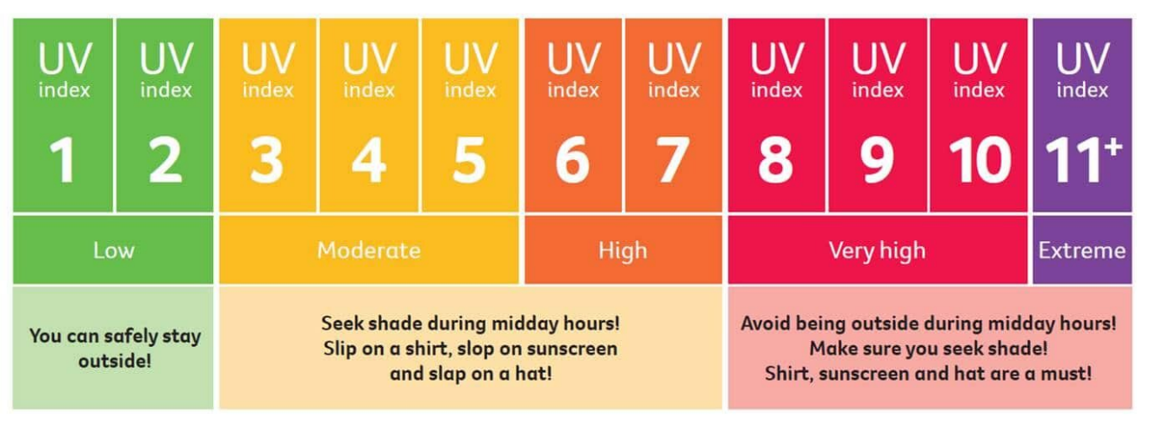
UV Index – An internationally standardised open ended numerical scale developed by the World Health Organization

Information on ultraviolet (UV) radiation is essential for our lives under the Australian sun. We have one of the highest levels of UV exposure and highest rates of skin cancer in the world. UV damage also causes sunburn, tanning, premature ageing and eye damage.
UV radiation is greatest in summer as the sun is high in the sky and its rays pass through less atmosphere before reaching the earth's surface.

When we think of UV, we often think of long, hot summer days. However, even though UV levels are higher in summer, sun protection such as hats and sunglasses aren't just summertime accessories.

Regardless of the time of year, it's important to check the UV index forecasts and use sun protection when the UV index is 3 and above.

Consider how much time you’re spending outside - including during work or recreational activities - any extended periods outdoors increase your need for sun protection.

The best way to avoid overexposure to UVR is to stay out of the sun, especially between 10am and 3pm. If you have to be outside, make sure you protect yourself.

How to reduce your risk
To decrease the risk:
- avoid direct sun in the middle part of the day and when the UV index is 3 and above:
- wear a broad-brimmed hat.
- wear sunglasses (especially the wrap-around kind).
- minimise your uncovered skin by wearing clothing; and
- where your skin is uncovered, apply broad-spectrum SPF 30+ sunscreen.
Also consider having your GP or dermatologist check your skin regularly for potential skin cancer in areas it’s hard to spot yourself.

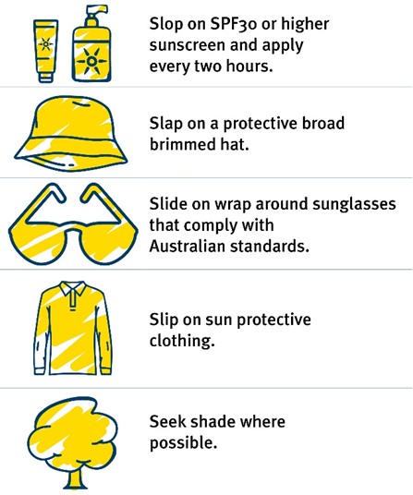
Remember: Sun protection is recommended when the UV index is 3 and above.
Outsmarting UV: top tips
Think UV, not heat! The sun can still be damaging on cool or cloudy days, and during the morning or early evening. UV radiation is not just a summertime concern.
Watch for sun protection times and UV levels for your location in our online weather forecasts, BOM Weather App and the SunSmart App.

Remember you can still get burnt on cool or cloudy days – so think UV, not just heat.

Heat related illnesses.
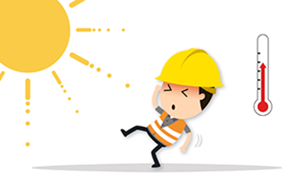
Heat-related illness can quickly become life-threatening. If you or someone near you is very unwell and does not respond to cooling and rehydration quickly (within 10 minutes), call triple zero (000) and ask for an ambulance.

Working in hot and/or humid environments can be uncomfortable, but more importantly lead to a heat-related illness, which can be fatal.
Heat-related illness occurs when the body is unable to cool itself adequately.

Heat-related illness includes dehydration, heatstroke, heat exhaustion, heat cramps and heat rash.
For more information on heat related illness and symptoms hot-weather-risks-and-staying-cool
The best way to reduce the risk of heat-related illness is to drink plenty of water and keep your body as cool as possible.

How can I do this?

- Keep hydrated by drinking water regularly during the day. This generally means drinking two to three litres of water a day, depending on heat, humidity and your physical activity.
- Drink water regularly throughout the day in hot weather – don’t wait until you’re thirsty.
- If your doctor normally restricts your fluid intake, check how much to drink during hot weather.
- Drinking too much water can also be dangerous, so monitor the colour of your urine.
It is recommended that your water consumption should ensure that your urine is light yellow.

- Avoid drinking drinks with high levels of sugar, caffeine and alcohol or very cold drinks.

- Eat smaller cool meals, such as salads. Do not take additional salt tablets unless prescribed by a doctor.
- Keep yourself cool. Use wet towels or scarves.
- Take breaks during the day in cool, shaded areas to bring your core temperature back to normal.

Notify your supervisor immediately if you start to feel unwell.
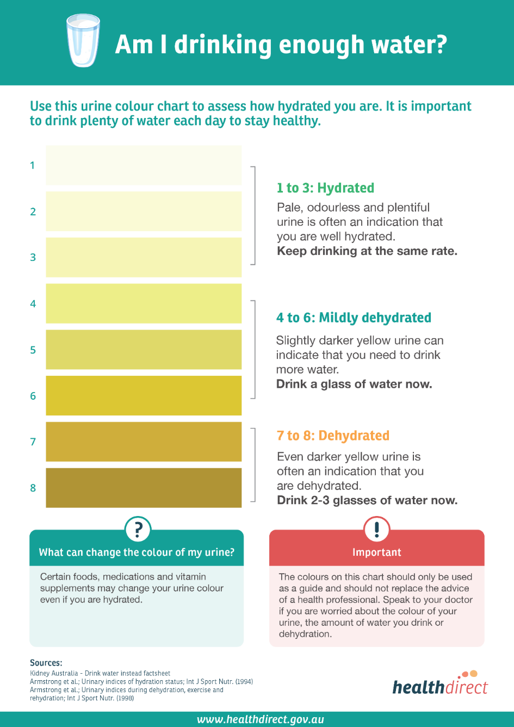

Prepared by: Michael Murphy | Contact Number: 0409 154 196
Approved by: Jennifer Mathofer-Borsic | Contact Number: 0410 469 346
Sign off Sheet
Service Name:
Learning Activity Name/description
Date: | Start Time: | Finish Time:

Name of Participant  Please place a tick against all persons present at the Safety Pause |  | Present   | Participant Signature
1
2
3
4
5
6
7
8
9
10
11
12
13
14
15
16
17
18
19
20
I confirm that all persons were present as marked:
Facilitator’s Name
Signature

