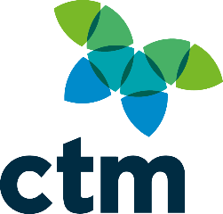

QTravel Program Frequently Asked Questions

SMART Portal – Password reset

Did you know that you can reset your own password at any time?

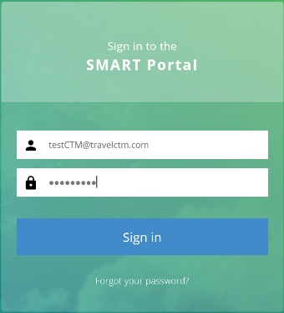
- Go to SMART Portal homepage and select the
“Forgot your password?” link.
- Enter your email address and a reset password
link will be sent directly to you
- Link received is used to reset your password

Locating Invoices and Itineraries via SMART Portal

• After logging into SMART Portal, select the “Invoices & Itineraries” icon from the Home page

INVOICES

• From the menu on the left-hand side, select “Invoices”
• The “Invoice Date” field will default to today’s date, you do not need to change this
• In the “Client” field enter the name of the traveller that you are wanting the document for.
You will need to enter the details with the Surname first. EG: SMITH/Robert (NOTE: You must select the traveler name that pops up, or you will receive an error when you click on “Search” in the next step)
• Select “Search”. This will display all the bookings for the selected traveller
• To view the invoice, select the icon under the “Actions” tab. This will download your
invoice in pdf format. ITINERARIES
• From the menu on the left-hand side, select “List Clients”
• Enter the traveller first name and last name in the required fields and select “Search”
• To view the traveller profile, select under the “Actions” tab
• To view the itinerary, select the link of the relevant booking number

Tramada Reporting

Several reports are available within the “Invoices and itineraries” icon. These can be accessed from the “Reports” tab at the top of the page. A user guide is available from the Tramada Next Generation reports” link is below.

Fare Forecaster

CTM’s Smart Fare Forecaster - gives a 21-day view of your chosen sectors outlining the cheapest day and time to travel. and highlights the cheapest day and time window to fly.

• Fare Forecaster is currently available to all agencies
• Accessed via the SMART Portal and can be customised to show 3 different itinerary segments if required
• To activate the widget, select the  icon on the fare forecaster tile.
• Once activated, select your city pairs and one way or return. Type the city name in the location bar.
• Select the window of time to view the fare prices relevant for your trip
• Hover over the bar graph to view the best available fare in the chose time window

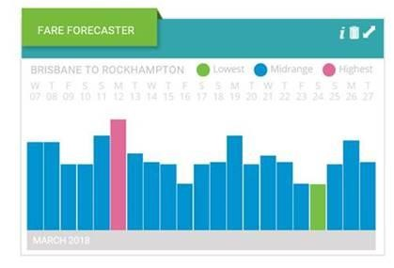

TripCase

Tripcase allows you to view your travel itinerary from your mobile device. Please see link below with further information.

CTM Group Travel
There are different types of group bookings and CTM manage them in different ways.
The Queensland Government’s dedicated CTM consultant team can assist with bulk group flight bookings, where travellers are travelling from multiple destinations on different dates to multiple destinations.
Where available, negotiated Queensland Government rates will be used. To access these rates, you will need to fill out the below Groups template and email the template to qldgov@travelctm.com
ETM (Event Travel Management) offer the full scope of group travel movements;
- Group Flights
- Group Accommodation, in conjunction with Flights
- Transportation and Ground Arrangements
- Conference Venue Finding
- Attendee Booking & Registration Service

What is a Group?
If you're booking a group of 10 or more on the same travel itinerary or have 20 or more passengers travelling to the same destination for a common purpose, ETM has you covered. With solutions to suit a variety of group types, sizes and travel needs, ETM can help you find the best travel option for your group, within the QTravel policy.

Please complete the below form and submit your enquiry to ETM via email qldgovgroups@eventsctm.com . One of our dedicated Groups Travel Consultants, will be in contact to discuss your requirements further.


Online Training Tutorials
Serko offer a variety of training tutorial videos that you can access at any time.
Click on the PDF to access the online training. Topics include:
- Making bookings
- Changing a booking online
- Clone a booking
Seating Requests Click on the PDF document to learn how to request seating for your bookings
Jetstar Baggage
When booking a Jetstar flight, you can add baggage to your booking.
Hotel / Car only search with Serko without AIR If you are booking a regional hotel or need to book a car only.
Tip for regional search – Add QLD to your location - example below Tully alone did not appear however Tully qld will return an option to select…
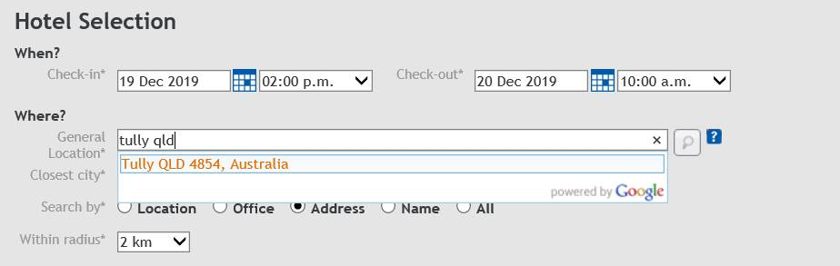
Unused Tickets Tips & Hints
Add Itinerary to calendar



Top Picks Program
The Top Picks Program (Hotel Consolidation) initiative is aimed at delivering further savings to the QTravel program by consolidating room nights into fewer hotels in Brisbane, Cairns and Townsville.
To select the top pick rate, refer to the room type that has ***Best Rate***, which indicates that this is the Top Pick rate at the Top Pick property.
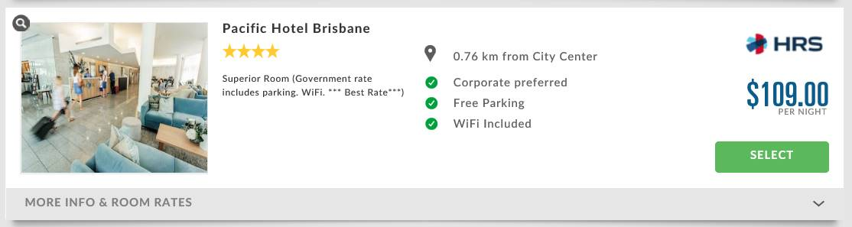

NB: Top Picks are not ‘preferred’ properties, this is Serko terminology only.
For further information on Top Picks, or a copy of the Top Picks List and Maps for 2020, please click on the below PDF Links

On Request Bookings
In Serko HRS’s hotels will appear with either the green  or orange  (Also known as ‘On Request’) booking button.
Indicates ‘Live’ availability in which once clicked your booking will be confirmed.
Indicates the property has limited allotments for the dates you are searching, or the property doesn’t have the technology to provide HRS with live availability for QTravel, in which, when selected you are requesting for the property to be contacted.
For further information on the steps of an On-Request Booking and the Quote Tool process, please click the below pdf link.

HRS Invoice Portal
The HRS Invoice Portal provides travel administrators and travel bookers with instant access to their accommodation invoices (post-stays) at any time, day or night.
Travel administrators and bookers can self-register to view and download their accommodation invoices. Travel administrators requiring global access (all invoices for your agency bookings), you will need to log a feedback ticket for HRS, requesting ‘admin rights’, and you will be promptly granted this access.
The Invoice Portal is located on the CTM Smart Portal under ‘Documents and links’. We encourage you to visit the link and self-register today.
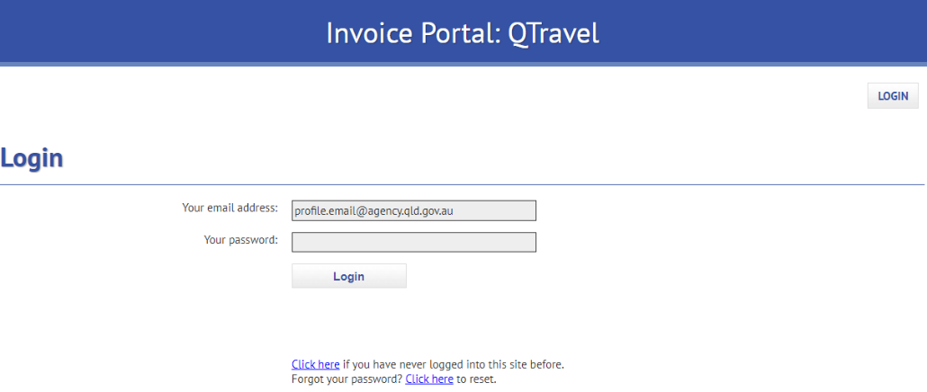

To learn how to set up access please click the below Invoice Portal FAQ.

Accommodation Group Bookings
HRS specialises in group accommodation bookings, providing exclusive QLD Government negotiated rates, centralised payment and booking data flow to BI. To access these rates, you will need to fill out the below Groups template and email the template to events-au@hrs.com.
For further information, click the below Group Accommodation Bookings FAQ and Group Accommodation Template.

HRS Hotel Directory
The Hotel Directory is used as a research tool for agencies to view more than 9,000 bookable properties in the QTravel program. Where a booker is not sure of the properties available to book in a certain location, they can open the Hotel Directory to view options available to them.
Adding a hotel in program
If a property you require is not found in program, please log a feedback ticket via CTM’s Smart Portal under ‘Documents and Links’. Based on the location the team may send you a ‘new hotel request’ form which requests further information about the property required. As you can imagine, QTravel have over 3,000 available hotels to book online. To maximise the Program’s buying power, new hotel requests are sent to QGP for consideration for locations where there are suitable options currently in Program.

Direct Bookings
The QTravel program discourages direct bookings being made with properties as it creates the following issues;
- Breaches some agency travel policy’s
- Creates a breach of the hotel’s rate agreement with HRS
- Encourages leakage
- Affects follow up quotes (supply and demand)
- Jeopardises the direct relationship between HRS and the hotel
- Interferes with duty of care as direct bookings are not visible on QTravel emergency reports, which are run during natural disasters or emergency events to locate travellers.

