People & Culture Leader Guide
My Recruitment+ (MRP) for Hiring Manager

Accessing MRP
You can access MRP on the Leading @ Endeavour Intranet Attraction page
https://intranet.endeavour.com.au/departments/people-culture/leading/attraction/planning/

New Users
New users will be required to contact the Talent Acquisition team to request their user set up for the MRP platform. Once this has been set up, an automatic email from MRP will be sent requesting to reset the password. Click on the Green Link stating “RESET YOUR PASSWORD”.

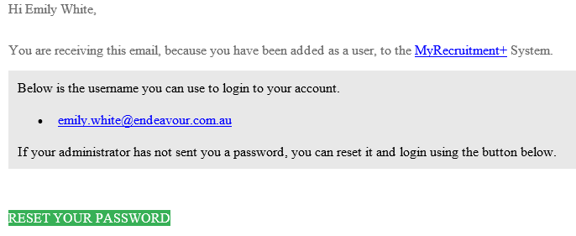

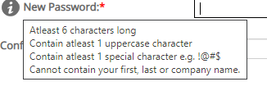
The new password must meet the complexity requirements – these requirements are below:

Note: Do not change or delete the “Current Password” and only update the “New Password” text Fields.

Once entered, click “Update”. If you meet the complexity requirements for the password it will take you straight to the MRP home page.

If a “System Error” Message pops up, your password doesn’t meet these standards and you will need to try again.

Submitting a Request to Recruit

- To Access the MRP Link through the Intranet follow below:

Staff Intranet > Departments > People & Culture > Leading > Attraction > Planning

Scroll down the bottom of the page for the My Recruitment+ Link

Alternatively, use the link below:
https://rec.myrecruitmentplus.com/NewHireRequisitionFromIntranet.jsp?entryPointId=33&token=E7EC0D33-7335-4CEA-8CD5-517A218E1350
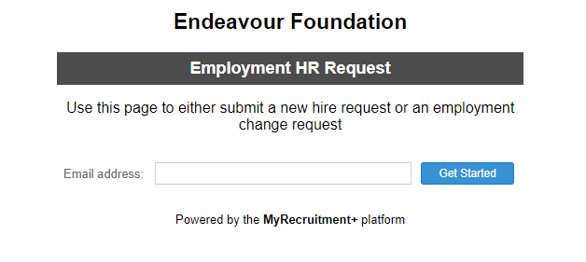
- Enter your Endeavour Foundation work email address and click “Get Started”.

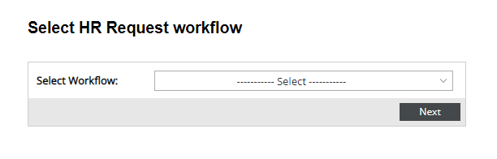
- Select your HR Request workflow from the dropdown box that best suits the role.
The options include
- Non-Service Delivery
- Support Worker
- Service Delivery Non-Support Worker
Once Selected, click “Next”.

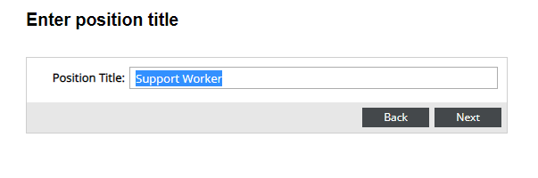
- Enter the Position Title that matches the Success Profile of the role. This should match how you would like it advertised or how it’s entered in PeopleSoft. Once Entered, Click “Next”.
Note: this title will flow through to the adverts, contracts, pay records etc. Ensure to check spelling and punctuation including capital letters as appropriate.

- Enter all the details of the position in the text fields and use the dropdown options to assist you where possible
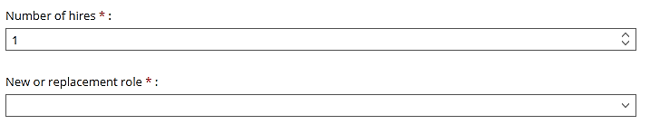
What you will need to know:
- How many people do you need to hire?
- Is this a new role or are you replacing someone?
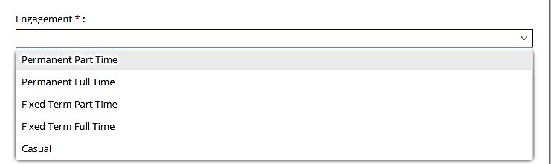
  - If you are replacing someone, be sure to go to PeopleSoft to find the position number of the vacant position, and the name of the person you are replacing
- The Portfolio the employee will work in eg Home, Community, Work
- What type of engagement do you need?
  - Permanent Full Time
  - Permanent Part Time
  - Casual
  - Fixed Term Full Time (and the duration team)
  - Fixed Term Part Time (and the duration of the term)
- How many hours will your new hire work?
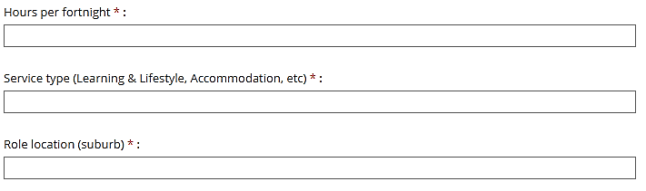
- Which type of Service will they work in?
  - L&L
  - Accommodation
  - In Home Support
  - Comac
- Which location you are recruiting for? If there the role is to work over multiple positions, there is an option to list these.
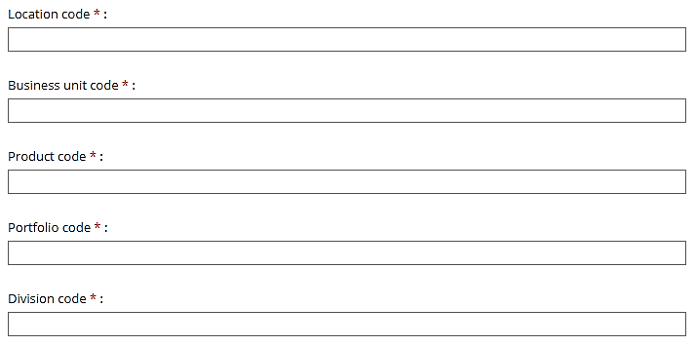
- Next you will need is DAX information for your new hire. Use the Financial Look up tool to help you http://dimensiontool.endeavour.com.au/home
  - Location Code eg 40200P
  - Business Unit Code eg LEARN, RESID etc
  - Product Code eg ZADMIN
  - Portfolio Code eg HOME, COMM, WORK
  - Division Code eg SDL

- Team Code – this represents your greater team or region. To find out your Team Code check link on the Structure Charts Intranet Page: https://intranet.endeavour.com.au/about/structure-charts/

- Tier/Supervisor Levels can be defined by the below structure. Note: If a role does not meet these groups, then the tier is 0.
Tier | Description
Tier 1 | Chief Executive Officer
Tier 2 | Executive Leadership Team: All positions reporting directly to the CEO with the exception of Internal Auditor, Head of Corporate Affairs, Project Manager and administration support roles
Tier 3 | All positions reporting directly to a Tier 2 position with the exception of administration support roles, but including Internal Auditor, Head of Corporate Affairs, Finance Manager and Project Manager.
Tier 4 | All positions reporting directly to a Tier 3 positions
Tier 5 | All positions reporting directly to Tier 4 positions in Service Delivery division and subsidiaries only
Tier 6 | All Executive Assistants to Tier 2 – ELT

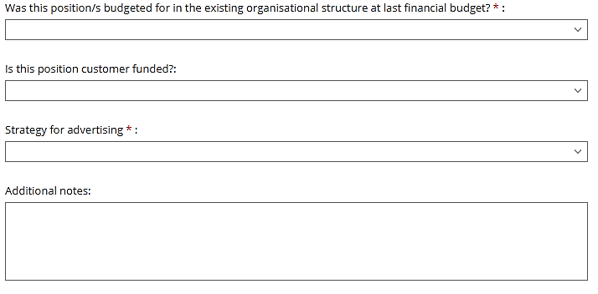
- Was the position Budgeted for in the existing organisational structure at the last financial budget? Please refer to the People and Culture Delegations of Approval to determine if you need additional approval to recruit.

- What is your strategy for recruiting, would you like to advertise internally only, or also advertise to the external market?

- Non-Support Worker Roles - You will need to attach the Success Profile – contact your People Experience Business Partner if you need a copy.

- Additional Notes: Iinclude here why you need to recruit which will help the approvers determine if they support your need. The more detail you enter here to clarify exactly what you need and why you need it, the more likely the approvers are able to push it straight through and reduce the need to have to contact you to get those details.

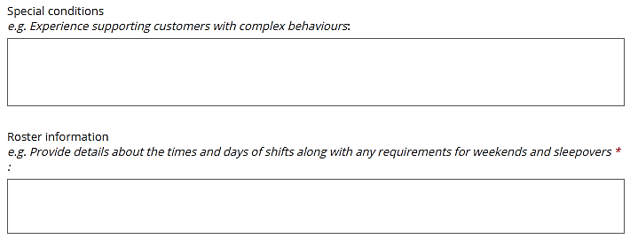
- Have roster details ready to enter as well as any specialised skills that might be required, such as Peg Feeding, experience using a hoist.

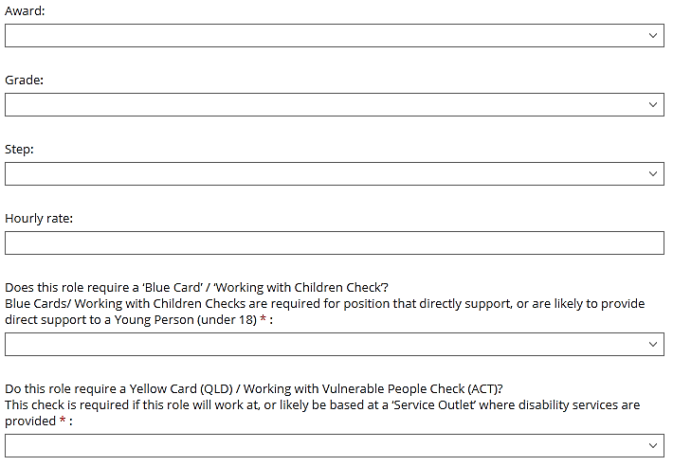
- Pay details
  - Award/Collective Agreement/ Individual Employment Contract
  - If it is an Award/CA role, choose the correct Grade and Step
  - Enter the Hourly Rate

- To find out the appropriate Working Screening checks for the role if the role needs ie )Blue Card, Yellow Card or Working with Children Check) refer to the Me @ Endeavour Worker Screening Page. https://intranet.endeavour.com.au/departments/people-culture/me/worker-screening/
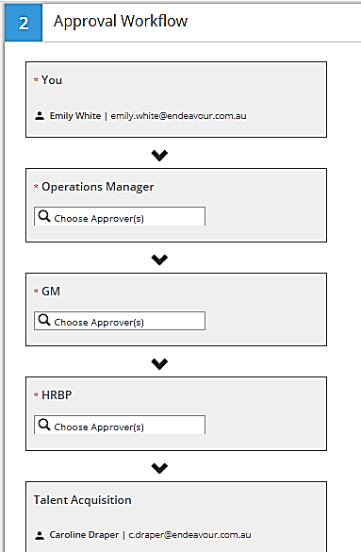
- Once all the details are entered, the Approval Workflow will need to be completed.
This will include :
  - Operations Manager
  - General Manager or Executive General manager (GM or EGM)
  - People Experience Partner (HRBP)To enter their names in the fields, Click on the magnifying glass and search for their name.
Once all the details and approval workflow are entered and accurate, at the bottom of the page, click “Submit for Approval”.
This will automatically send an email to your first approver in the Approval Workflow to approve the position. Once it has gone through and been approved by everyone in the Approval Workflow, the Talent Acquisition team will be notified and the recruitment process can commence at that point.

Troubleshooting
Which Web Browser should I use to Login to MRP?
The functions in the MyRecruitment+ Platform is not supported in Internet Explorer. All links for accessing MRP will need to be copied into the Google Chrome or Microsoft Edge Internet Browsers. To ensure all links you click on via emails are automatically opened in one of these browsers, you can change your default browser through the below steps:

Control panel > default programs >set your default programs >web browser > google chrome

Note: If you do not have Google Chrome or Microsoft Edge on your computer, you will need to lodge a ticket with IT so they can assist you.

When I click on a link to use MRP, it opens up a white page with an error message. What should I do?
Take a look at the hyperlink and see how it begins. An Http site is unsecured and may potentially be blocked by IT. Https is the secured option (safe website) and will work within the Endeavour Foundation’s Internal IT.
If your website is not loading, check your link to ensure it begins with https.

HTTP HTTPS

Note: If MRP isn’t loading after the hyperlink change, you may require a software update on your computer. Log a ticket with IT so they can review the issue.

