How to search for contracts under my division?
- Access https://endeavour.app.jaggaer.com/  - Click on Staff Login | 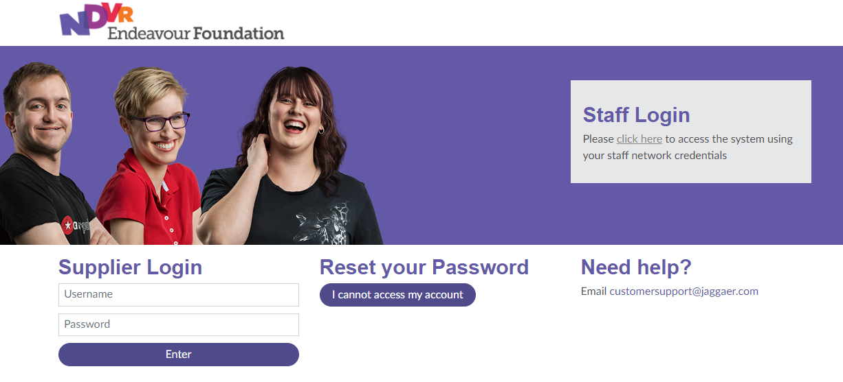
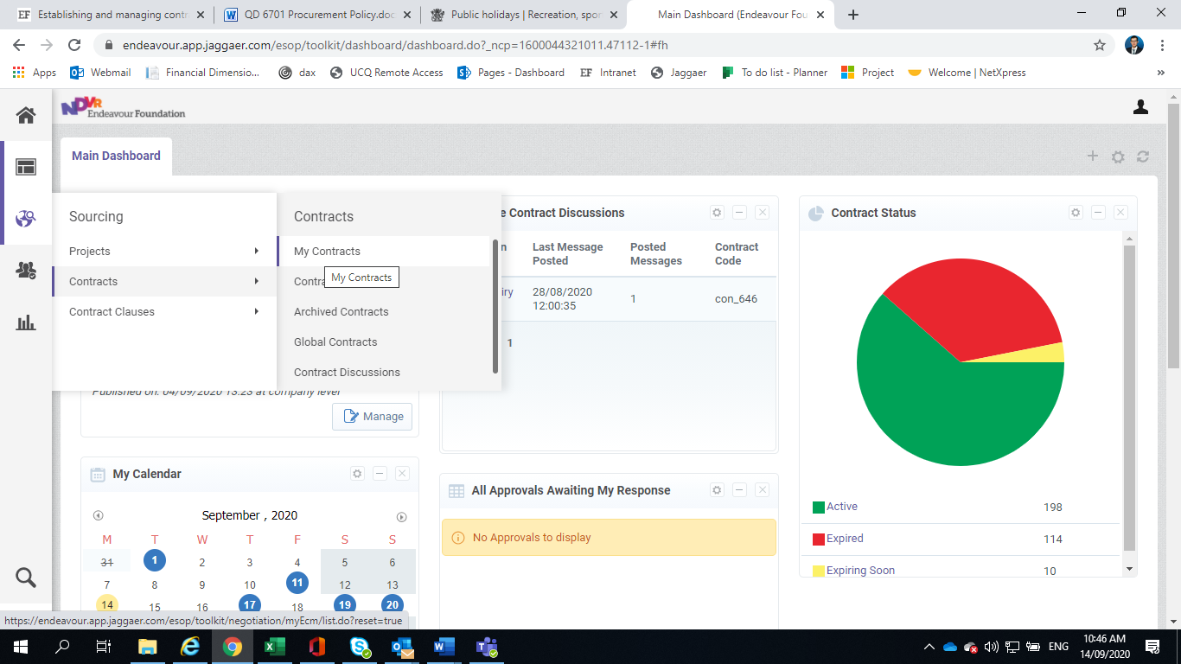
- Click on -> Contracts -> My contracts

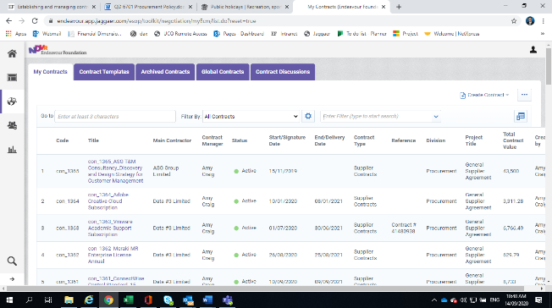  - Click on | 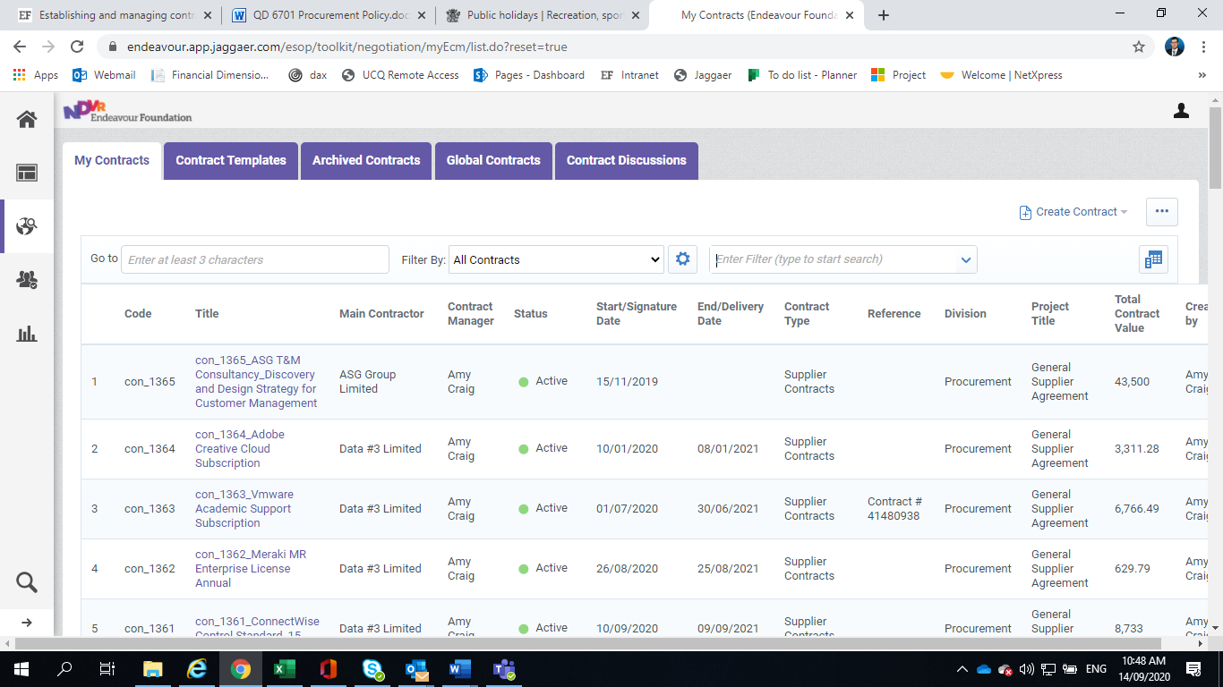
- Click on Business Units | 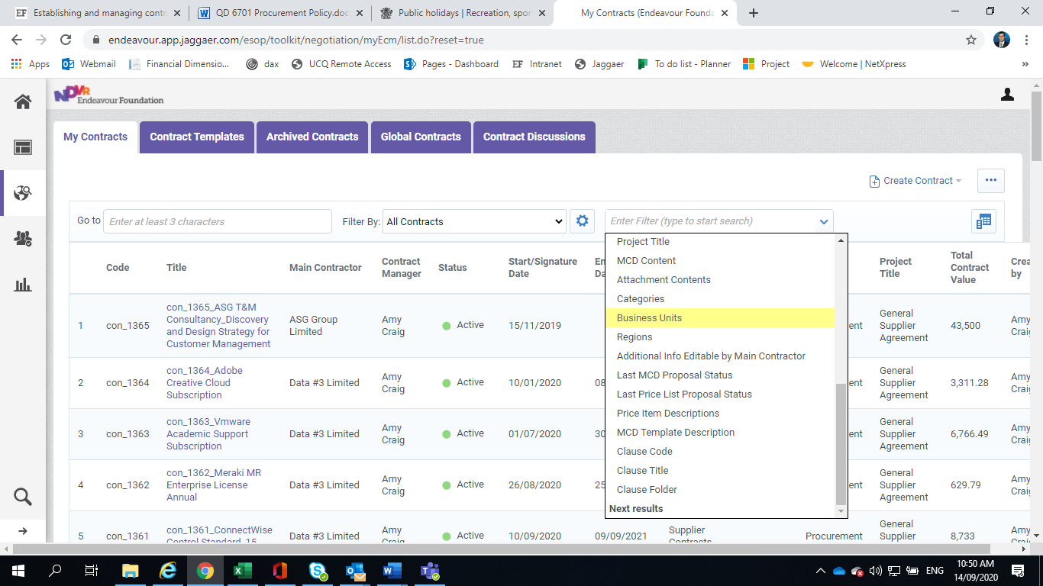
- Click on Select Business units | 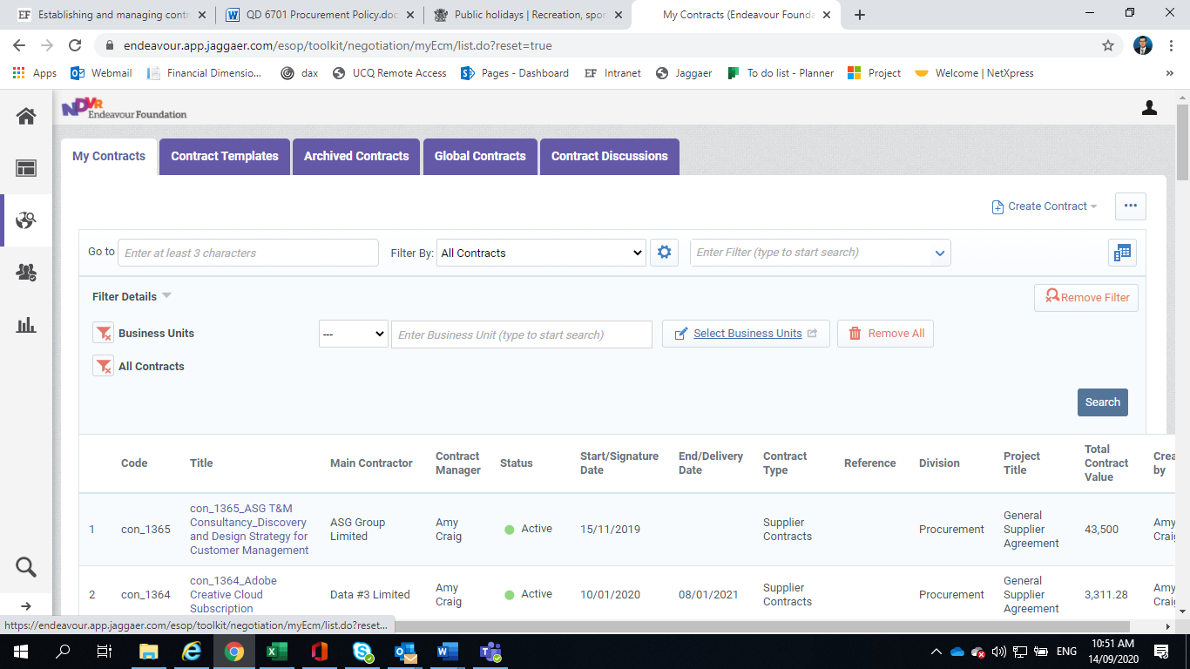
- Select business unit and confirm | 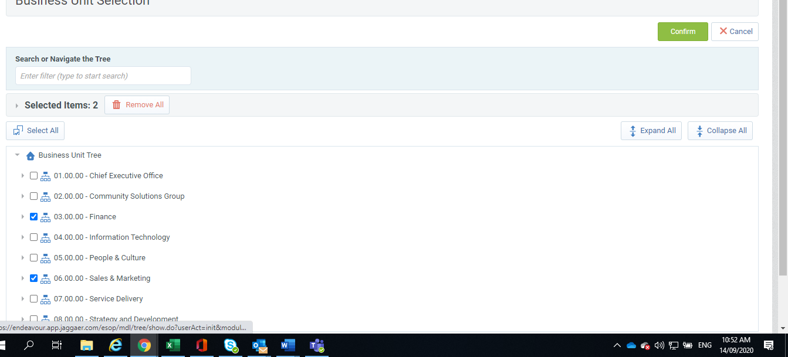
- Click on ‘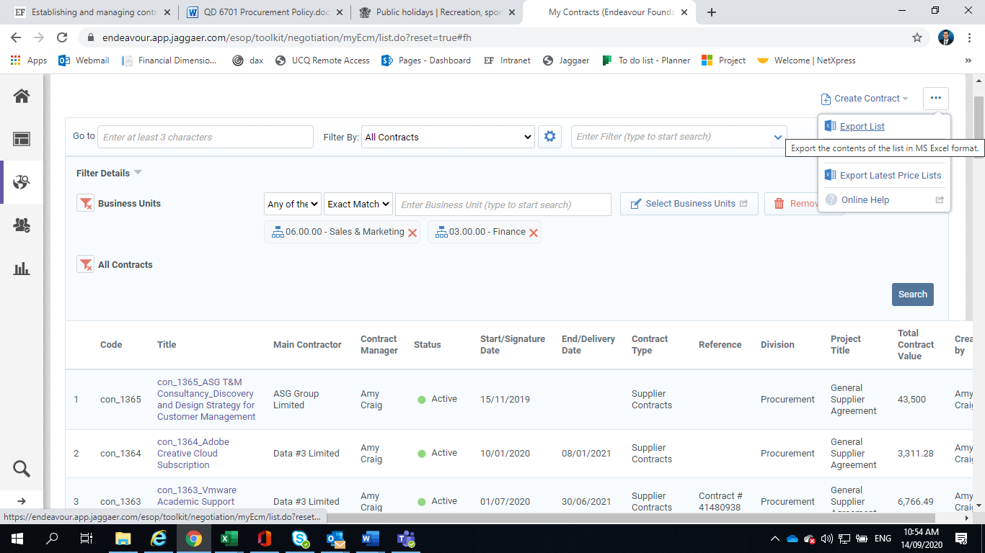’
- Click on ‘Search’ to apply the filters.
- Click on Export list

