In the Staff Intranet, select the About tab and click on ChemAlert

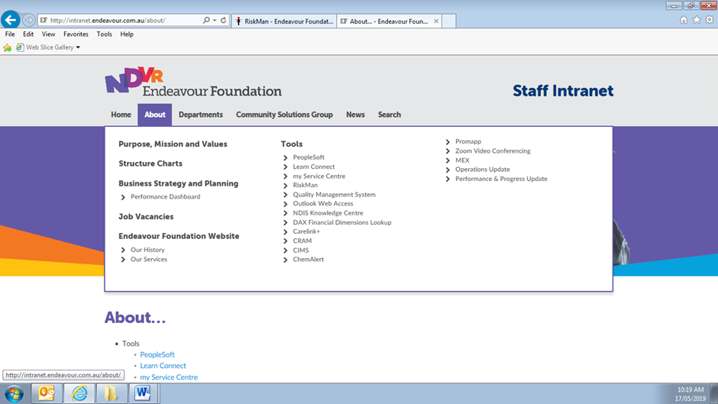
Click on ChemAlert

OR the Second Method
In the Staff Intranet, select Safety under the Departments tab

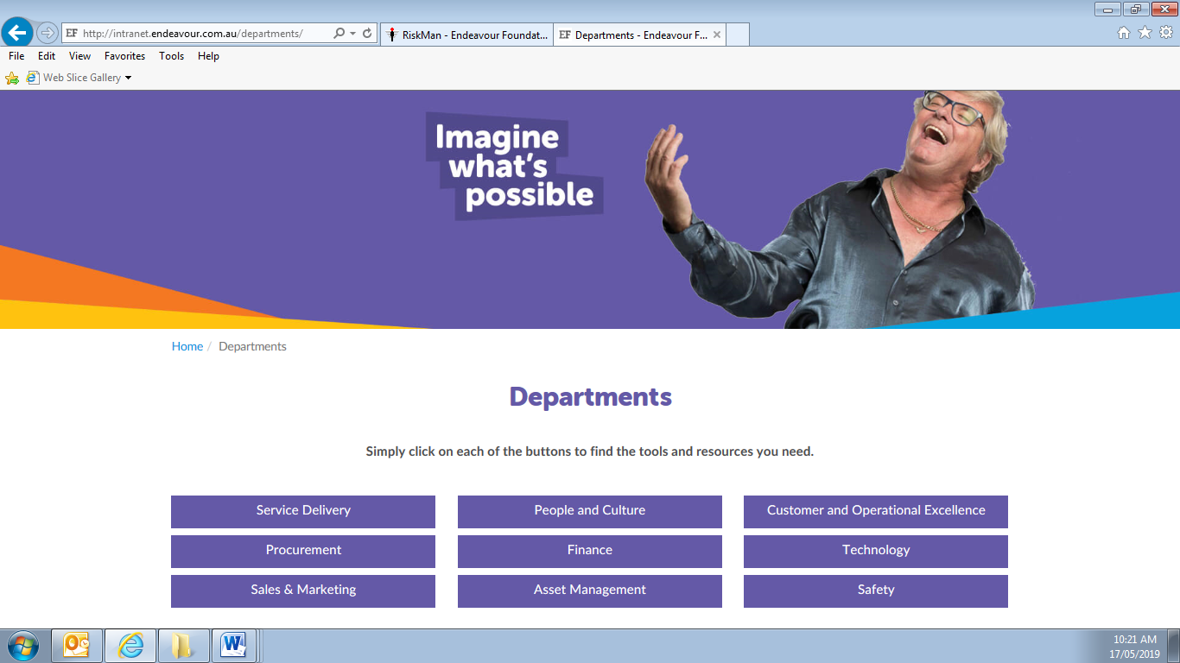
Click on Safety

Click on Work Health & Safety (WHS)
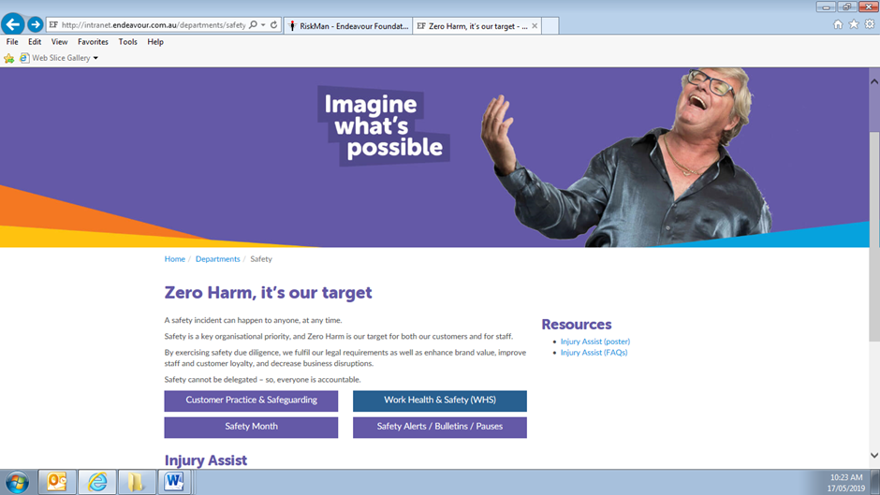
Click on
Work Health & Safety (WHS)

Then click on ChemAlert in Quick Links
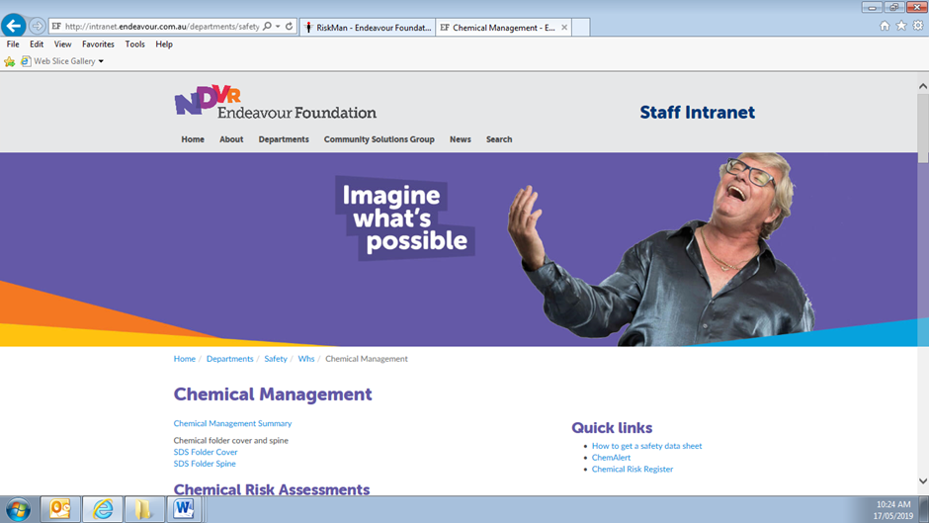
Click on ChemAlert

Click on the Anonymous button when the ChemAlert screen opens.
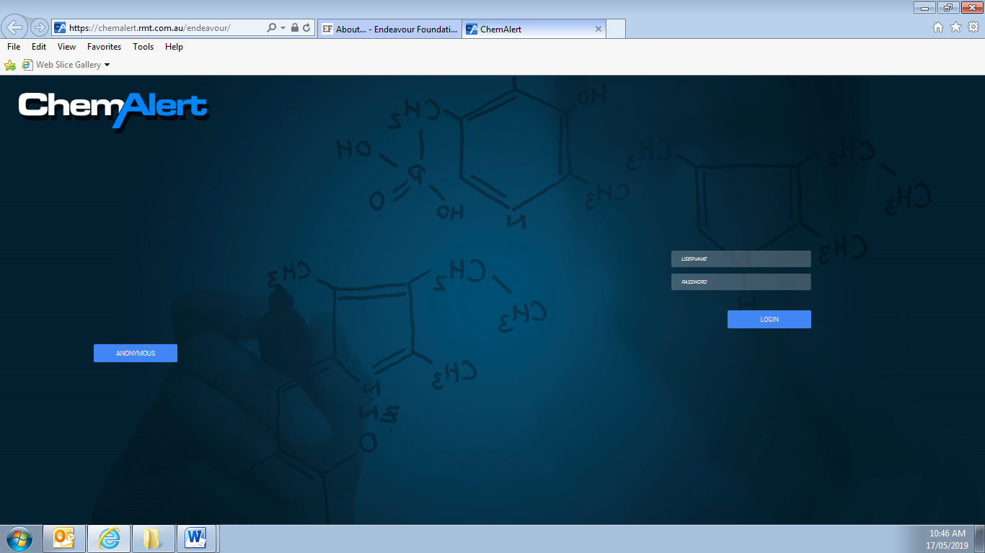
Click here

Use the search engine to locate your product
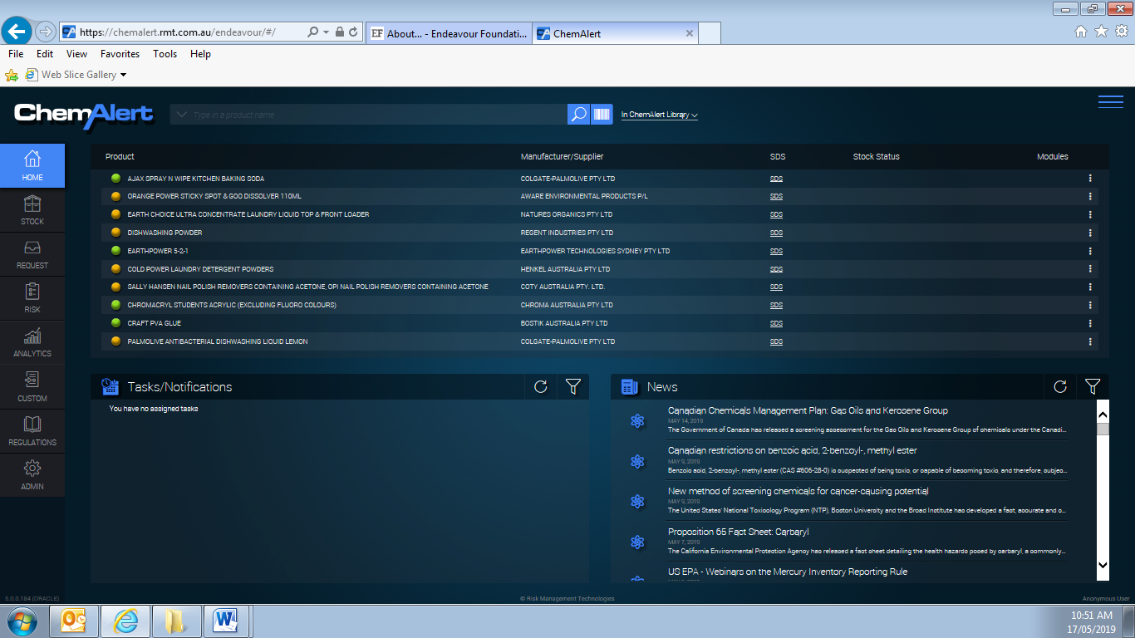
Click here for the ChemAlert Search Engine

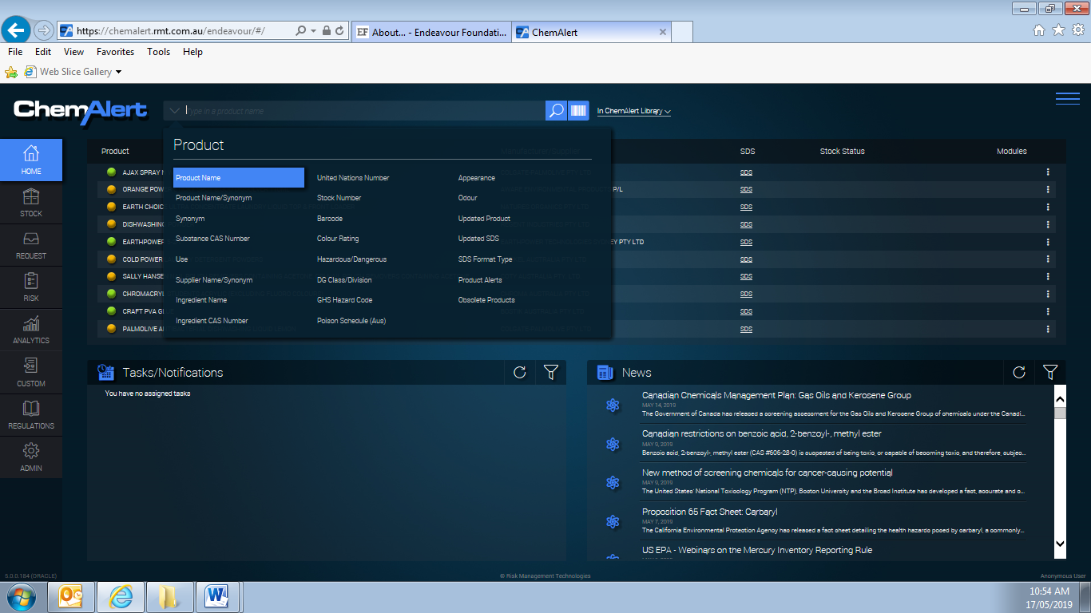
Enter the product name and click search
Default search is Product Name, but you can change to suit your search

Conducting a search for “Ajax” reveals 18 items found.
Double click on the product name with the correct manufacturer.
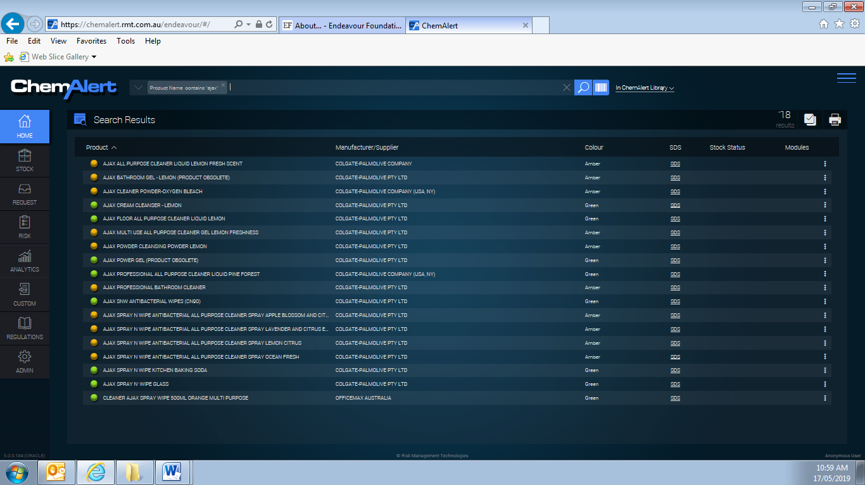
Double click on the product that has the correct manufacturer
This search found 18 items under Ajax

Click on Reports/Labels
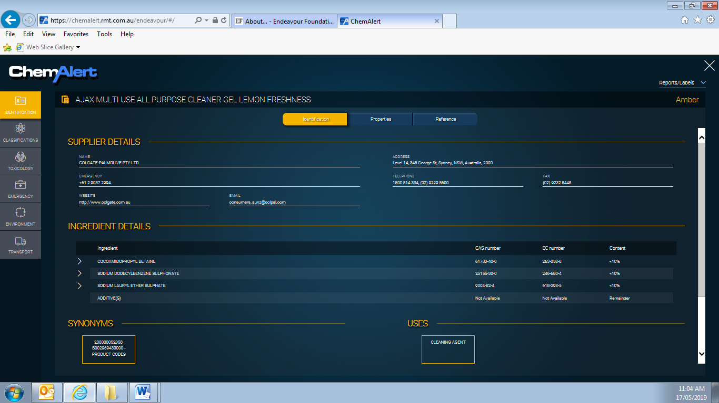
Click on Reports/Labels

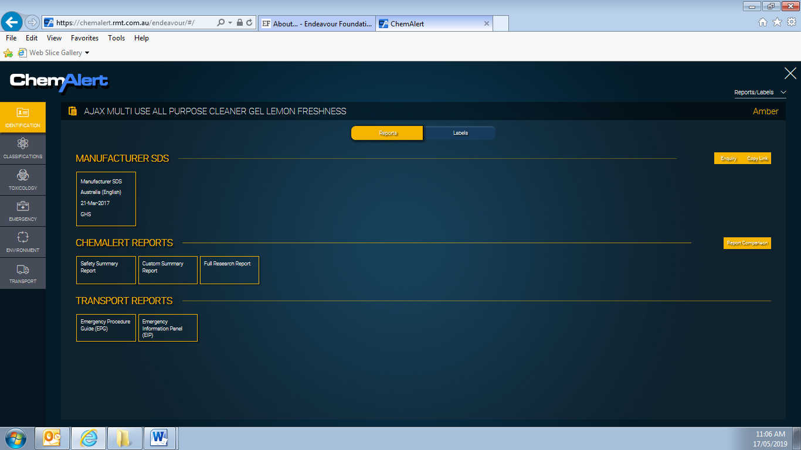
Click on Custom Summary Report

Select the View/Print button on the screen
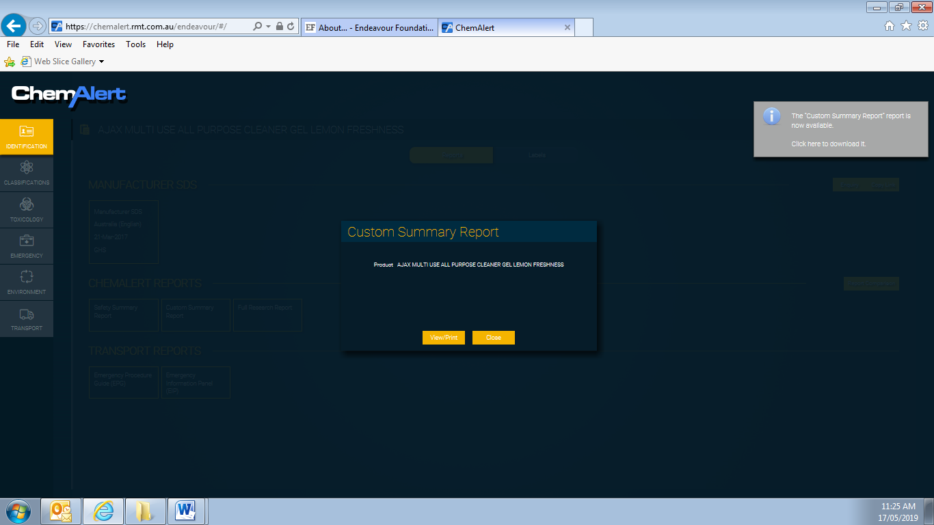
Then click here to download the report
Click on View/Print

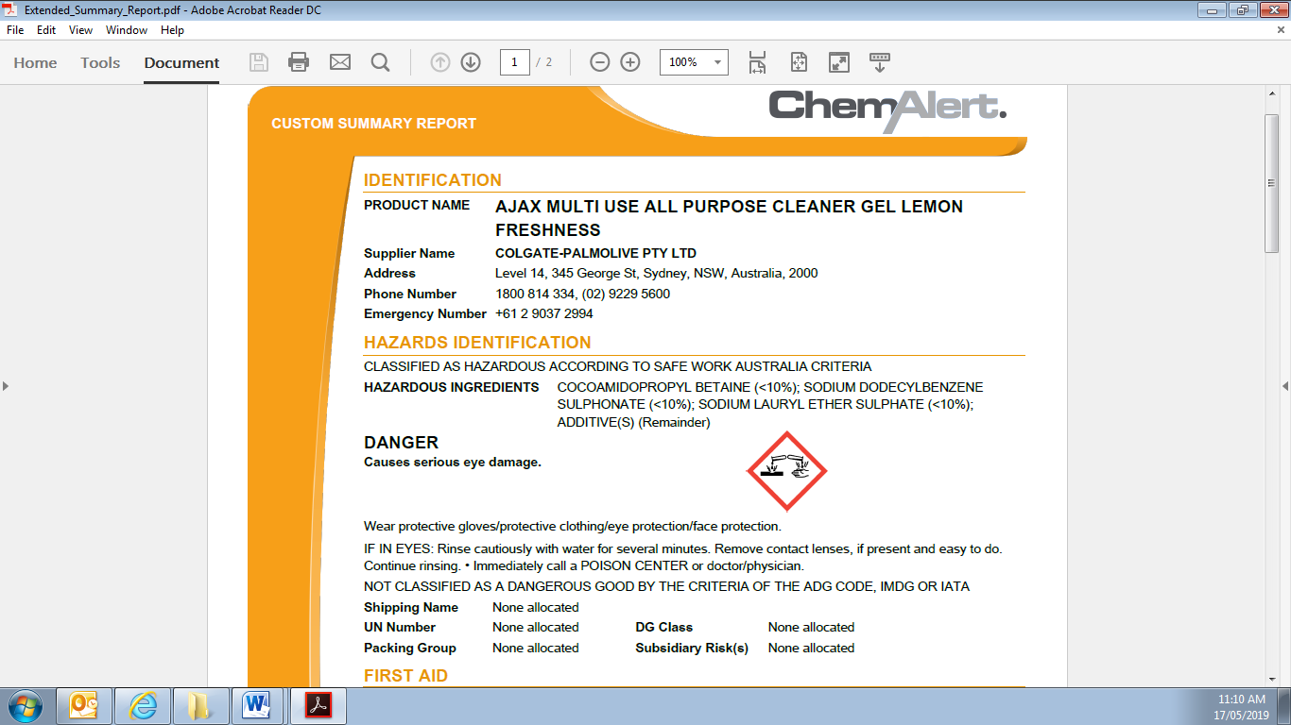

To print the report, click File and select Print from the drop down box.

