

GENERAL LEDGER PROCESSING USER GUIDES

Version: 1.1 Update
Date: 21/7/2017

Table of Contents
1. General Information 5
1.1 System Overview 5
1.2 System Summary 5
2. Getting Started 5
2.1 Create a New Ledger Main Account 5
2.2 Setting up Financial Calendars 8
Financial Periods 8
Financial Calendar 8
Create a New Financial Year 10
Close/Restrict Module Access by Periods 11
2.3 Account Structures and Advanced Rules 12
Overview 12
Viewing the current account structures 12
Maintaining the Account Structure business restrictions 12
Edit Account Structure 13
Activate Account Structure 15
Adding the Account Structure to the Ledger Definition Form 16
Exporting the Account Structure to Excel 17
Financial dimensions 18
Overview 18
Creating/maintaining Division & Establishment dimension values 20
Creating/maintaining all other new dimension values 22
Inactivating an existing dimension value 23
Financial Dimension sets 24
3. Using General Ledger journals 24
3.1 Journal Import Tool 24
3.1.1.1 Setting up the journal import template 25
3.1.1.2 Generating the General Journal Import template 27
3.1.1.3 Populating the template 27
3.1.2 Uploading the populated template 27
3.1.2.1 General Template Column Rules 28
3.1.2.2 NDLS and Challenge Fund Journals 30
3.1.2.3 Payroll Template Column Rules 31
3.1.3 Uploading the populated template 33
3.1.4 Using the Journal Import Function 33
3.1.4.1 Journal import form 33
3.1.4.2 List of Journal Import templates and functions 33
3.1.4.3 Sample of completed GL Template for Client Deduction Upload Journal 34
3.2 Manual General Journal Transaction Entry 35
3.2.1 Create and post general journals 35
Journal with account and offset account being ledger accounts, and balancing on a single line 36
Journal with account and offset account being ledger accounts, and split over multiple lines 44
Journal for a cash receipt where the amount received is posted to a customer account and a donations ledger account 46
Reversal Journal with account and offset account being ledger accounts, and balancing on a single line 48
Journal with GST to be calculated 50
3.2.2 Post the transaction as normal. 51
3.2.3 Writing off a Bad Debt 51
3.3 Attaching Notes and Documents to Journals 54
4. End of Month Steps 55
4.1.1 Processing Month End Journals 56
4.1.1.1 Accruals and Reversals 56
4.1.1.2 Allocation Journals 57
4.1.1.3 Asset Journals 59
4.1.2 Month End reconciliations (please delete/add to as required) 59
4.1.2.1 Ledger Reconciliations 59
4.1.2.2 Bank Reconciliations 59
4.1.2.3 Asset Movement Reconciliations 59
4.1.2.4 Project Reconciliations 59
4.1.3 BAS 59
4.1.3.1 Creating Additional BAS boxes 59
4.1.3.2 General ledger > Periodic > GST payments > Australian BAS. 61
4.1.4 Changing Period Status to stop posting 62
4.1.4.1 Changing Ledger Calendar Period Status 62
4.1.4.2 Period Status 63
4.1.4.3 Set period status: 63
4.1.4.4 Allowing User Groups access to Current Period 63
4.1.4.5 Setting Period Status when All Processing is Complete 64
5. End of Year Process 65
5.1 End of Year Setup 65
5.1.1 Set Up Financial Year Close Parameters 65
5.1.2 Delete close-of-year transaction during transfer 66
5.1.3 Create closing transactions during transfer 66
5.1.4 Set fiscal year status to close 66
5.1.5 Voucher Number 66
5.1.6 Year-end checklist steps 66
5.2 Run Financial Year Close 67
5.2.1 Opening Transactions Form 69
6. Reporting & Inquiries 71
6.1 Voucher transactions 71
6.2 Exporting a Screen to Excel 72
6.3 AX Reporting is done via Management Reporter 72
7. Journal Approval Workflows 77
8. Appendix 78
8.1 Appendix 1 – End of Month Checklist 78
8.2 Appendix II – End of Year Checklist 79
8.3 Trial Balance Run Error 80

Version Control
# | Date | User | Details
0.1 | 20/7/2017 | CT | Final
0.2 | 21/7/2017 | Rochelle Pangan | Bad Debt Write-off Workflow
0.3 | 25/08/2017 | CT | Added instructions for Adding accounts, Financial Dimension sets, Account structure, Workflow, Journal upload templates, Inquiries and Reporting
0.4 | 25/9/2017 | TA | Added instructions for NDLS and Challenge Fund Journals
0.5 | 10/10/2017 | TA/CU/JH | Update for final UAT
0.6 | 23/10/17 | TA | Add in Trial balance error

General Information
Endeavour Foundation uses the same Chart of Accounts within all entities. The Legal Entities set up in AX are as follows:
- EF – Endeavour Foundation
- CF- Challenge Fund
- CSG – Community Solutions Group
- EC – Elimination Company
- NDLS – National Disability Living Solutions

System Overview
The AX ERP System has been commissioned and configured to cater for the following modules:
- Accounts Payable
- Accounts Receivable
- Fixed Assets
- Projects
- Inventory
All of which are integrated with the General Ledger.

System Summary
The General Ledger module is maintained for all of the above entities either through use of the above mentioned modules or for trial balance imports and journals from other parts of the business not maintained in AX.
As such the Endeavour Foundation uses AX as a repository for financial information that is used for consolidated reporting.

Getting Started
All users who operate in AX will need to be set up with the appropriate access and given roles which allow processing.

All users who process General Ledger Journals will be set up with the appropriate roles and user groups to access the following AX functions required for day to day processing, End of Month and End of Year, where required.

The functionality included in this section is generally a one-off task, however is included for information for users who need access for testing and checking.

Create a New Ledger Main Account
Path: General ledger -> Common -> Main accounts.
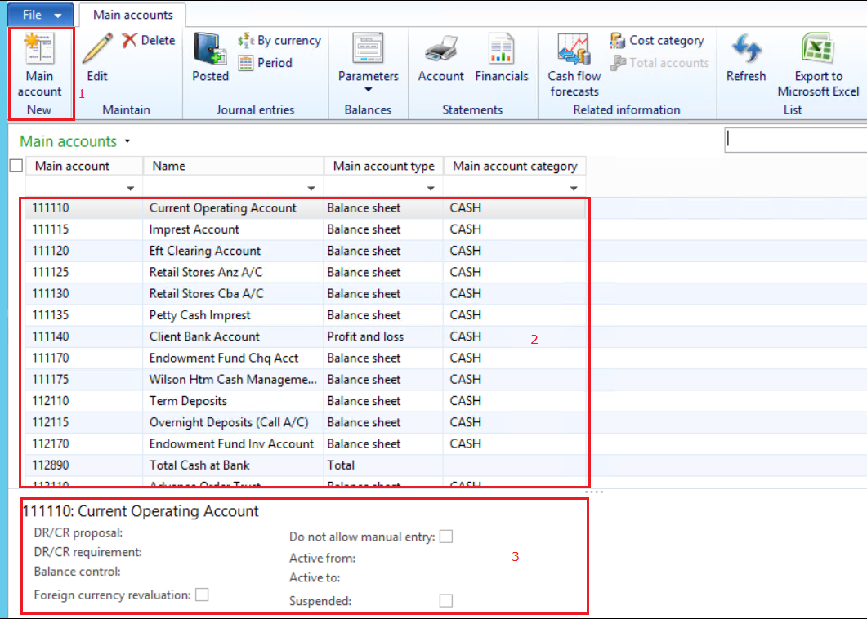
The Main Accounts list has the following:
- Point 1: New account button on the Action Pane
- Point 2: List of ledger accounts
- Point 3: Details of the selected account.
Click the Main accounts > New button (point 1 highlighted above)
When the new Main account form opens (see below), enter the data according to the table below the image.
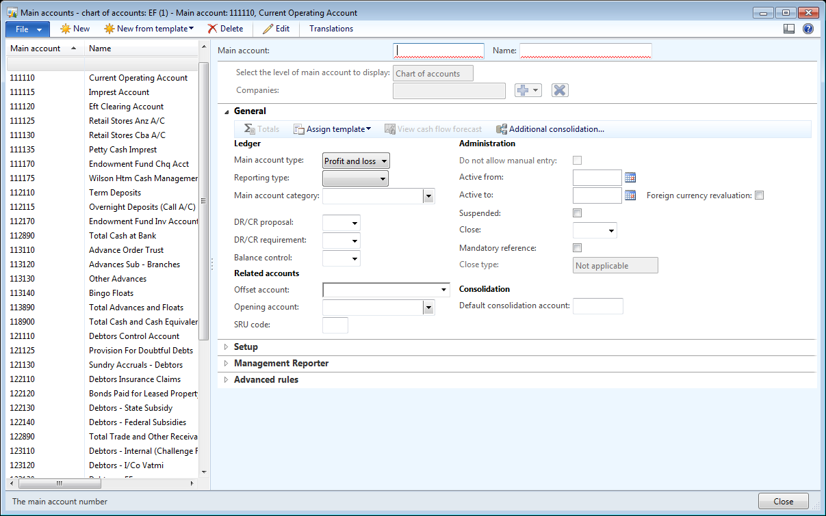
This table does not address all fields in the form, but selects those that are mandatory or most likely to be used.
Field | Description
General Tab
Main account | Enter the main account number
Name | Enter the name of the account
Select the level of main account to display | This field becomes available once the Main Account and Name are saved  Options for this field are:  - Chart of accounts – COA global setting  - Companies – define settings for a SPECIFIC company COA  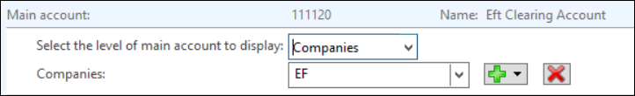  The image above shows the field when “Companies” is selected. Use the Plus and Minus icons to add company codes to the selection list
Main account type | Select the main account type from the list
Main account category | Select the main account category from the list. This determines categories for reporting purposes- refer statutory reporting and BI and Management Reporter for appropriate groupings.
Do not allow manual entry | This field, if checked, prevents the account from being used for posting in the General Ledger. Normally the field is checked for control accounts for sub-modules.  Check the account if required.
Active from | If the account is to commence usage from a future date, enter the date.
Active to | If the account is to stop being used on a certain date, enter the date
Suspended | An account can be suspended by checking this box.  This does not delete the account but means that it cannot be used until the Suspended checkbox is cleared. This option can be used to suspend an account in a legal entity if it does not relate to that entity. Refer below.
Consolidation | If the account is to consolidate to a different account in the consolidation accounts, enter the account number here.  If the account consolidates to the same account number in the consolidation accounts, leave the field blank.
Financial Dimensions Tab
Establishment | These fields set the DEFAULT dimension codes for the account in the selected COMPANY ACCOUNTS.  Select the Establishment code from the list. The DESCRIPTION of the establishment will display.
Fixed Value/Not Fixed | The value of this determines how the default dimensions are used:  - Not fixed – if an entered transaction has a different dimension from the default setting, then the transaction dimensions overwrite the default dimensions  - Fixed value – the default dimensions cannot be changed on a transaction.

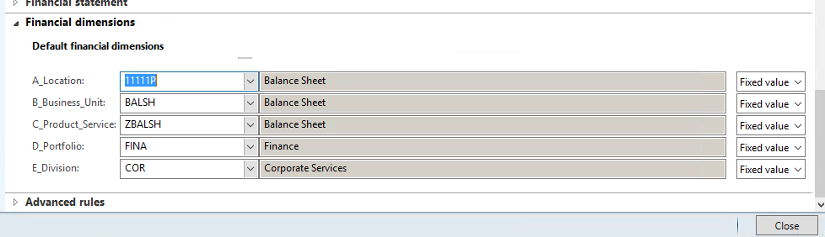
When all details are entered, close the form.
Note: If you want to use a chart in a specific company only. Set up as per above. Add in relevant Company databases as required.
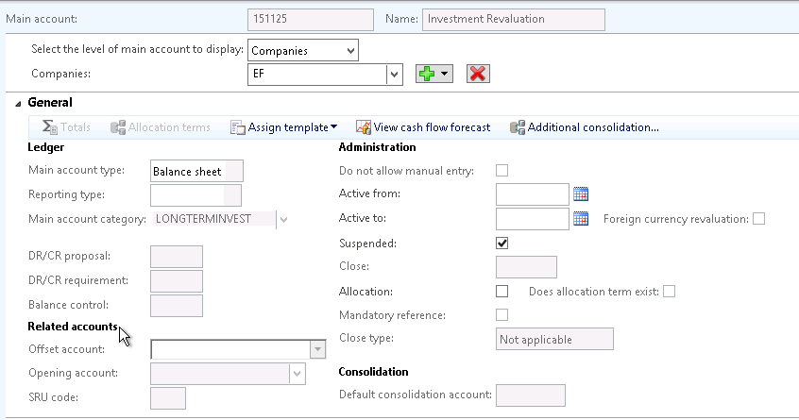

If not to be used in specific Company database then mark as suspended.
If marked do not allow manual entry (this can only be done at a share values level) then entries can not be posted to this account. This is used for control accounts ie. Debtors, Creditors etc.
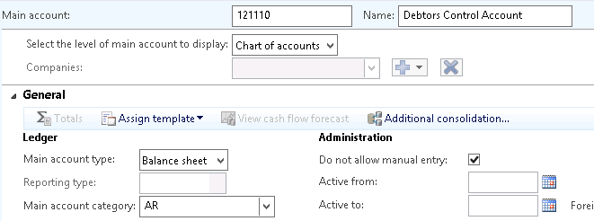

Setting up Financial Calendars

Financial Periods

Financial Calendar
Dynamics AX is a transaction date based system meaning the financial year can be:
- Set to any length
- Divided into any number of periods
- Shared across multiple legal entities
Path: GL > Setup > Financial Calendars
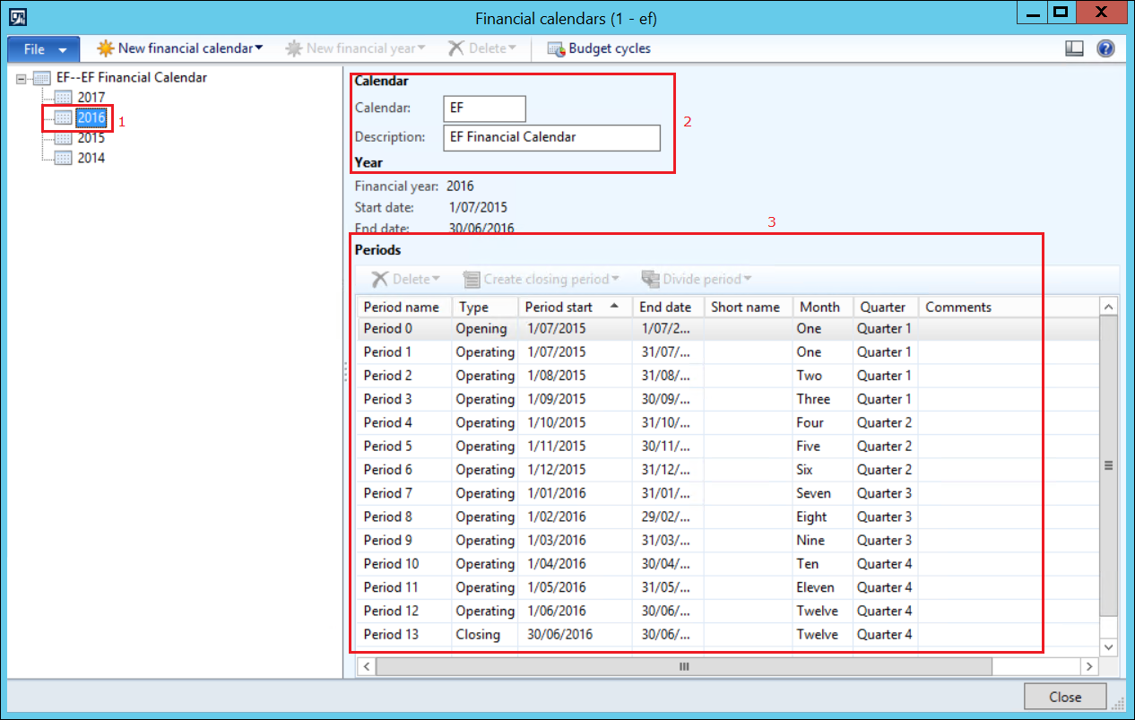
The image above shows the following:
- Point 1: Defined financial years
- Point 2: Calendar code and description
- Point 3: Defined periods
  - With this set up, Dynamics AX has 14 periods in the financial year.
  - Period 0 – used for the financial year opening balances
  - Period 1 – 12 – used for posting transactions
  - Period 13 – used for closing balance calculations
  - Periods have a “Type” – Opening, Operating, and Closing as seen above
  - Periods have a “Start” and “End” date as seen above
  - AX also allocates a Month number and Quarter numbers to each period.

Create a New Financial Year
Path: GL > Setup > Financial Calendars
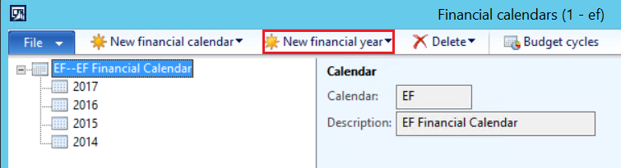
Click the “New financial year” button (Highlighted above). The form below will open.
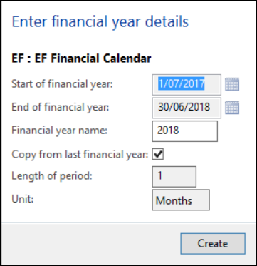
If there are existing financial years in the system, the field details will be populated with values for the year AFTER the last defined financial year.
Click “Create” for the new financial year to be created in Dynamics AX. See the image below.
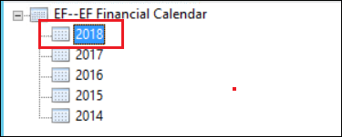

Close/Restrict Module Access by Periods
At the end of each Month various Modules may be required to be restricted to prevent posting once the Month End processing has been finalized.
Access can be set to certain User Groups to allow continuation of processing, All or None.
Path > General Ledger > Setup > Ledger
Select Ledger calendar from the top menu
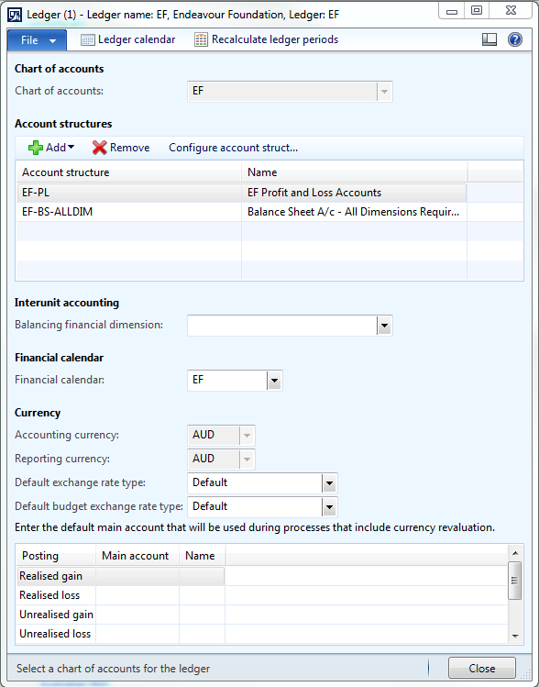
In the Ledger calendars, Maximise the EF – EF Financial to display all Financial Calendars by selecting the +
When all transactions have been finalized for the Month End, the old period is set to On hold and the New to Open
(## The Period Status field may be hidden from view as this is on the right hand side of the Comments field) move the Period Status field to where it can be viewed.)
Please note that Period Status should be set to either Open or On hold.
DO NOT SET THE PERIOD STATUS TO CLOSED

- Highlight the Correct Period
- In the Module access level change the Access level to either None, All or a User Group
Example to stop posting in a particular month:
- AP - Change the Access level on Vendor and Purchasing.
- AR – Change the Access level on Sales Orders and or Customer

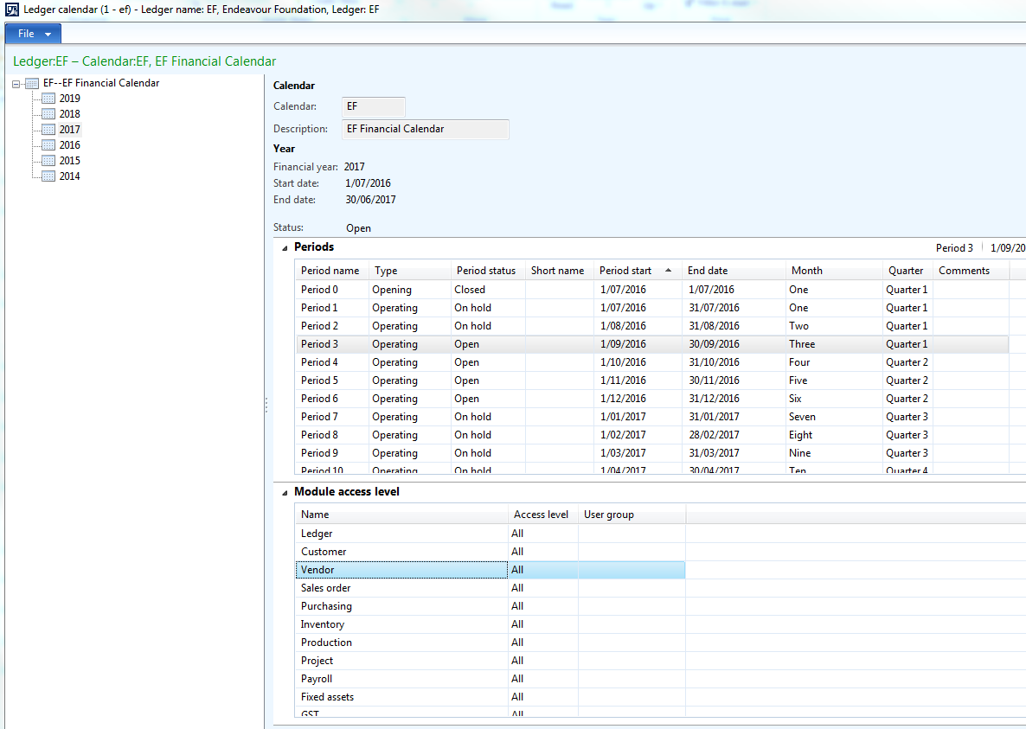

Account Structures and Advanced Rules

Overview
Account structures consist of main accounts and can include financial dimension segments. The account structures are used to define the valid combinations, which together with the main accounts, form a chart of accounts. The account structures allow you to define the sequence for the entry of the main account and financial dimension.
Multiple account structures allow a company to track information for specific accounts while not affecting other accounts. For example, balance sheet accounts may not require as many financial dimensions as profit and loss type accounts.
For balance sheet accounts, you might only be interested in Department. For profit and loss accounts, you might also want to track Cost Centre, Purpose, and Region.

Viewing the current account structures
Path: General Ledger -> Setup -> Chart of Accounts -> Configure Account Structure
2. Select EF-PL (Active)
3. Expand the [-] grouping under each of the dimensions listed in the columns.

Maintaining the Account Structure business restrictions
Path: GL > Setup > Chart of Accounts > Configure Account Structures
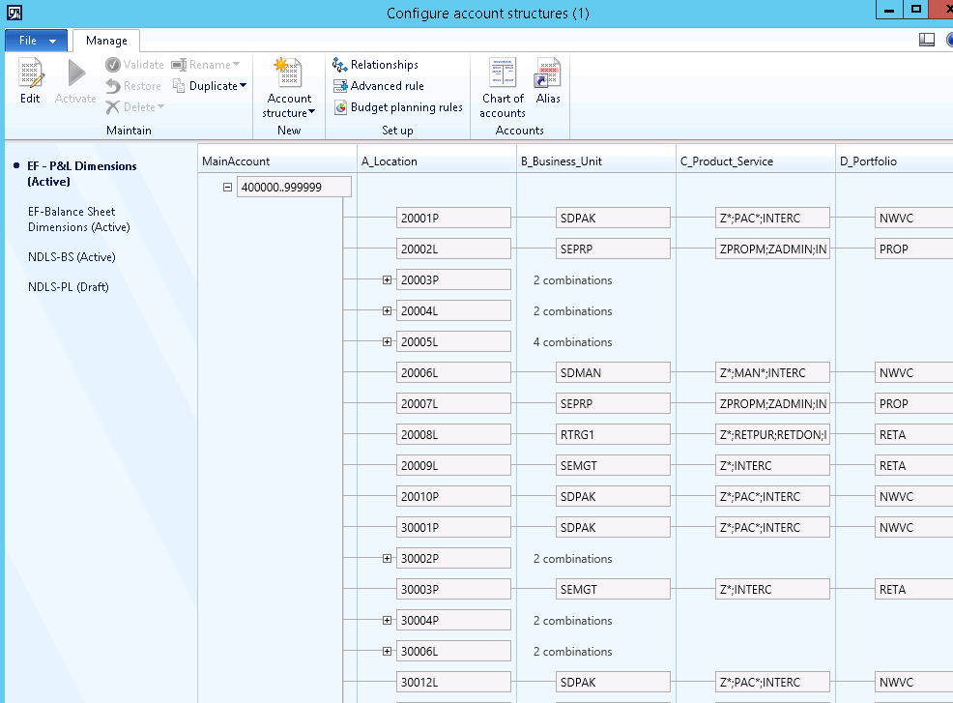

In this example, the account structure EF-PL (Profit and Loss accounts) will be illustrated. Note the following points:
- Point 1: Edit button.
  - An account structure has 2 modes: Active and Draft. Editing cannot be done in ACTIVE mode. To edit the structure, click the Edit button. The system will change the mode to DRAFT to allow change.
- Point 2: Open/Close structure
  - In the image above the structure is OPEN.
  - Click the “+/-“ sign to close or open the structure so that the elements can be viewed.
- Point 3: the combination structures. This shows the combinations for the dimensions – the “what goes with what”.
- Point 4: Note account structures for all Legal Entities (databases are maintained here)

Edit Account Structure
Form in edit mode: when the structure is in EDIT mode, several buttons become active – Activate, Validate, Restore, Delete and Rename.
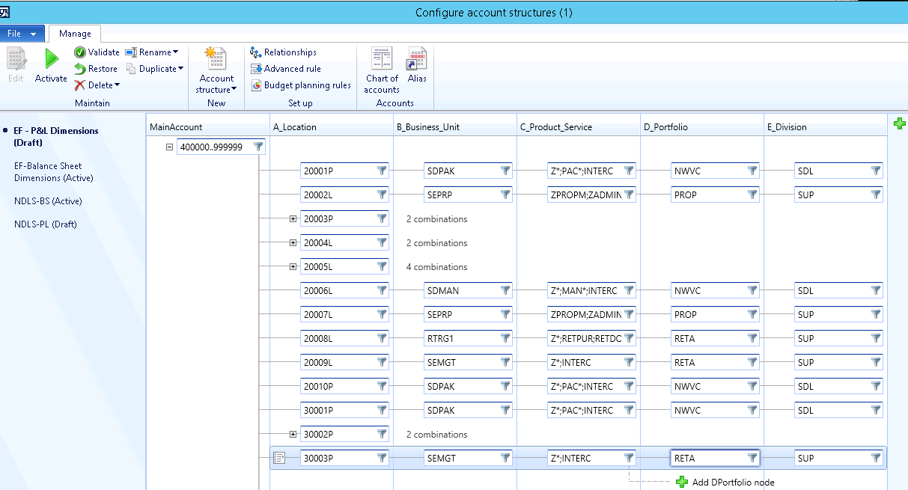
To display the filter list, click the FILTER funnel (highlighted above). The form below will display listing the account filters set on the currently selected dimension.
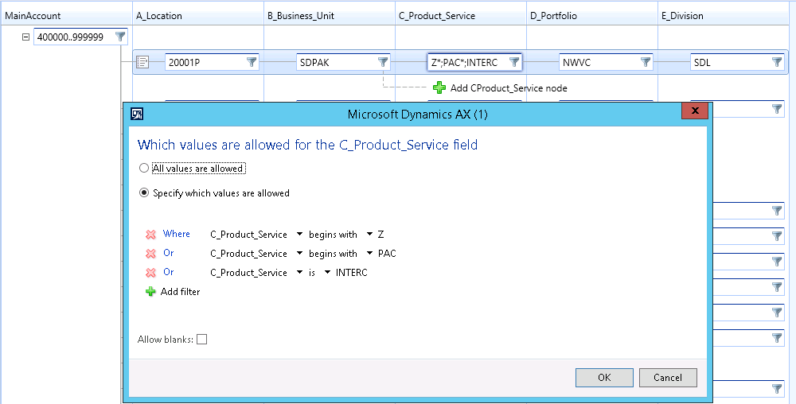
Add filter lines to compose a list of accounts to be included/excluded as required. Use the range options to define all the accounts required. The completed filter list below shows a list of multiple account ranges throughout the chart of accounts.
Line items can also be entered with a semi-colon as the separator to achieve the same result. * function can be used to determine begins with ie in example above Z* is used to allow all products that start with a Z. PAC* is used to allow all products that start with the prefix PAC. If all values are allowed ie any combination of Dimensions then this box can be ticked. Do not tick allow blanks as all Dimension Combinations are required..
Continue this process for each dimension column to build the required structure and filters. EF uses account structures on Locations only.
In the image above, the structure shows:
- Main account – The account range included is 400000 to 999999 – all the profit and loss accounts
- Location code - 20001P
- Business Unit – SDPAK
- Products – Z*, PAK* and INTERC
- Portfolio – NSVC
- Division – SDL

Activate Account Structure
When the required account structure is final, the account structure must be “Activated”. Activating the structure means that any transaction entered into Dynamics AX will be validated against the account structure. To activate the structure, click the “Activate” button (highlighted below).
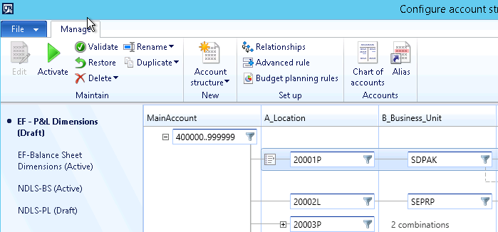

A message form will display (as below). Please note the text “YOU CANNOT ENTER OR POST TRANSACTIONS WHILE THE UPDATE IS IN PROGRESS”. Click “YES” to start the update. Depending on the complexity of the structure, the update may take a couple of minutes to process.
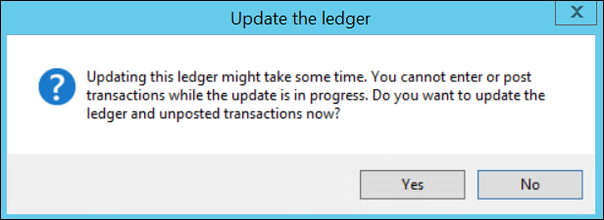
When completed, close the Account Structure form.

To Delete an account structure
Ensure you don’t delete active account structures. Take a copy of the account structure using the duplicate function as a back up.
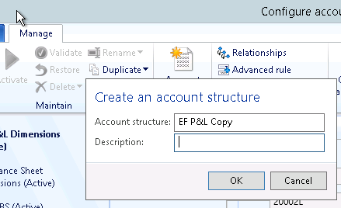
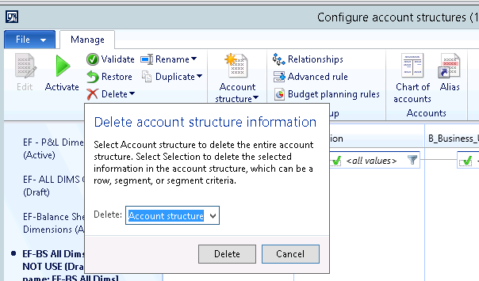

Adding the Account Structure to the Ledger Definition Form
Path: GL > Setup > Ledger
In the LEDGER form (shown below), check that the account structure is included in the ledger account structure section. If not, click ADD and select the required Account Structure. Adding an account structure to the ledger form will take some time.
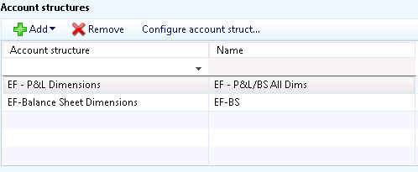
When the process is completed, close the form.
Note: adding a structure to the ledger form can take a significant amount of time; it will not complete instantly.
The account structure sets the restrictions and rules for the posting of future transactions. So, new values can be added or defunct ones removed as part of a managed administration maintenance process. It is best done outside business-hours to avoid changing the rules at the same time as someone is posting. The Validate and Activate step takes a significant time to execute.

Exporting the Account Structure to Excel
Path: EF/ General ledger/Area page
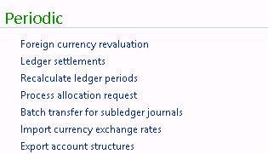

Note below:
- Select path where you want the file saved to
- No to draft account structures will only give you the active account structures
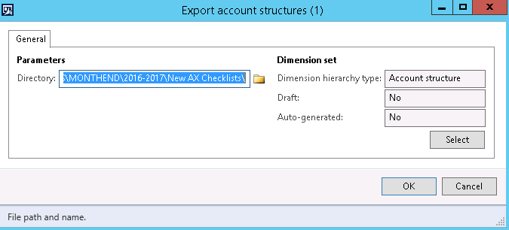
This will save a file in the format below to the path specified. Note * replaced with %
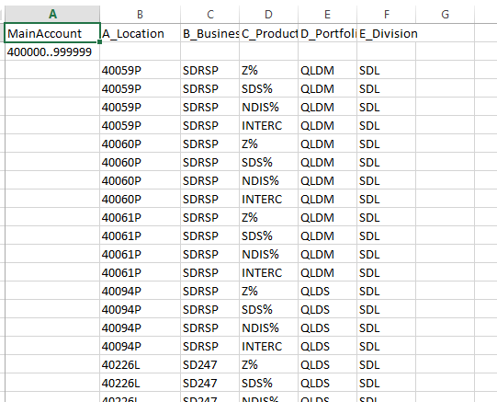

Financial dimensions

Overview
General Ledger (GL) accounts are uniquely defined by their main account number (as listed in the Chart of Accounts), and five other dimensions listed below:
  - Location (Utilizes the AX Business Unit)
  - Business Unit (Utilizes the AX Cost Centre)
  - Product / Service (Custom Dimension in AX)
  - Portfolio (Custom Dimension in AX)
  - Division (Utilizes the AX Department)
These Dimensions uniquely define the geographic and functional position occupied by that particular business unit.
Financial dimensions have the following characteristics:
- Provide a more detailed description of a transaction.
- Simplify the accounting process when you enable detailed analysis without the creation of a detailed Chart of Accounts.
- Are defined to analyse and classify financial transactions as follows:
- Financial transactions are usually organized according to voucher and account number.
- Additional grouping and classification options are available when you assign several dimensions to transactions.
- Enable you to view the data file from different perspectives to improve the effectiveness in tracking figures across accounts.
- Can be used throughout the system.
- Add dimensions to base data such as:
- Ledger accounts
- Customers
- Vendors
- Are copied to transactions automatically from the master record or the defined default dimensions.

Dimension Relationships

LOCATION > BUSINESS UNIT > PRODUCT > PORTFOLIO > DIVISION

Location: Physical Street Address of Service Provision. Note P denotes properties owned by Endeavour and L denotes leased properties.
(Building No, Street Name, Suburb, State, Postcode)
Code: 30003P Code Description: 188 High Street, KEW, VIC, 3101
Code: 40034P Code Description: 115 Queens Rd, Kingston, QLD, 4114
Code: 40024L Code Description: Unit 3A/17 Tile Street, Wacol, QLD, 4076
Code: 99999P Code Description: 33 Corporate Drive, Cannon Hill, QLD,
Code: 99220P Code Description: People Experience

Business Unit: Responsibility center - an organization subunit – A distinct Business Unit within the EF organization.
Code: LEARN Code Description: Lifestyle & Learning
Code: TWFOS Code Description: Twenty Four Seven
Code: CEFIN Code Description: Central Finance
Code: PRPMA Code Description: Property Maintenance
Code: MANUF Code Description: Manufacturing

Product/Service: Tangible Products Group or Service Categories that Endeavour Foundation provide to Customers or Non-Service Delivery Departments
Code: ZPROPM Code Description: Property Management
Code: VMEL17 Code Description: Melbourne Cup 2017
Code: NDIS01 Code Description: Assistance with Daily Life
Code: LOT419 Code Description: Lottery 419
Code: MANFAS Code Description: eSafe First Aid Supplies Sales
Code: RECTIP Code Description: Tipshop
Code: MANFOO Code Description: eSafe Footwear

Portfolio: Area Managers level of responsibility
Code: QLDN Code Description: QLD North
Code: QLDM Code Description: QLD Metro
Code: TECH Code Description: Technology
Code: FINA Code Description: Finance
Code: TAQN Code Description: Talent Acquisition
Code: RGCF Code Description: Regulatory Compliance & Funding

Division: Organisational Structure within Company
Code: COR Code Description: Corporate Services
Code: SDL Code Description: Service Delivery
Code: SAM Code Description: Sales & Marketing
Code: PEO Code Description: People and Culture
Code: CEO Code Description: Chief Executive Office

Creating/maintaining Division & Establishment dimension values
The Location, Business Unit and Division dimensions are drawn from the Business units, Cost centres and Departments in AX which are defined in the Organisation administration module (ie not in the General Ledger).
Path: EF > Organisation administration > Organisation > Operating units OR can be done via:
Path: EF > General Ledger Setup > Organisation
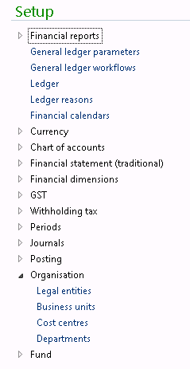

To create a new Location, click New. The list below displays:
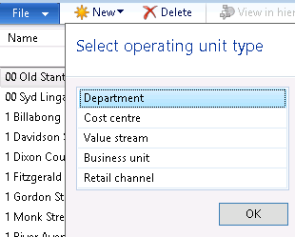

Select the Operating unit type being created. At Endeavour Foundation, the following rules apply:
  - Location - AX Business Unit
  - Business Unit - AX Cost Centre
  - Division - AX Department
On right hand pane of the form, complete the details of the new dimension.
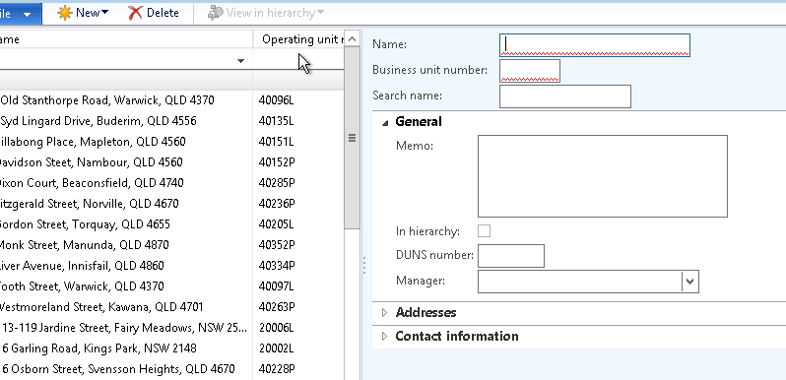

Location Numbers are denoted by State postcode ie. 40228P is an owned property in Qld, 20002L is a leased property in NSW.
To determine next sequential number type start of state sequence with *. Click on Operating unit number highlighted below to sort in numeric order.

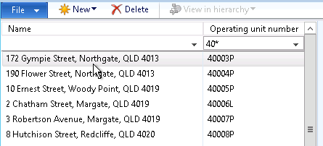

Give new location the next sequential number
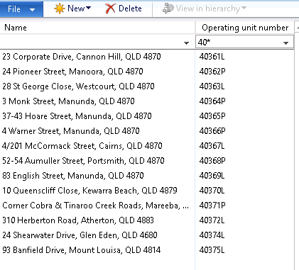

Check the Results
Path: General Ledger -> Setup -> Financial Dimensions -> Financial Dimensions
Select the dimension type to be checked.
Click Financial dimension values button
Confirm that the new value has been added for location:

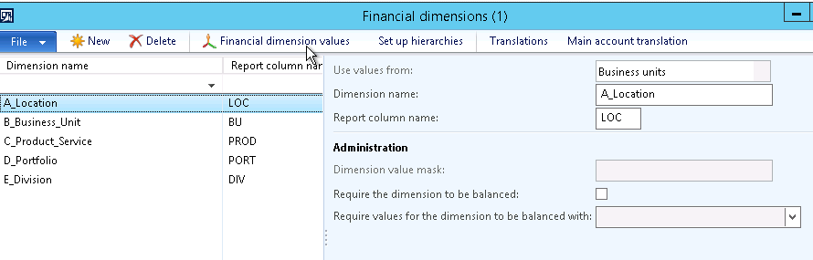
For a Business Unit:
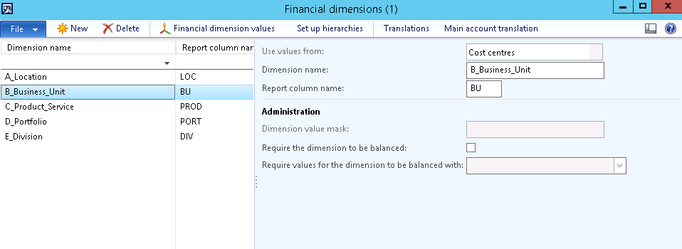
For a Division:
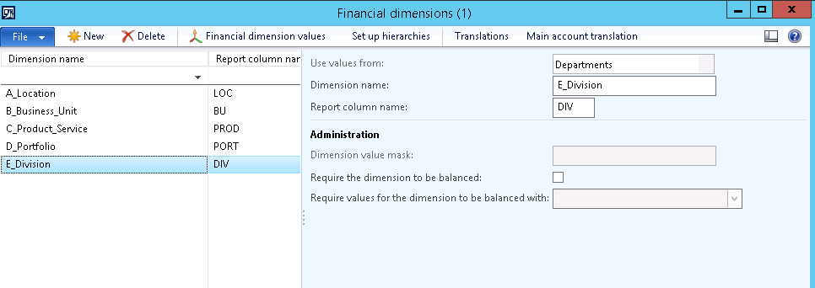
Close the form.

Creating/maintaining all other new dimension values
Other dimensions that are not Location, Business Unit or Division ie Product/Service or Portfolio are maintained directly through the Financial Dimensions form.
Path: General Ledger -> Setup -> Financial Dimensions -> Financial Dimensions
Select the dimension type to be maintained.
Click Financial dimension values
Click New
The Product and Portfolio Dimensions are custom dimensions and can be edited/added in the financial dimension area.

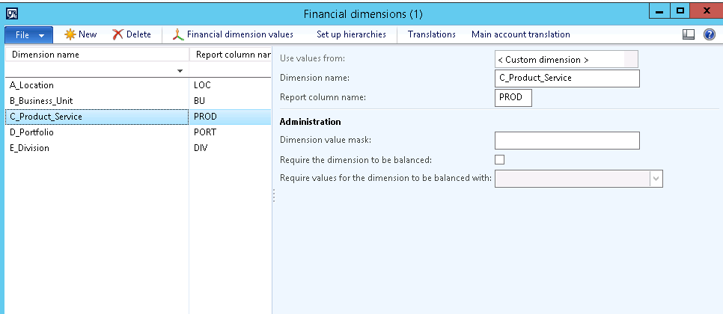

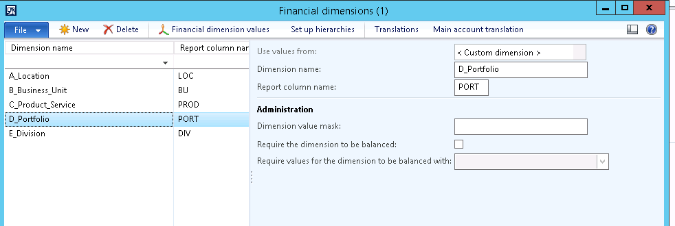
Add in the new dimension value & description.
Under the General fast tab, enter a date that this dimension is active from (if relevant)
Move to the “Do not allow manual entry” field and check the box.

Inactivating an existing dimension value

Preparation
Ensure that the Account Structure business restrictions no longer include the dimension value about to be inactivated. (See instructions above for maintaining Account Structure business restrictions).

Complete Inactivation
Path: General Ledger -> Setup -> Financial Dimensions -> Financial Dimensions
Select the dimension name in which the dimension value to be inactivated is listed
Click Financial dimension values
Select the dimension value to be inactivated.
Under the General fast tab, enter a date in the field “Active to” date for the last date that this dimension is active.
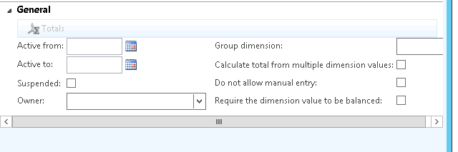

The dimension will still be available for historic reporting purposes, but is no longer available for new transactions after the Active To Date.

Financial Dimension sets
Financial Dimension Sets are created to display data in the Trial Balance and via reporting with a specified matrix of dimensions. The following Financial Dimension Sets have been created.

- All – Display all Dimensions Values
- Ma_Pr – Main Account and Product
- Ma_BU – Displays the Main Account and the Business Unit.
- Main account set – Display the Main Account only.
- PR_SRV – Product Service

Once created, the Dimensions Sets must be initialised and Built before data is displayed.
Select > GL > Setup> Financial Dimension Sets
Move the required Available financial dimension to the Selected financial dimensions
Select Initialise balances and select the Batch Server to process. Once completed the wording will change from Initialise to Rebuild Balances. The RE-Build Balances function should be run following Data Migration of large volume transactions.

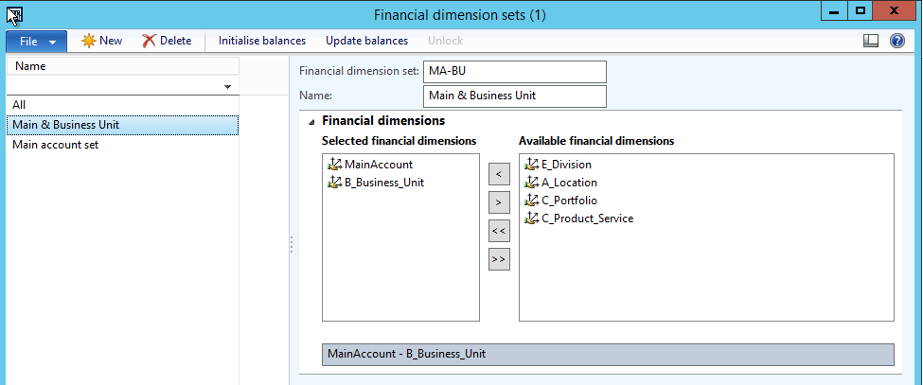

Should no transactions appear in the Trail Balance, recommended that the Rebuild and Update balances function be run.

Using General Ledger journals

Journal Import Tool

Description | The Journal Upload Tool enables Dynamics AX users to upload General Journals from Excel files for processing. The tool uploads journals as General Journals.
Trigger | Financial transactions need to be recorded in the General Ledger
Pre-conditions | Using the journal upload tool  There are 4 key components to using the Tool:  - Setting up the Journal import template  - Generating the template  - Populating the template  - Uploading the populated template
Post-conditions | Journal imported and posted successfully

Setting up the journal import template

Create import templates to define the columns needed for the import Journal
Navigate to: General Ledger> Setup>Journals>Journal import templates

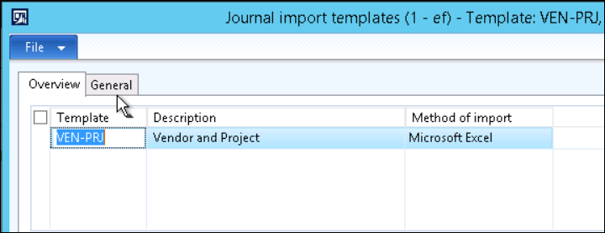

The Overview Tab shows templates currently setup in the environment, their description and file type related to the definition.
To create a new template click File > New
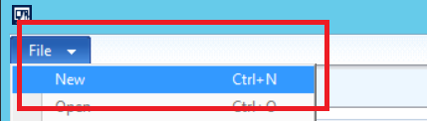

Enter a Code and Description for the new template. Then move to the Lines tab.
The Lines Tab details the fields that are to be populated in the journal lines, their corresponding position (column number) in the related import file and any default values to be imported to the mapped field.
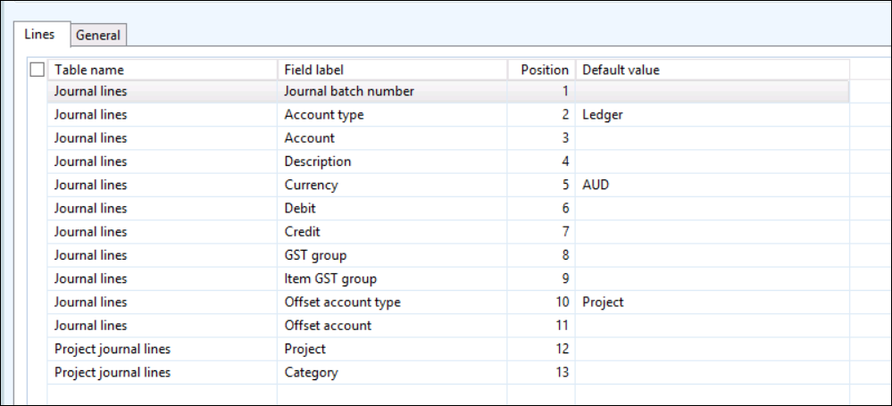

The image above shows configuration for a GL journal with ledger account with a project account offset.
The table below details additional information regarding each of the columns available on the Lines tab;
Column
Table name | The destination table for the data in the column. Options are:  - Journal Lines  - Project Journal Lines  - Asset Journal Lines
Field Label | The destination field for the data value in the upload
Position | The column in the upload file that contains the related data for upload (where the data is defaulted from the template setup, this can be set to 0)
Default | The default data value to be upload to the related field (if not entered in the related file)

Notes related to the Lines tab:
- To add the initial line to the line tab; with the cursor in the line tab grid, hit File, New
- The Journal Batch Number field does not need to be defined in the Lines tab , as the Journal Batch is selected as the journal is imported
- Where the Account type is ledger, in the related Account or Offset account values provide the below details in the associated General tab
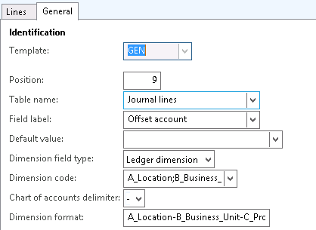
Select all dimensions related to the Account Structure for the entity

- In the Dimension code field add all dimensions related to the entities account structure. In this instance, Location, Business Unit, Product Service, Portfolio, Division.
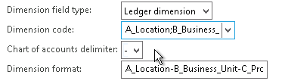
Order the dimensions as per the account structure for the entity
- In the Dimension format order dimensions to match the account structure for the entity and the related delimiter (a dash - )

Generating the General Journal Import template
Once the template definition has been established, the template must be generated.
This is done by accessing the Generate template button on the Template definition and saving the file to the desired location.
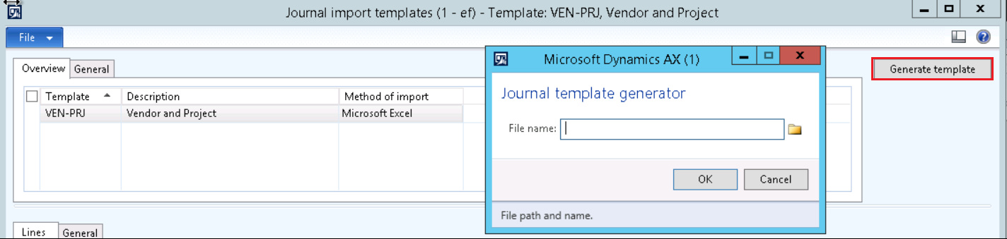

NOTE: IT IS ONLY NECESSARY TO CREATE A TEMPLATE ONCE

Populating the template

The template/s can be populated to upload any Journal. The existing templates are for General Ledger Journal. This template will be used for all uploads except for People Soft payroll journals.

Notes on populating templates:
- DO NOT over write or delete the header line (the system needs those red hooks in the XLS file! Or the first line of numeric data if using a .CSV type file)
- DO NOT add or delete columns
- The account string for a LEDGER ACCOUNT type must replicate the dimension format detailed in the template (see below)
In the case of blank dimension elements, a dash will replace the dimension value.
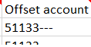
- The template can be saved with any file name prior to uploading
- The template can be used as many times as required

Uploading the populated template

Once the template has been populated for upload follow the below to upload.
• Create a Journal Header and select the Journal name
• Path to General Ledger> Journals>General Journal>Select “New”
- Under Name, select “GL” for General Ledger, Project, Vendor & Customer Journal. Select “PS” for payroll journals (i.e. Payroll Journal, Predicts Journal & Client Deduction Journal)
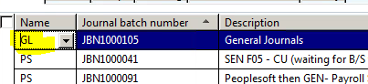

• Create a Journal Header and select the Journal name
o NOTE – if it is a GL Journal – The approval workflow will be triggered and the journal will need to be submitted from the header screen once all lines are populated
• Import the journal as shown below by accessing the Import journal from file button and selecting the related template definition and file to be uploaded
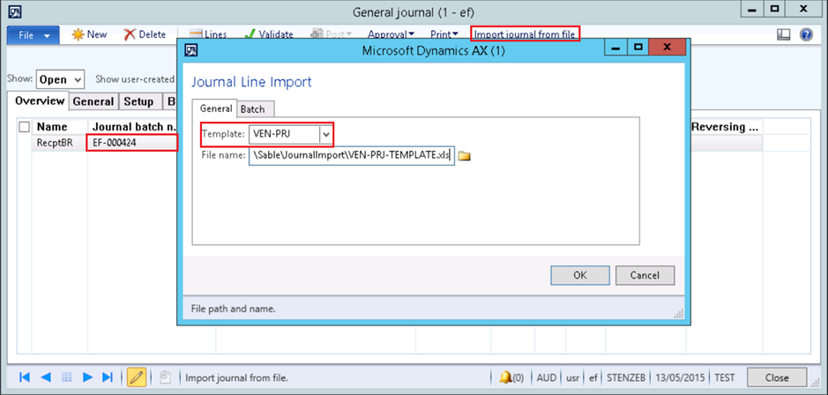

General Template Column Rules

Choose below template “GEN” for journal import (General Ledger, Project, Vendor & Customer).

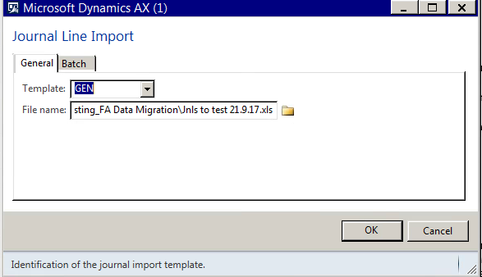

The following table represents the Template Column Headers and the fields that need to be populated depending on what type of Journal is being processed.
TEMPLATE COLUMN HEADERS | GENERAL LEDGER | PROJECT | VENDOR | CUSTOMER
Date | Posting Date | Posting Date | Posting Date | Posting Date
Account type | Ledger | Project | Vendor | Customer
Account | Main Account Number and Dimension String | Project Number | Vendor Number | Customer Number
Dimension | BLANK | OPTIONAL | OPTIONAL | OPTIONAL
Description | Text | Text | Text | Text
Debit | Transaction Amount | Transaction Amount | Transaction Amount | Transaction Amount
Credit | Transaction Amount | Transaction Amount | Transaction Amount | Transaction Amount
Offset account type | Ledger | Ledger | Ledger | Ledger
Offset account | BLANK | BLANK | BLANK | BLANK
Transaction type | BLANK | BLANK | BLANK | BLANK
GST group | OPTIONAL | OPTIONAL | OPTIONAL | OPTIONAL
Item GST group | OPTIONAL | OPTIONAL | OPTIONAL | OPTIONAL
 | OPTIONAL | OPTIONAL | Tax Invoice Number | OPTIONAL
  Tax Invoice
Document | OPTIONAL | OPTIONAL | OPTIONAL | OPTIONAL
Document date | OPTIONAL | OPTIONAL | Enter Document Date | OPTIONAL
Invoice URL | BLANK | BLANK | Enter URL | BLANK
Payment reference | BLANK | BLANK | Reference Number | Reference Number
Bank transaction type | OPTIONAL | OPTIONAL | OPTIONAL | OPTIONAL
Deposit slip | BLANK | BLANK | BLANK | OPTIONAL
Company accounts | EF | EF | EF | EF
Project | BLANK | Project Number | BLANK | BLANK
Category | BLANK | Project Category | BLANK | BLANK
Quantity | BLANK | BLANK | BLANK | BLANK
GST group | BLANK, SP or NA | BLANK, SP or NA | BLANK, SP or NA | BLANK, SP or NA
Item GST group | BLANK or GS | BLANK or GS | BLANK or GS | BLANK or GS
Sales currency | AUD | AUD | AUD | AUD
Line property | BLANK | Only one of the following per line  - Non-Cap  - Cap  - Billable  - Non-Billable | BLANK | BLANK
Cost price | BLANK | EQUALS the Debit or Credit amount entered | BLANK | BLANK
Project date | BLANK | Any date | BLANK | BLANK
Method of Payment | BLANK | BLANK | BLANK | Method of Payment

NDLS and Challenge Fund Journals

All journals are uploaded using the GEN template for NDLS and Challenge Fund.
TEMPLATE COLUMN HEADERS | NDLS | Challenge Fund
Date | Posting Date | Posting Date
Account type | Ledger | Project
Account | Main Account Number and Dimension String | Main Account Number and Dimension String
Dimension | BLANK | BLANK
Description | Text | Text
Debit | Transaction Amount | Transaction Amount
Credit | Transaction Amount | Transaction Amount
Offset account type | Ledger | Ledger
Offset account | BLANK | BLANK
Transaction type | BLANK | BLANK
GST group | OPTIONAL | OPTIONAL
Item GST group | OPTIONAL | OPTIONAL
Company accounts | NDLS | CF

Payroll Template Column Rules

Below is an example of People Soft journal received from payroll

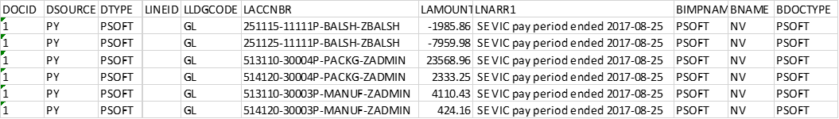

Only populate below fields in General Ledger Template for payroll journal import

The following table represents the Template Column Headers and the fields that need to be populated for People Soft Journals

TEMPLATE COLUMN HEADERS | GENERAL LEDGER
Date | Type the Payroll Date (25/8/2017 in this example)
Account type | Type Ledger in every line
Account | Copy from People Soft journal column LACCNBR. 4 dimensions only (e.g. 513110-30004P-PACKG-ZADMIN)
Dimension | Blank
Description | Copy the description from People Soft journal column LNARR1 (SE VIC pay period ended 2017-08-25 in this example)
Debit | Copy LA MOUNT column from People Soft journal in this column only (i.e. Debit & Credit amount in the same column)
Credit | Leave blank
Offset account type | Type Ledger in every line

To import the journal into AX:

Choose “PS” for payroll journals.

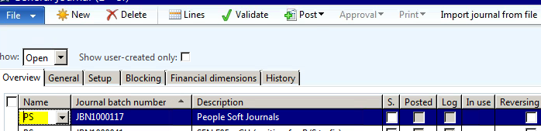

Choose template “GEN” for journal import.
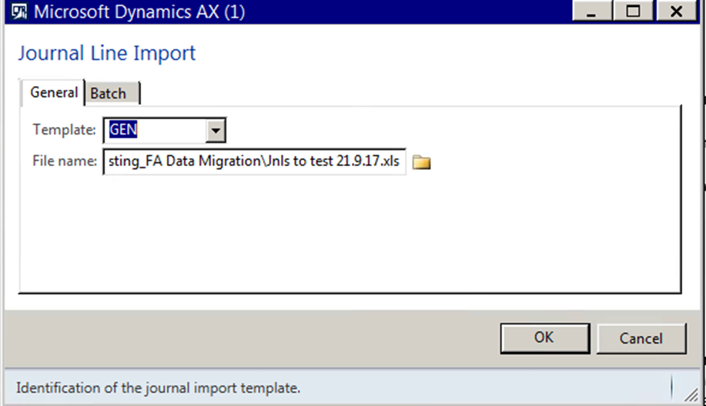
Sample of completed GL Template for payroll journal.

Uploading the populated template

If the upload is successful the below message will display. If the upload is not successful a message will be displayed outlining the issue for your attention.
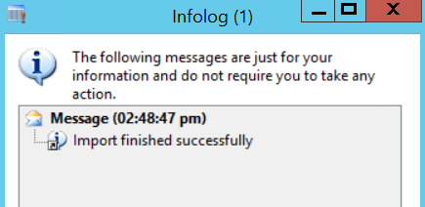

Using the Journal Import Function
This document relates to a journal with a ledger account and multiple accounts as offset accounts.
Dynamics AX provides the ability to have the account and offset account as a single line; the journal template allows this to be done if required. The journal template is designed to upload entries affecting all the Sub Ledgers used in EF.

Journal import form
In the Journal Import form – the user must select the correct template to use. The table in 3.1.5.1 explains the different templates and what they are used for.

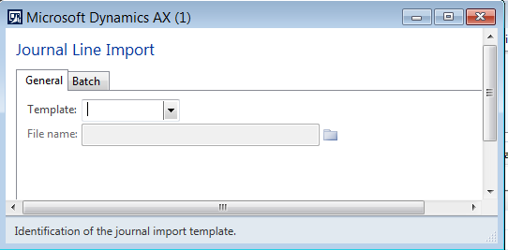

List of Journal Import templates and functions

Template | Description | How Used | Journal Name | Security | File
GEN | General Journal | Includes General Journal lines and Project Lines in the one file.  Transaction Type = General Journal  Payroll Journal - Staff FN Ended xxxx…..  AON Holiday/Superannuation xxx  LSL Liability | GL | Accting
PeopleSoft | PeopleSoft Payroll Import | General Journal > Transaction Type = General Journal. No GST/Item GST Groups  Staff FN Ended xxx Predicts | PS | Accting

Sample of completed GL Template for Client Deduction Upload Journal

Path to General Ledger> Journals>General Journal>PS>GL

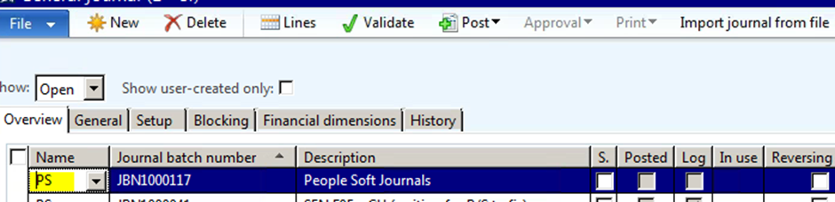

As per the table in section 3.1.2.2 – the necessary fields for upload have been populated with Data in the correct format

Manual General Journal Transaction Entry
Follow the steps below to create and post a new journal to check the newly-created Journal Name.

Create and post general journals
The General Ledger Journal form is used to create and post journals to the ledger accounts and other sub-module accounts. Dynamics AX allows access to all Sub Modules in the General Ledger Voucher form.

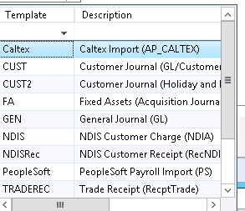
- Customer
- Vendor
- Project
- Bank
- Fixed assets
These account types can be selected as either the account or the offset account.
At Endeavour Foundation, the general journal form is used for several different journal types including:
- General journal
- Client journals
- Receipt journals
- PeopleSoft journals
The general journal form also provides the facility to import journal information from Excel sheets. This topic is covered separately.
This instruction covers creating several different journal types:
- Journal with account and offset account being ledger accounts, and balancing on a single line
- Journal with account and offset account being ledger accounts, and split over multiple lines
- Journal for a cash receipt where the amount received is posted to a customer account and a donations ledger account.
- Reversal Journal with account and offset account being ledger accounts, and balancing on a single line

Journal with account and offset account being ledger accounts, and balancing on a single line

Journal Header
Path: EF > General Ledger -> Journals -> General Journal.

Form: General Journal Header

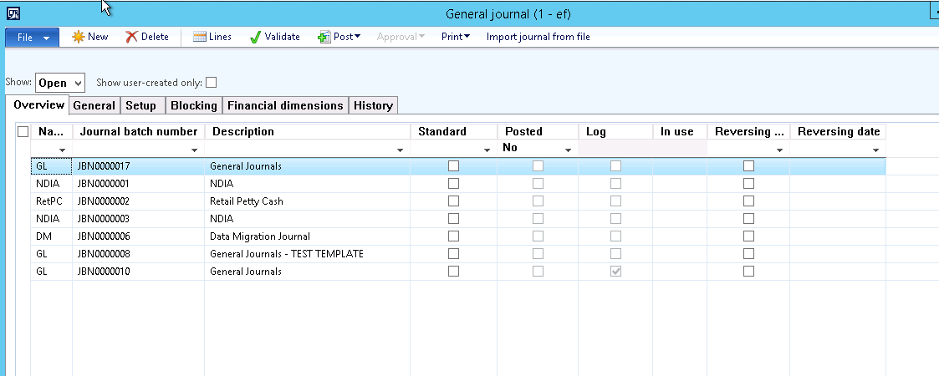
The journal header form is shown above. Note the following characteristics:
- Show filter: use this selection to show
  - Open – journals that have not been posted
  - Posted – journals that have been posted
  - All – all journals
- Show user-created only: set this checkbox to “Checked” to show only the journals that the user created.
Click New. Enter data using the table below as a guide:
Field | Description
Name | Select the Journal Name from the list
Journal batch number | Allocated by AX; cannot be changed. JBN sequential numbers.
Description | Enter an appropriate description

Other fields will be addressed later in this document.

Journal Voucher Lines
Click the “Lines” button to open the journal voucher form. The form will open with the cursor in the “Date” field.
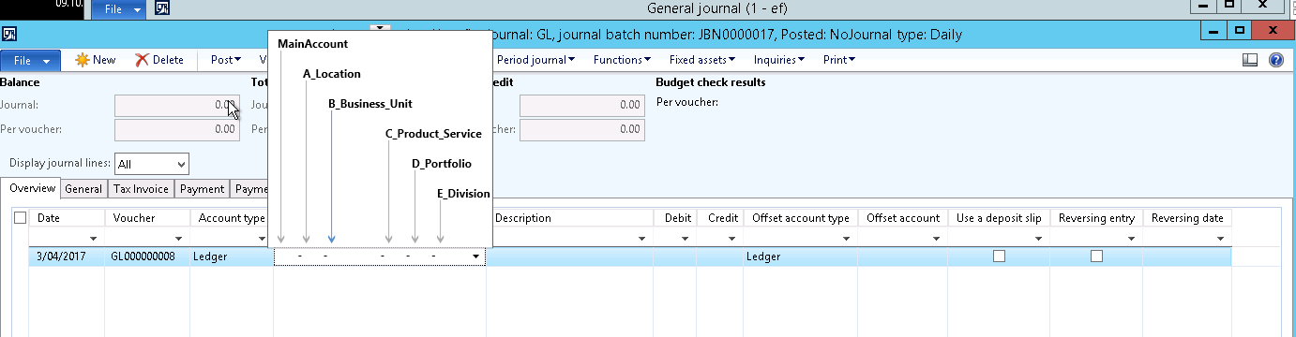
Note click on the arrow button highlighted below and this brings up the GL and Dimension fields required to be entered and in which order.
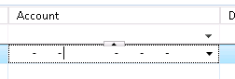
Use the drop down arrow below to give you the options for each dimension available. Account Structure, Dimension defaults and User Profiles are used to pre-populate some of these relevant to each location and each user which will mean only relevant dimensions will be shown in the drop down options available.
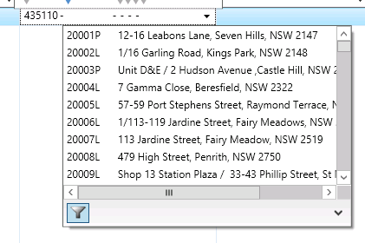
Enter data using the table below as a guide:
Field | Description
Date | Select or enter the POSTING date for the journal
Voucher | Allocated by AX; cannot be changed
Account type | Default is “Ledger”  For this example, “Ledger” will be used
Account | Select the Ledger account from the dropdown list. The account number can be typed in if known.  Select or enter the Location code as the second field in the string.  Press TAB key to go to the next dimensions to be populated ie. Business Unit  Press TAB key to go to the next dimensions to be populated ie. Business Unit  Press TAB key to go to the next dimensions to be populated ie. Product  Press TAB key to go to the next dimensions to be populated ie. Porfolio  Press TAB key to go to the next dimensions to be populated ie. Division  Note in some circumstances where there is a one to one relationship between the location and the Portfolio and Division these dimensions will automatically default.  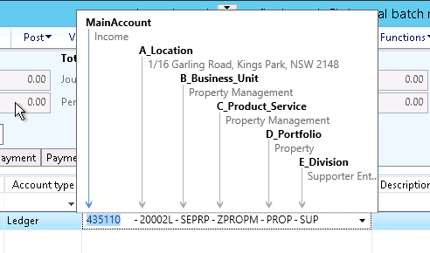  Click into the “Description” field after entering the dimensions above.  Enter an appropriate Description
Description | Enter a description for the line
Debit/Credit | Enter the debit or credit value for the line
Offset account type | Default is “Ledger”  For this example, “Ledger” will be used
Offset account | Select the Ledger account from the dropdown list. The account number can be typed in if known or use the drop down option as per above.  Select or enter the Location code as the second field in the string.  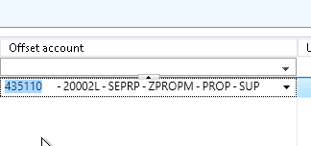  Press TAB key to enter the remaining dimensions above or if some pre-populated check the offset coding.
This is all the data needed to populate a simple journal with an account type of Ledger and an offset account type of Ledger.
Please refer to the notes below for other points relating to the journal voucher form:
- Point 4: GST group/ Item GST group:-
  - If GST is required on the journal, enter the appropriate codes
- Point 5: Balance fields. Dynamics AX records the following balances:
  - Total Debits – total of all the debit values entered in the journal and voucher
  - Total Credits – total of all the credit values entered in the journal and voucher
  - Balance – net of total debits and total credits entered in the journal and voucher.
NOTE: Dynamics AX will NOT post a journal that is not in balance.
Note: to add in a new line to the journal you can use the new line function which will add the line in above the current line you are on.
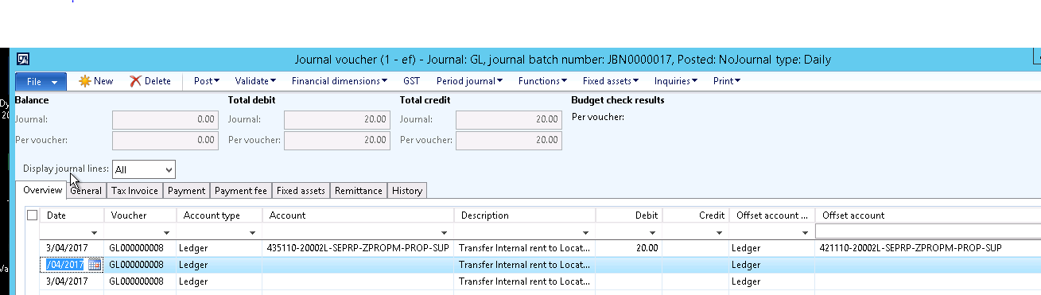
If you want to add in a line below the line you are currently on then you can use the arrow keys at the bottom of the screen.
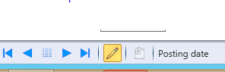

You can attach notes, files and URL;s to journals using the paperclip icon.

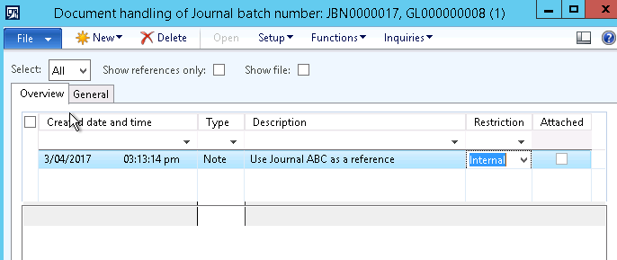

Validation and Posting
All Dynamics AX ledger journals can be validated before posting. We recommend you validate a journal before posting.
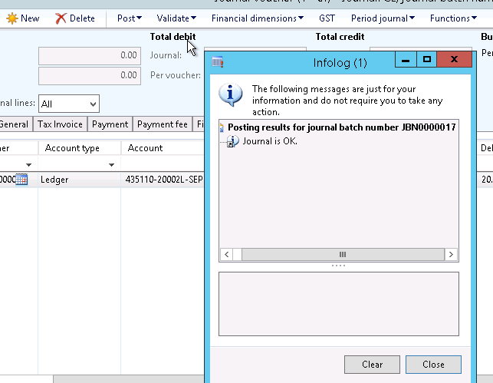
When in balance, click the Validate menu option and select the “Validate” option. An Infolog message will display with any errors or warning messages, or a message that the journal has validated correctly as per above.
If errors or warnings are displayed, take corrective measures as required.
To Post the journal, click the Post menu option. There are 2 options on the Post function; “Post” and “Post and transfer”:
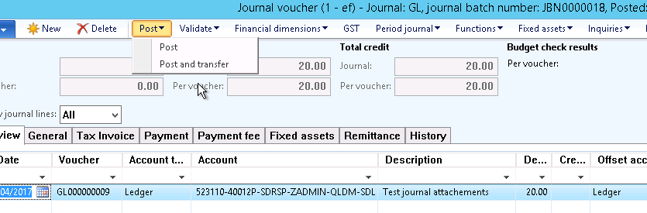
- “Post” will simply post the journal and, if errors or warnings are detected, no lines of the journal will be posted.
- “Post and transfer” will post those journal vouchers that are able to be posted and then transfer any unposted vouchers to a new journal. In this situation, the new journal must be checked, corrected and posting process completed.

NOTE: if the journal name is configured for the journal to have only “One voucher number only” then the “Post and transfer” function cannot be used. Many journal names at Endeavour Foundation are configured as “One journal voucher number only” meaning “Post and transfer” will not function ????

Once posted you will get the following message. Note for reversing entries the number of vouchers posted to the journal should be 2.
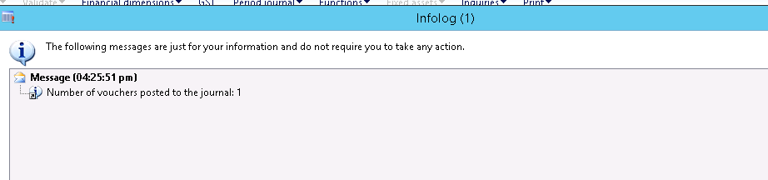
Note the journal voucher number eg JBN 0000018 and Voucher number GL 000000009. To do an inquiry on a voucher number copy from here.

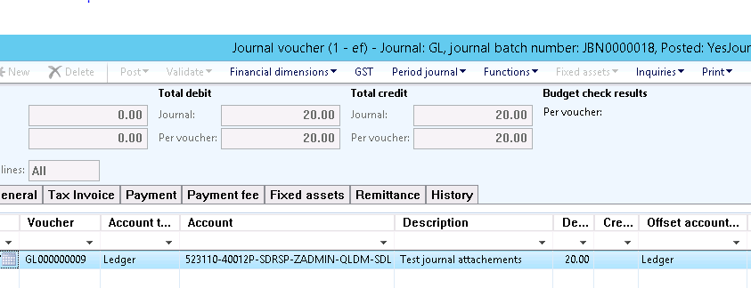

Review Voucher Posting
To review the posted vouchers, click “Inquiries” and select “Voucher”.
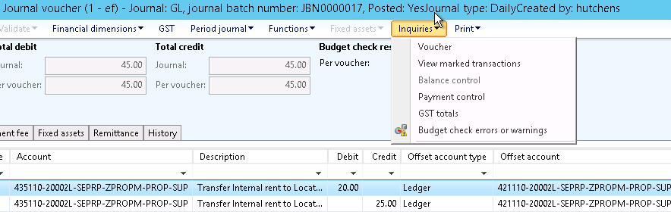

A screen similar to below will display. The highlighted sections are:
- Upper section – lines that make up the voucher
- Lower section – account details for the selected voucher line

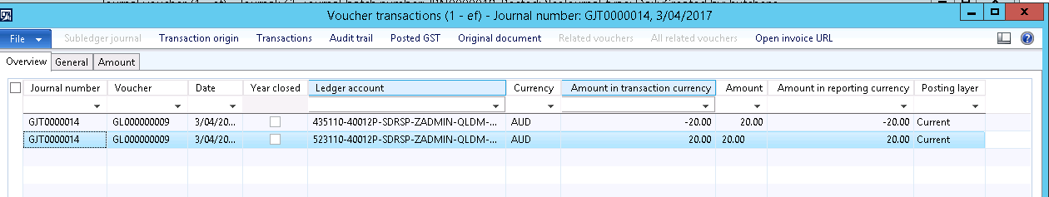

Checking GST component of transactions in a General Journal
GST can be posted through a GL Journal if required. To do this, both GST Group and Item GST Group fields on the journal voucher form must contain a valid GST group value. The amount entered on the voucher line (debit or credit) will be inclusive of GST. To review the GST calculation, click the “GST” menu option to open the POSTED GST form (example below).
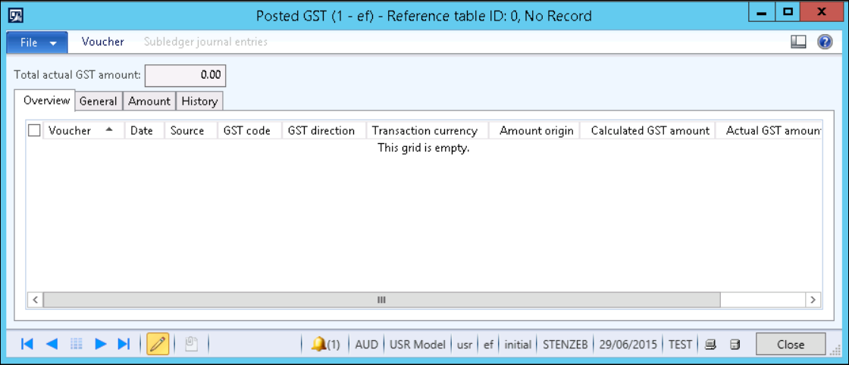

Print Journal Reports
There are several journal reports that can be printed as required. Click the “Print” menu option to open the print menu and print the reports. The menu list is shown below.
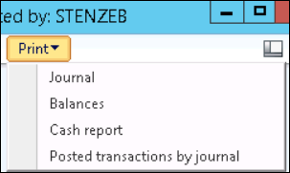

Close Forms
When finished with the journal, close all forms using the “Close” button or the Windows form close (red X) button.

Journal with account and offset account being ledger accounts, and split over multiple lines
This section covers creation of a journal where an amount is to be distributed to more than 1 ledger account.
Because the steps to create, validate, post, and print reports are the same in any journal, those sections will not be restated. If information is required with regard to those steps, refer to the previous sections.
This section will start at the point where the Journal Voucher form is open ready for data entry.
Path: EF > General Ledger -> Journals -> General Journal > Lines.
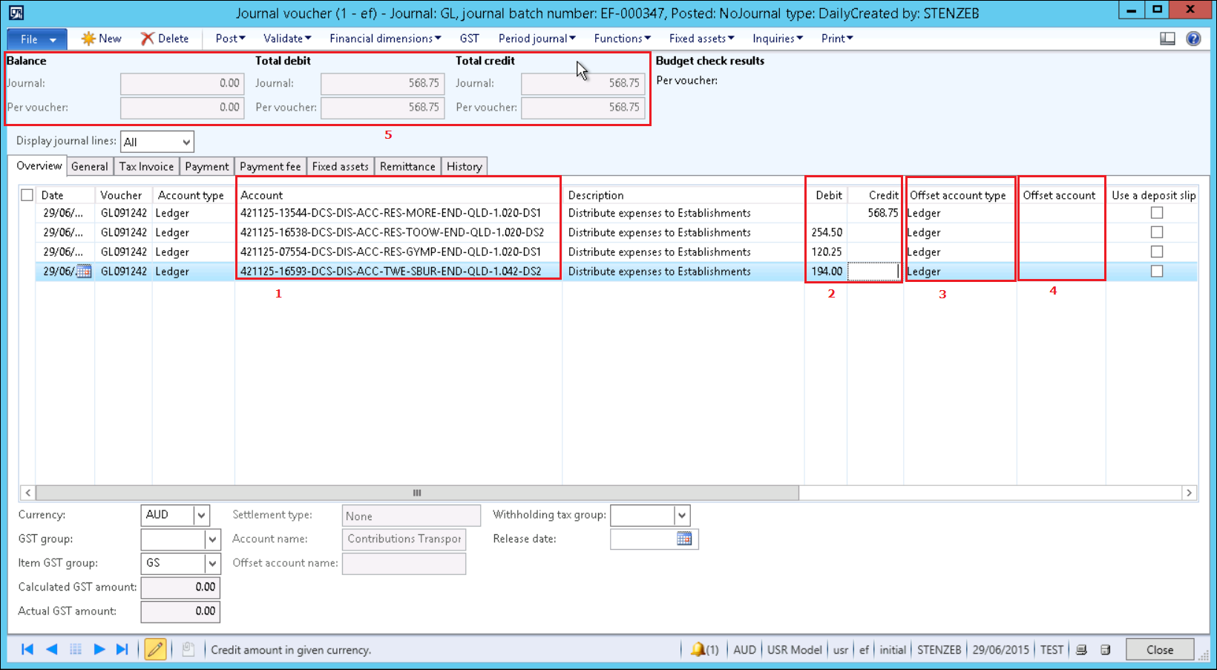
The example journal above is taking an amount posted to an establishment code and distributing this amount to 3 other establishments meaning there are 4 lines in the voucher.

Enter data using the table below as a guide:
Field | Description
Line 1
Date | Select or enter the POSTING date for the journal
Voucher | Allocated by AX; cannot be changed
Account type | Default is “Ledger”  For this example, “Ledger” will be used
Account | Select the Ledger account from the dropdown list. The account number can be typed in if known.  Select or enter the Establishment code as the second field in the string.  Press TAB key for the remainder of the default dimensions to be populated.  Click into the “Description” field after entering the Establishment code  Refer to Point 1 in the image above.
Description | Enter a description for the line
Debit/Credit | Enter the debit or credit value for the line  Refer to Point 2 in the image above.
Offset account type | Default is “Ledger”. For this example, an offset account will not be used so “Ledger” will appear as the default.  Refer to Point 3 in the image above
Offset account | Because the 1 entered value is being split across multiple ledger accounts, an offset account will not be entered and must be left BLANK.  Refer to Point 4 in the image above.
Line 2
Date | Select or enter the POSTING date for the journal
Voucher | Allocated by AX
Account type | Default is “Ledger”  For this example, “Ledger” will be used
Account | Select the Ledger account from the dropdown list. The account number can be typed in if known.  Select or enter the Establishment code as the second field in the string.  Press TAB key for the remainder of the default dimensions to be populated.  Click into the “Description” field after entering the Establishment code
Description | Enter a description for the line
Debit/Credit | Enter the debit or credit value for the line.
Offset account type | Default is “Ledger”. For this example, an offset account will not be used so “Ledger” will appear as the default.
Offset account | Because the 1 entered value is being split across multiple ledger accounts, an offset account will not be entered and must be left BLANK.
Continue entering additional lines until the transaction is complete.
When all lines are entered, the “Balance” group of the journal voucher form (Point 5 above) will show:
- Total debits is equal to Total credits
- Balance is ZERO
Please refer to the previous section for notes on validation, posting and printing reports.

Journal for a cash receipt where the amount received is posted to a customer account and a donations ledger account
This section covers creation of a journal where a single amount is to be distributed to a Customer account and the balance to a ledger account (say a donations account). A bank deposit slip is also required to be printed.
Because the steps to create, validate, post, and print reports are the same in any journal, those sections will not be restated. If information is required with regard to those steps, refer to the previous sections. This section will start at the point where the Journal Voucher form is open ready for data entry.
Path: EF > General Ledger -> Journals -> General Journal > Lines.
Image 1: Journal Voucher Form
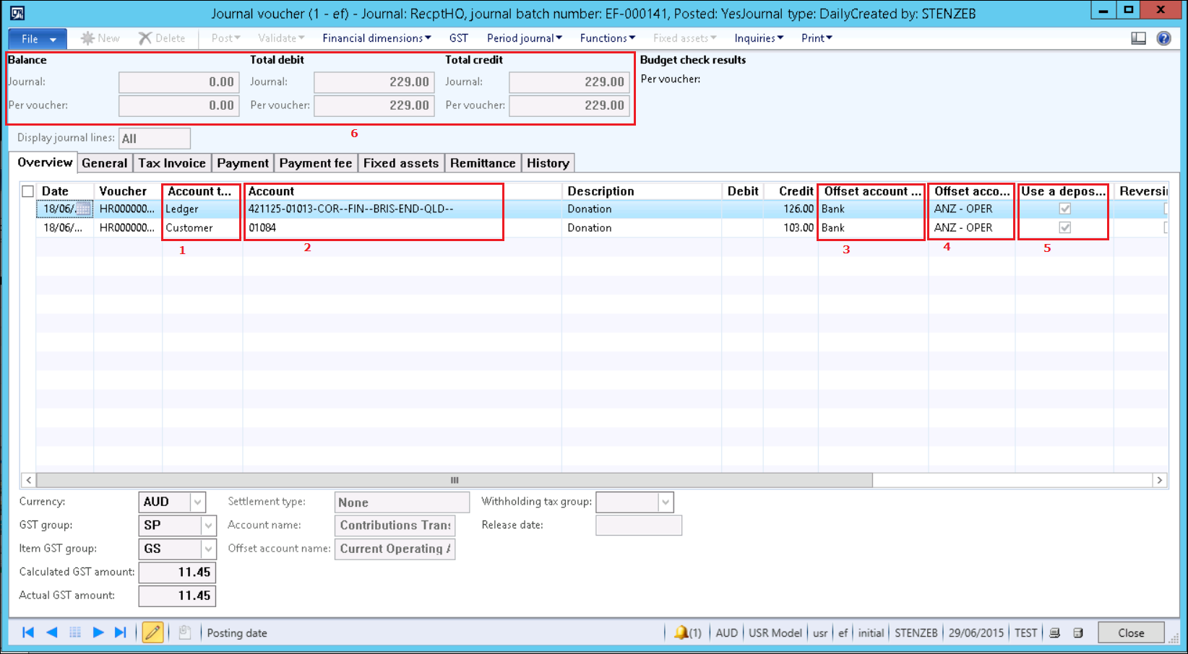
Image 2: Payment Details Tab Form
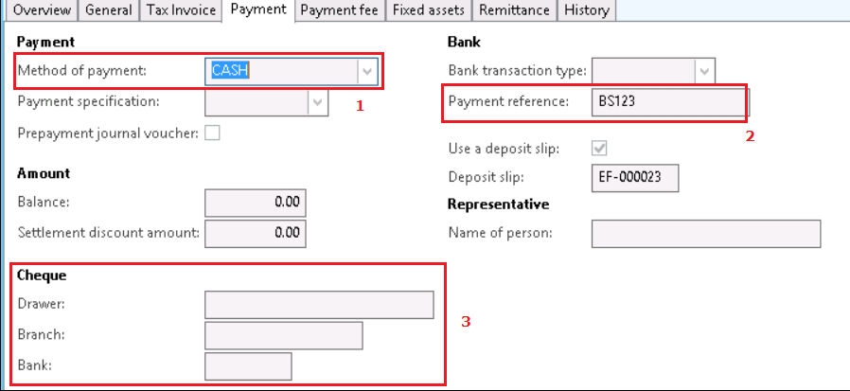
The example journal above is taking an amount received where portion is payment to a customer account transaction and the balance is being treated as a donation.
Creation of the bank deposit slip is also detailed.
Enter data using the table below as a guide:
Field | Description
Line 1: Ledger account line
Date | Select or enter the POSTING date for the journal
Voucher | Allocated by AX
Account type | Default is “Ledger”. Leave the default setting for the first line (See Point 1 in the journal voucher form above)
Account | Select the Ledger account from the dropdown list. The account number can be typed in if known.  Select or enter the Establishment code as the second field in the string.  Press TAB key for the remainder of the default dimensions to be populated.  Click into the “Description” field after entering the Establishment code  See Point 2 in the journal voucher form image above.
Description | Enter a description for the line
Debit/Credit | Enter the amount received for donation
Offset account type | Default is “Ledger”. Select “Bank” from the dropdown list for the offset account type.  See Point 3 in the journal voucher form image above
Offset account | Select the BANK ACCOUNT required from the list displayed.  See Point 4 in the journal voucher form image above.
Use a deposit slip | If a deposit slip is required, check this box. See Point 5 in the journal voucher form image above.
Payment tab details: | Enter payment details for the line (Image 2 above)
Method of Payment | Point 1: Select the method of payment from the dropdown list
Payment reference | Point 2: Enter the payment reference
Cheque | Point 3: If the Method of Payment is CHEQUE, enter the DRAWER, BRANCH and BANK DETAILS.
These details will be printed on the Bank Deposit Slip
Line 2: Customer receipt line
Date | Select or enter the POSTING date for the journal
Voucher | Allocated by AX
Account type | Default is “Ledger”. Select “Customer” from the dropdown list (See Point 1 above)
Account | Select the Customer account from the dropdown list. The account number can be typed in if known.  Click into the “Description” field after entering the Customer code  See Point 2 in the image above.
Description | Enter a description for the line
Debit/Credit | Enter the payment amount received from the customer
Offset account type | Default is “Ledger”. Select “Bank” from the dropdown list for the offset account type.  See Point 3 in the image above
Offset account | Select the BANK ACCOUNT required from the list displayed.  See Point 4 in the image above.
Use a deposit slip | If a deposit slip is required, check this box. See Point 5 in the image above.
Payment tab details: | Enter payment details for the line (Image 2 above)
Method of Payment | Point 1: Select the method of payment from the dropdown list
Payment reference | Point 2: Enter the payment reference
Cheque | Point 3: If the Method of Payment is CHEQUE, enter the DRAWER, BRANCH and BANK DETAILS.
These details will be printed on the Bank Deposit Slip
Once the lines are entered, review the “Balance” group to ensure that debits and credits are in balance. Validate and post the journal.
Please refer to the previous section for notes on validation, posting and printing reports.

Reversal Journal with account and offset account being ledger accounts, and balancing on a single line

Journal Header
Path: EF > General Ledger -> Journals -> General Journal.

Form: General Journal Header
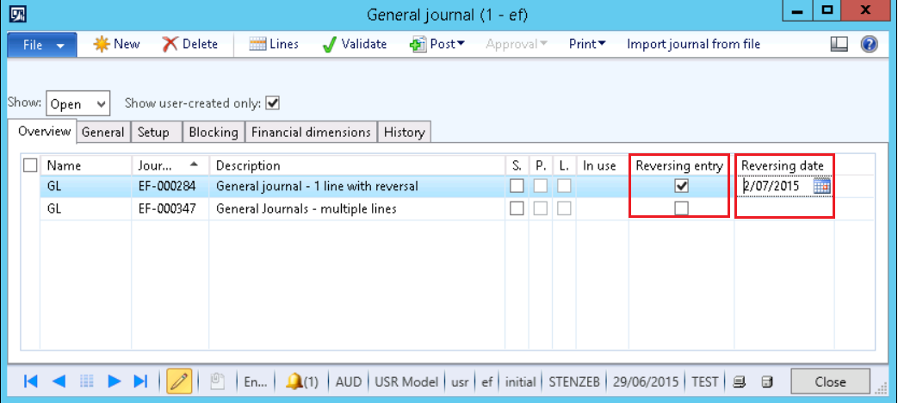
The journal header form is shown above. Note the following differences to a non-reversing journal:
- Reversing entry – check this box to indicate that this is a Reversing journal
- Reversing date – select the date which will be the posting date for the journal created as the reversing entry.

Journal Voucher Lines
Click the “Lines” button to open the journal voucher form. The form will open with the cursor in the “Date” field.
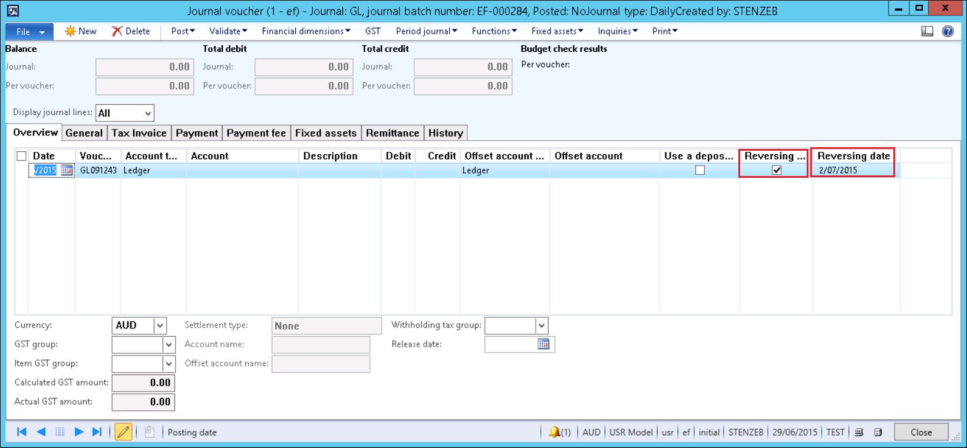
Note that the fields highlighted (Reversing Entry and Reversing Date) are filled with the values entered on the journal header.
Enter a single line journal using a Ledger account type and a Ledger Offset account type.
Post the journal.

The Infolog message displays as normal. However, note that the “Number of vouchers posted” is 2.
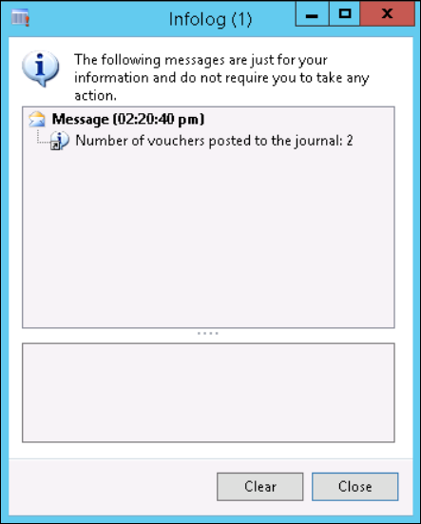
Close the Infolog.
In the journal voucher, Dynamics AX has created and posted the reversing entry as a second voucher line (highlighted below).
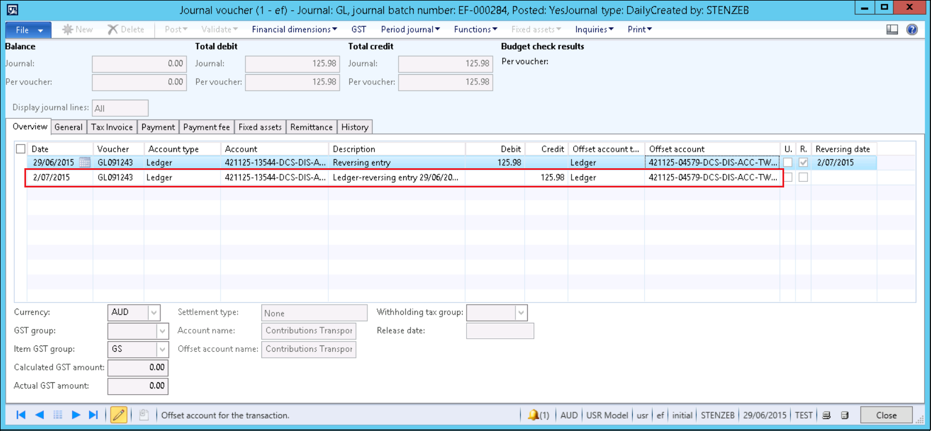
All other steps in entering a reversal journal are the same as entering a general journal. Please refer to previous sections on entering journals if more information is required.

Journal with GST to be calculated
Dynamics AX provides the capability in the journal form to calculate GST when needed. The GST calculated is initiated by the combination of the GST Group and Item GST Group selections.
Because the steps to create, validate, post, and print reports are the same in any journal, those sections will not be restated. If information is required with regard to those steps, refer to the previous sections. This section will start at the point where the Journal Voucher form is open ready for data entry.
A journal is created using a Ledger Expense account with the offset account being the BANK Account. Accounts were verified as below:
- The Bank account (ANZ-OPER) does not have a default Establishment code attached.
- The GST Control account (242115) has a default Establishment dimension in the Chart of Accounts (01000)
- The Ledger expense account (523115) was selected at random and an Establishment dimension applied.
Voucher form completed as below.
- Ledger account selected (point 1)
- Bank account selected as offset account (point 2)
- GST Group and Item GST Group populated (point 3)

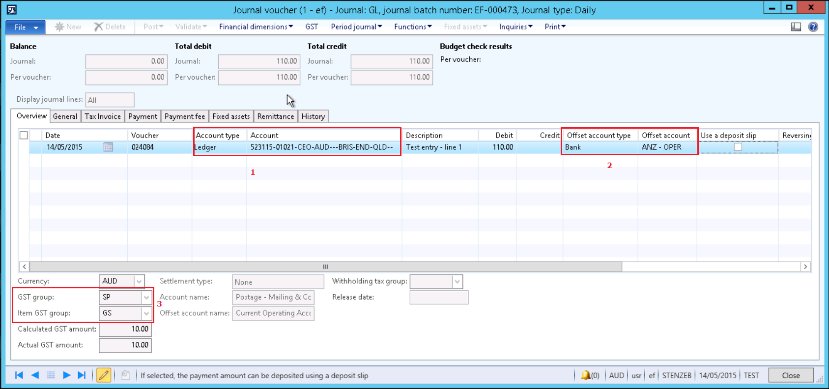

Field | Description
Line 1: Voucher line
Date | Select or enter the POSTING date for the journal
Voucher | Allocated by AX
Account type | Default is “Ledger”. Leave the default setting for the first line (See Point 1 in the journal voucher form above)
Account (Point 1) | Select the Ledger account from the dropdown list. The account number can be typed in if known.  Select or enter the Establishment code as the second field in the string.  Press TAB key for the remainder of the default dimensions to be populated.  Click into the “Description” field after entering the Establishment code  See Point 1 in the journal voucher form image above.
Description | Enter a description for the line
Debit/Credit | Enter the amount received for donation
Offset account type | Default is “Ledger”. Select “Bank” from the dropdown list for the offset account type.  See Point 2 in the journal voucher form image above
Offset account | Select the BANK ACCOUNT required from the list displayed.  See Point 2 in the journal voucher form image above.
Use a deposit slip | If a deposit slip is required, check this box. See Point 5 in the journal voucher form image above.
GST details: | Enter GST details for the line (Point 3 above)
GST Group | Select the GST Group for the line
Item GST Group | Select the Item GST Group for the line
Calculated GST Amount | The amount of GST for the line will be displayed in the Calculated GST Amount
Actual GST Amount | Confirms the amount of the GST.  If there is a requirement to OVERRIDE the GST amount (in the case of having differences between the calculated GST amount and the GST amount on source documentation), then click on the GST menu button.  In the case where the GST Amount
When the GST form displays, a list of the transactions and the GST amount will show (see below):
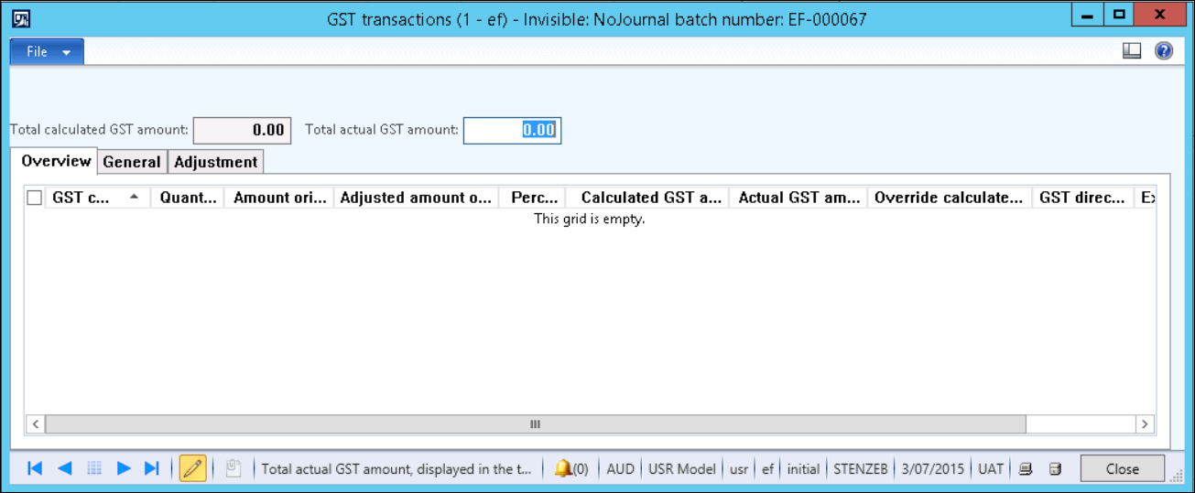
To change the amount of GST, enter the correct value in the field “Total actual GST amount”. This value will transfer to the field “Actual GST amount” when the form is closed.

Post the transaction as normal.

Writing off a Bad Debt

Navigate to: General Ledger>>Journals>Journal

- Create or select CM-JNL in the Journal Name. Yellow bar across the journal name appears with the Submit button indicating the journal has to be submitted to workflow before posting
- Click on lines. Specify the bad debt account
- Enter a credit or debit amount and the offset account
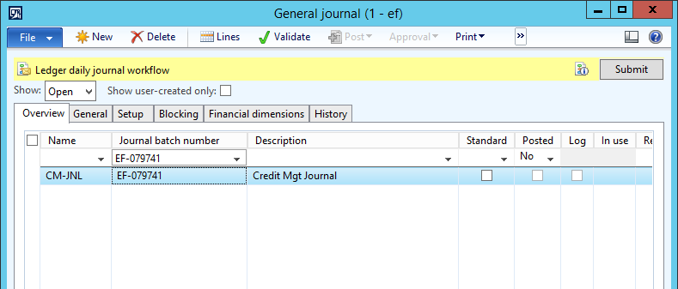

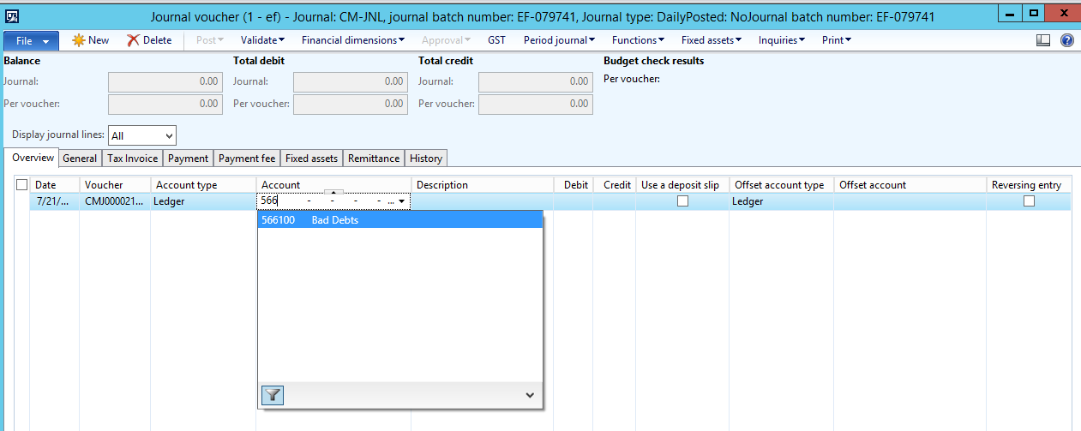

- Once the lines have been populated, click close to return to the General Journal form
- In the General Journal form, click on Submit to send the document to workflow. The Submit button turns into Action button.
- To know who is approving the transaction, click on Action>> View History
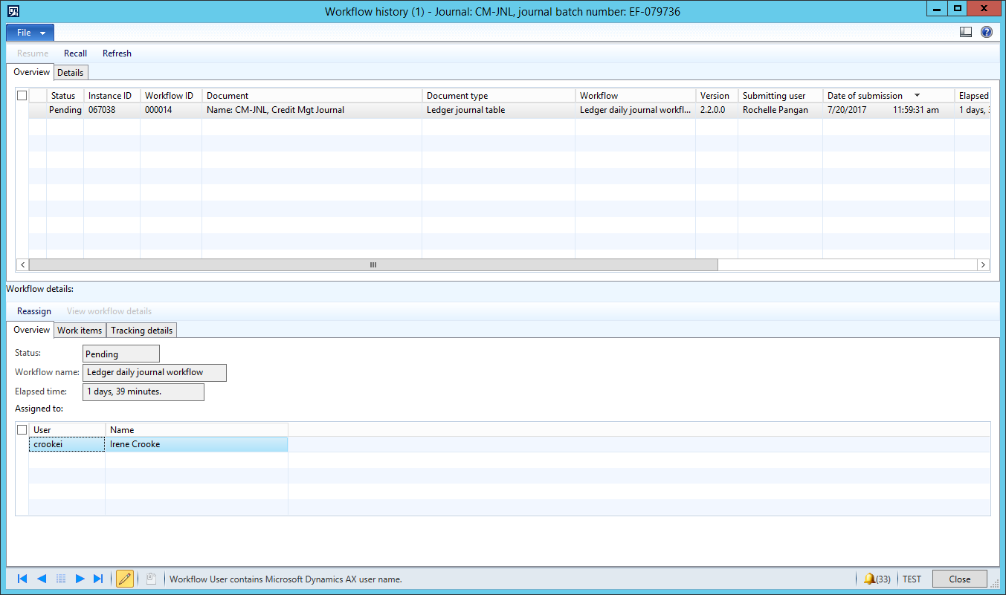

Attaching Notes and Documents to Journals

AX allows attaching Notes, Documents and Files to a journal. This is done using the document handling function.

Documents can be attached at both the header and line level in the journal using the document handling icon. This functionality is available throughout AX in certain forms and screens.

This view shows the Journal Header

- Click on the Journal Header Line
- Select the document handling icon to open the document handling form
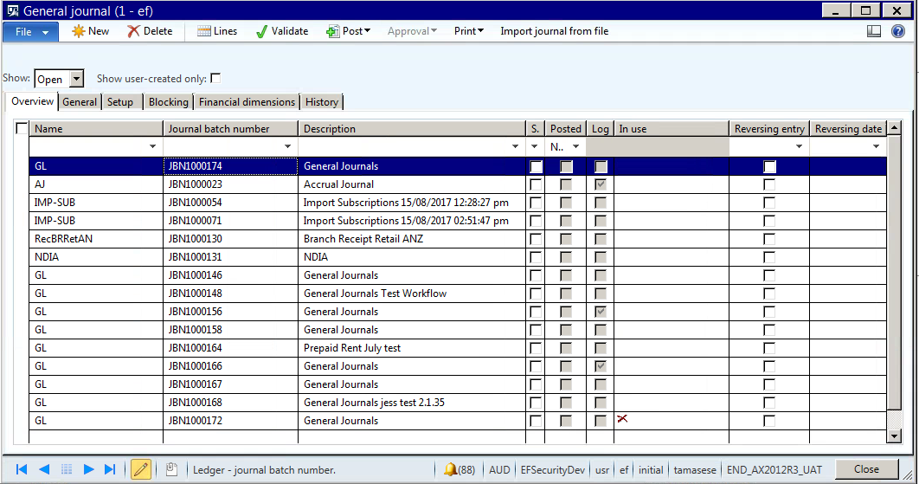

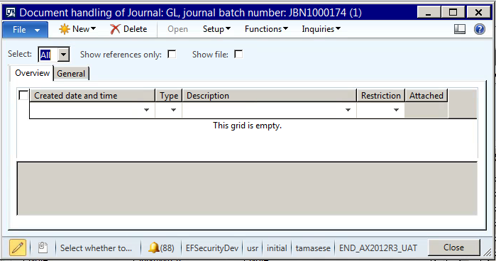

When you click on New – four options are presented:
- Document – will allow the user to create a word document which can be edited and saved. The user will also need to ensure that the document is checked in.
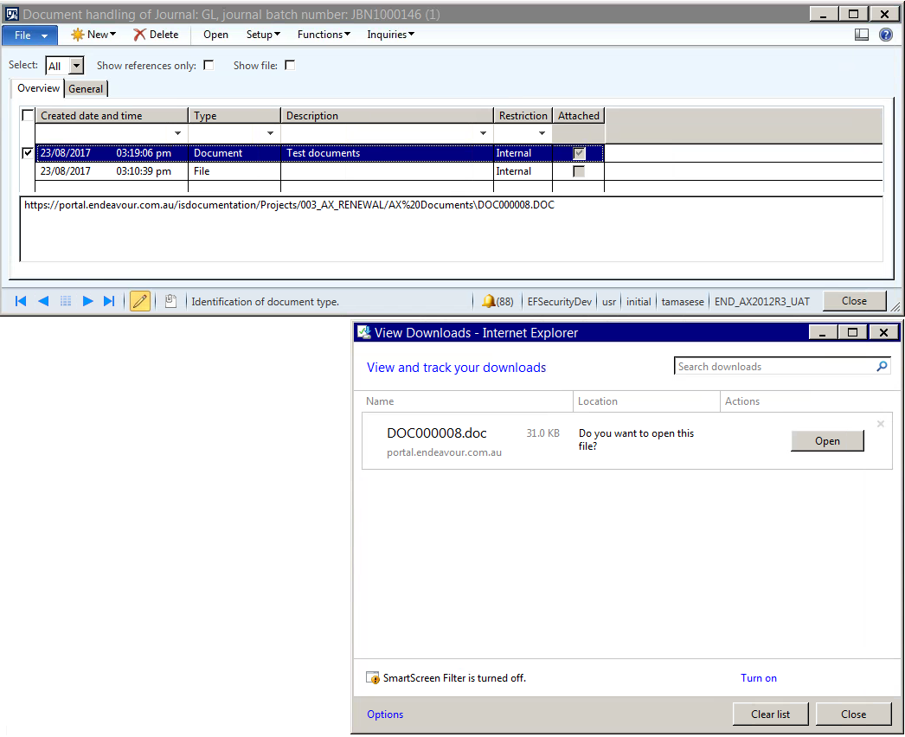
To re-open the document – the user can select the document in the form (tick the line) and click open
- File – will allow attachment of a file, word, excel or PDF format. To re-open the document – the user can select the document in the form (tick the line) and click open
- Note – The user is able to write notes that will be attached to the journal in the text field below.
URL – The user is able to paste a URL in the text box below. To open the URL – the user can select the document in the form (tick the line) and click open

End of Month Steps

Description | These steps relate to setting period access and user group access for end of month processing and moving into a new period.  It DOES NOT list any reports to be printed in preparation for these processes. Which reports are selected to be run is a decision for each business and not something that AX will dictate.  In itself, this section is not mandatory. However, the steps outlined here define a sequence of settings that are aimed at ensuring that transactions are posted in the appropriate period and users have access to the data required for them to complete monthly processes.
Trigger | Calendar month end
Pre-conditions | All transactions to be posted in the calendar month are processed
Post-conditions | Month End transactions have been processed, Accounts have been reconciled, BAS completed and Calendar month stopped for processing further entries.

Processing Month End Journals

Accruals and Reversals
Description | This User Guide describes the steps to create a reversal journal for accruals.
Trigger | Accruals need processing and reversals need to be processed on nominated dates
Pre-conditions | An accrued journal is requested. Reversal dates have been determined.
Post-conditions | - Success end condition – Journal is posted and reversal entry is also created for the nominated date in the same journal.

The upload journal function is used for Accrual Journals. The reversal function within AX ensures that reversals are processed on a nominated date.

- Prepare the Journal Template
- Upload the journal
- Path to General Ledger> Journals>General Journal
- Create or select the Journal you require the template lines to be added to
- Import the journal as show below by accessing the Import journal from file button and selecting the related template definition and file to be uploaded
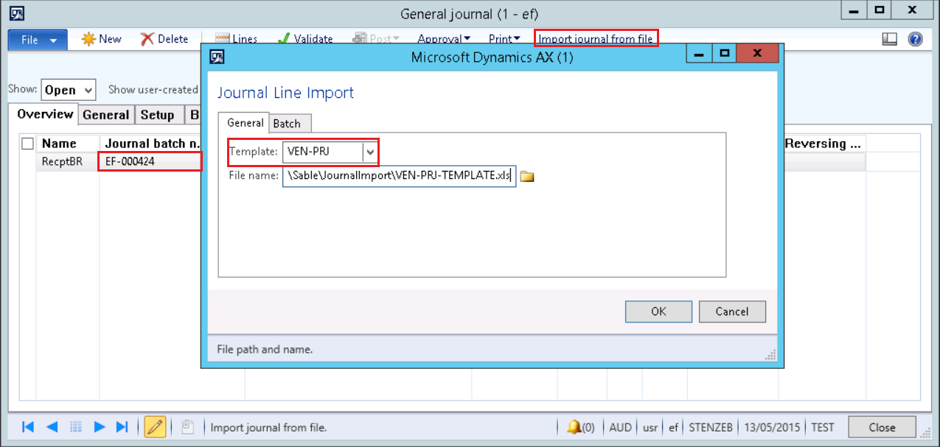

- If the upload is successful the below message will display. If the upload is not successful a message will be displayed outlining the issue for your attention.

- Navigate to the Journal Header and tick the reversal check box
- Enter the reversal date

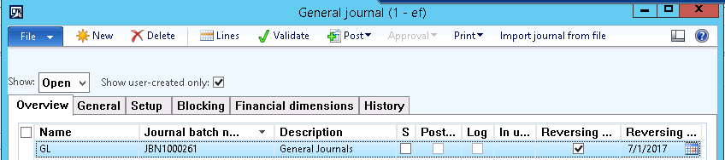

- Post the journal

Allocation Journals

Description | This User Guide describes the steps used to process allocation rules that have been configured and set up for use. This functionality can be used to allocate a global amount in several combinations of account/financial dimensions. The key of the repartition can be fixed or linked to another account. In an allocation rule, there are several components:  - the source: select the account/dimension you want to allocate. The total of the amount from all the journals will be the base of the allocation.  - the destination: select all the combinations of account/dimensions that will receive an amount.  - the rule: select the way of calculation of the allocation. It can be fixed (enter directly a percentage) or variable (with a linked to another account for example).  - The allocation rule, can be setup with several methods:  - Option A: Basis allocation method  - Option B: Fixed percentage method  - Option C: Fixed weight  - Option D: Distribute the source document amount equally.
Trigger | Request to allocate or reallocate amounts that have been posted to GL account/s
Pre-conditions | Allocation Rules have been set up
Post-conditions | - Success end condition – Amount in a source account has been allocated/re-allocated as per rules that have been set up. Example:  - Failure end condition – the allocation job is not run and amounts are not allocated correctly.

Step 1: Create ledger allocation basis
Access: GL > Setup > Posting > Ledger allocation basis
- Create one basis rule for each combination of account/dimension. In the example we need to create 3 rules.
- Enter a description
- Click on Basis
- Create a first line and select “Main account” in “Field setting”,
- In “Source criteria”, select the main account. In the example, the value 613200,
- Create a second line and select “Financial Dimension” in “Field setting”,
- In financial dimension filed, select the dimension you need. In the example, it is “budget”,
- In “Source criteria”, select the main account. For the first rule, it is “001”.
- Create two other rules with the 2 other budget values.
- Click on active of each ledger allocation basis.
Step 2: Create ledger allocation rules
Access: GL > Setup > Posting > Ledger allocation rules
- Create a new ledger allocation rule
- Enter a description
- Go to the “General” tab,
- Select the allocation method “Basis”,
- Select a journal name.
- Go to the Offset tab,
- Select the offset account
- Click on “Source”
- Select the main account that needs the balance reallocated.
  - Add lines for financial dimensions
- Click on “Destination”
- Create a line with the Basis rule. Select the Basis rule, the ledger account and financial dimension of the destination
- Go back to the first form and activate the rule by clicking the active button.
Step 3: Execute allocation rule
Access: GL > Periodic > Process allocation request
- Select the allocation rule,
- Select the start date to retrieve amount for the allocation,
- In proposal option, select “Proposal only” to be able to check the journal or “Post only” to directly post the journal.
Step 4: Review and Post Allocation Journal
Access: GL > Journals > Allocation
- Open the new allocation journal created by Dynamics AX.
- Post the journal if all is OK.

Asset Journals
Please refer Asset User Guides for processing instructions

Month End reconciliations (please delete/add to as required)

Ledger Reconciliations
PLEASE REFER BUSINESS FOR RECONCILIATION ACCOUNTS AND PROCESSES

Bank Reconciliations
PLEASE REFER BUSINESS FOR RECONCILIATION ACCOUNTS AND PROCESSES

Asset Movement Reconciliations
PLEASE REFER BUSINESS FOR RECONCILIATION ACCOUNTS AND PROCESSES

Project Reconciliations
PLEASE REFER BUSINESS FOR RECONCILIATION ACCOUNTS AND PROCESSES

BAS
Description | This guide outlines instructions to print a Business Activity Statement (BAS). The BAS is used to report sales and purchases tax for a specific settlement period and transaction date to the Australian Taxation Office (ATO).
Trigger | End of Month
Pre-conditions | Transactions for the month are completed and all reconciliations are done
Post-conditions | BAS is printed and clearing entries automatically processed

Creating Additional BAS boxes
General ledger > Periodic > GST payments >Additional BAS report boxes

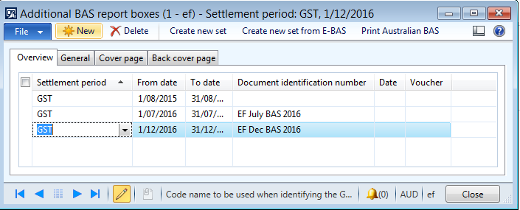

- Create New
- Select GST
- Enter the dates for the reporting period
- Click on General Tab

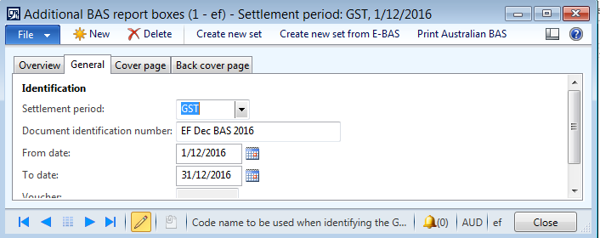

- Enter the Document identification number – eg Dec BAS 201XX
- Click on Back cover page Tab
- Enter the appropriate amounts in the relevant boxes to be reported for the period
  - In EF – Fuel tax credits are to be reported

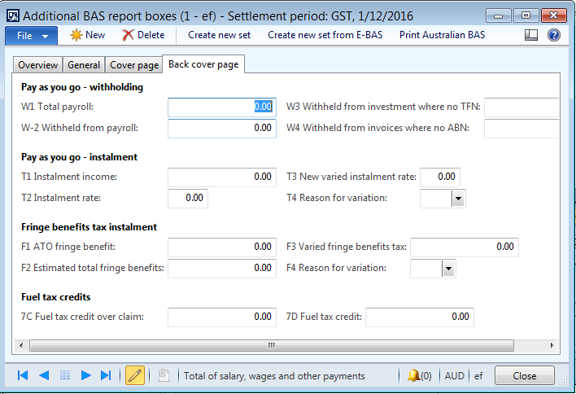

General ledger > Periodic > GST payments > Australian BAS.
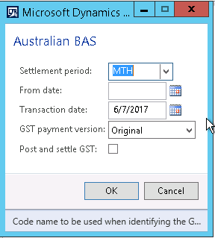

Field | Description
Settlement period | Select the settlement period. Settlement periods are defined in the Sales tax settlement periods form.
From date | Enter the starting date of the settlement period.
Transaction date | Enter the posting date for the sales tax settlement.
GST payment version | Select the version of the GST report to settle.
Post and settle GST | Select this check box to post and settle the transactions for Goods and Services Tax (GST).

Changing Period Status to stop posting

Changing the module parameters starts from the Ledger Definition form.
Path: GL > Setup > Ledger

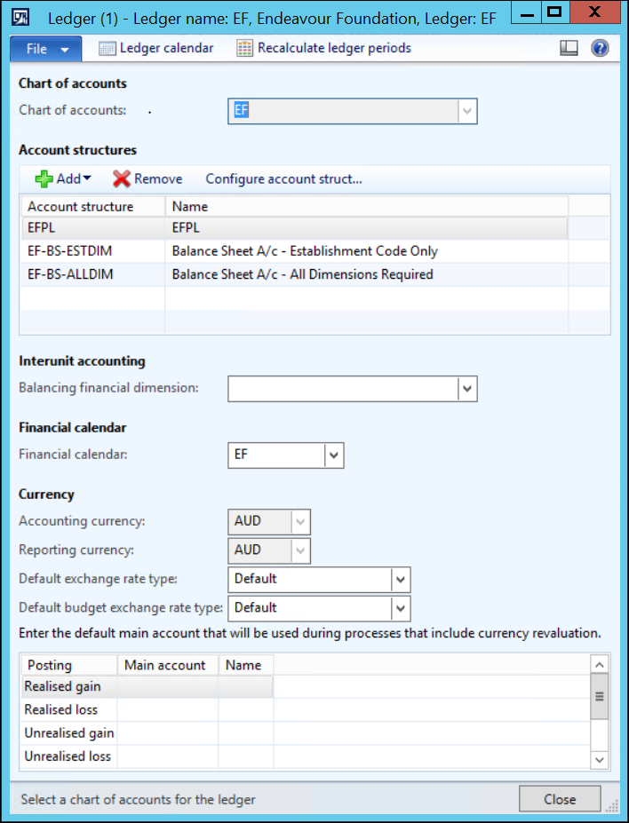
Select the “Ledger calendar” button (highlighted above).

Changing Ledger Calendar Period Status
The Ledger Calendar form will open.
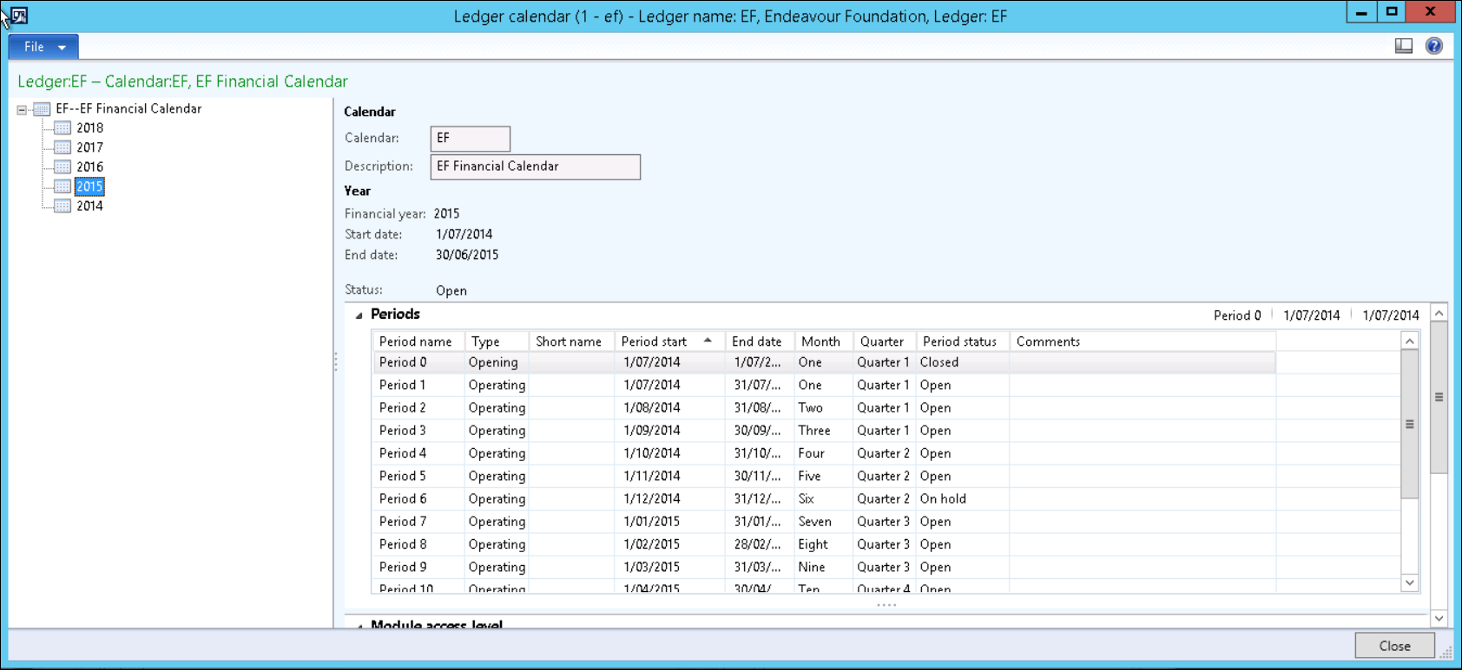

Open financial calendar (using 2015 in the example above). Resize the form so that the column “Period status” is visible.

Period Status
Dynamics AX has 3 period statuses:
- Open – transactions are able to be entered and posted
- On-hold – transactions cannot be posted. However the period status can be set to “Open” to allow transactions to be posted.
- Closed – transactions cannot be posted. The period status CANNOT be changed.

Set period status:
If needed, set current period to “On hold” and open the next period for processing.
Set the next period to “Open” so that transactional processing can commence in the new period. Note that it is common practice to have future periods open for many businesses.
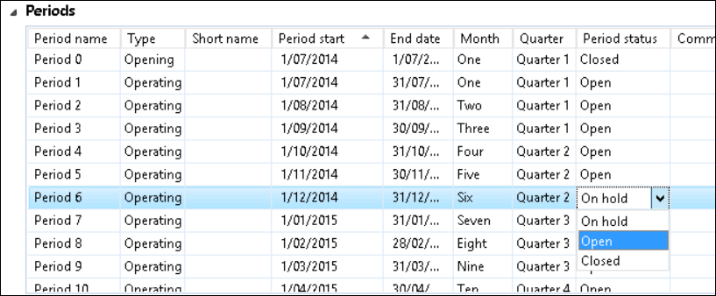

Allowing User Groups access to Current Period
If some user groups require ongoing access to a module, leave the period open and move to the Module access level fast tab. This is the lower pane of the Ledger calendar form and is shown below.
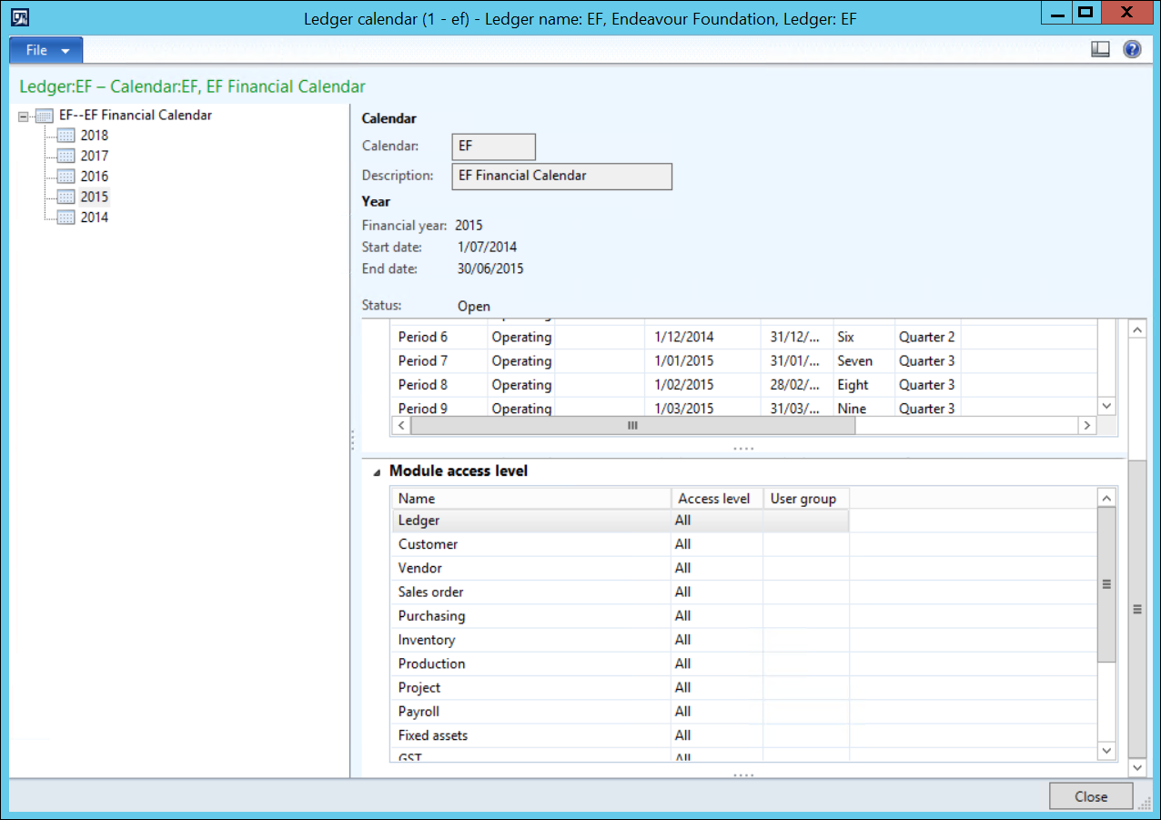

Move to the module name required, then in the Access level field select “User group”; move to the “User group” field and select the User group that is allowed access to the module.
This means that ONLY USERS THAT ARE MEMBERS OF THE USER GROUP can transact for the selected module and period combination
.
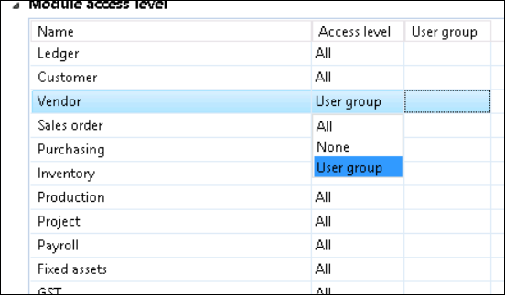

Close the forms.

Setting Period Status when All Processing is Complete
When all the end of month processes are completed, return to the form and set the period to “On hold”. This means that no users can enter transactions without the period status being changed.

End of Year Process

Description | End of year process includes setting access to the period as per the end of month process.  Additionally, a process is required to move the current year P&L balances to the retained earnings accounts and to roll balance sheet account balances through to the new financial year. Dynamics AX refers to this as the “Opening balances” process. The process can be run multiple times to accommodate the inevitability of year-end adjustments having to be processed and rolled into the next financial.
Trigger | End of Financial Year
Pre-conditions | All financial transactions have been captured  Reconciliations complete  - Bank  - Inventory  - Suspense Accounts
Post-conditions | Profit or Loss determined in Accounts  Balance Sheet closing balances have been transferred to new FY  All periods placed on hold for any further processing

These steps do not list a series of reports to be printed; AX does not dictate which reports should be printed at end of year.

End of Year Setup

Set Up Financial Year Close Parameters
At the completion of the Fiscal year EF will need to process a year-end close in AX. Dynamics AX has a different year-end close than most systems, as it can be run as many times as needed. In other systems when processing a year-end close, once you do it, there is no going back and it is difficult to make adjustments as needed.
In Dynamics AX there are several parameters that are important to understand before processing the Opening Transaction job. The parameters for the Fiscal Year close can be located by navigating to:
General Ledger >> Setup >> General Ledger Parameters >> Ledger >> Fiscal Year Close

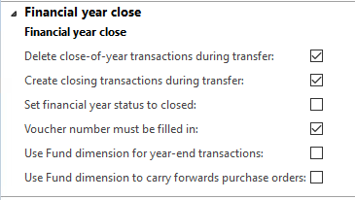

Delete close-of-year transaction during transfer
This setting comes into play when you have to re-run the opening balance job. If you have run the opening balance job and then want to go back and make adjustment entries, this parameter setting will determine what happens to those adjustment entries. For example, when this option is checked it will delete the initial year-end close transactions and create a new one. When this option is unchecked, instead of deleting the year-end close, it will now create adjustment entries for those amounts. At this point, you will see your original closing entries and your adjusting entries.

Create closing transactions during transfer
This setting has an effect on how your trial balance will look at the end of the year. When this option is checked it will zero out all of your ending balances on the last day of the fiscal year, and create a new Opening transaction on the first day of the new fiscal year. For example, if you want to look at your balances as of 12/31 it would show up as zero. It is best to have this option unchecked.

Set fiscal year status to close
When the opening balance job is complete, it will set the status as “closed” if checked. It is recommended not to check this. Period status can be set to “closed” manually and this should be done after the balance sheet is audited. However, it depends on the client’s requirement.

Voucher Number
This refers to the voucher number on the opening transaction job. It is recommended to be checked.

Year-end checklist steps
Once you have set your parameter settings for the “Opening Balances” job it is now time to go through your year-end checklist.

Please refer Appendix I

Run Financial Year Close

Run Trial Balance and export to Excel

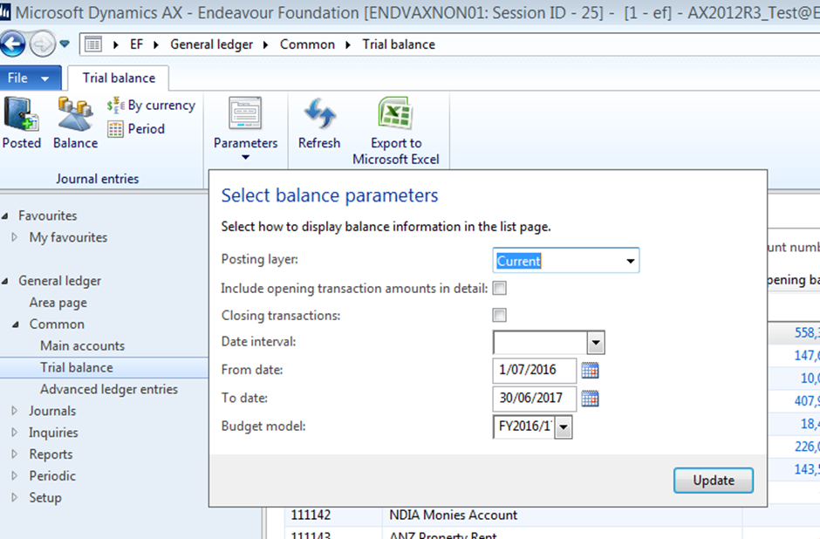

Ensure users are all logged out – AOS ones

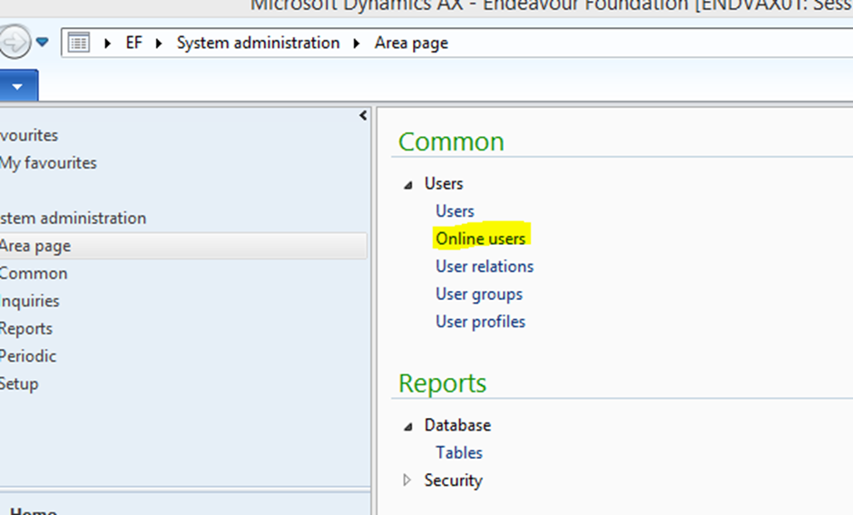

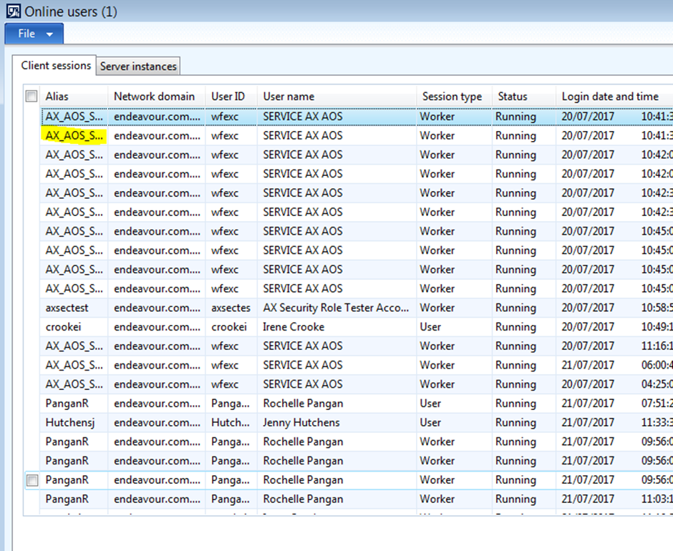

Opening Transactions Form

Navigate to General Ledger>>Periodic>>Financial Year Close>>Opening transactions

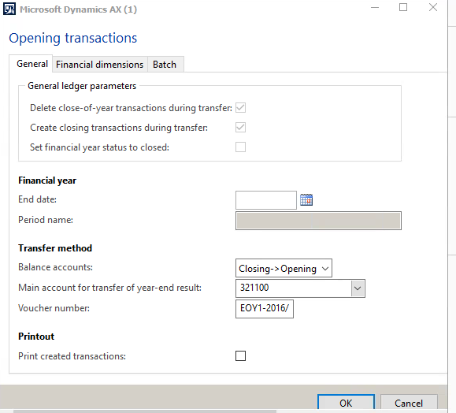

- End date: Last date of Financial Year eg 30/06/2017
- Balance Accounts: Closing->Opening
- Main Account for transfer of year-end-result: Retained Earnings Main Account
- Voucher Number: As per Company Naming Convention – eg: EOY1 – 2016/17
- Print created transactions: Tick if you wish to print a report of the created transactions

- Select “Batch” for running year end closing. Leave Batch group as empty.

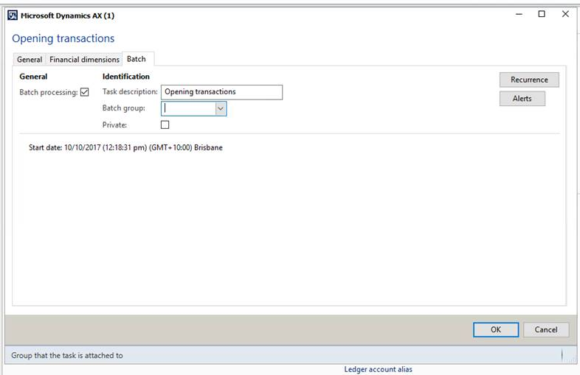

You will get this message

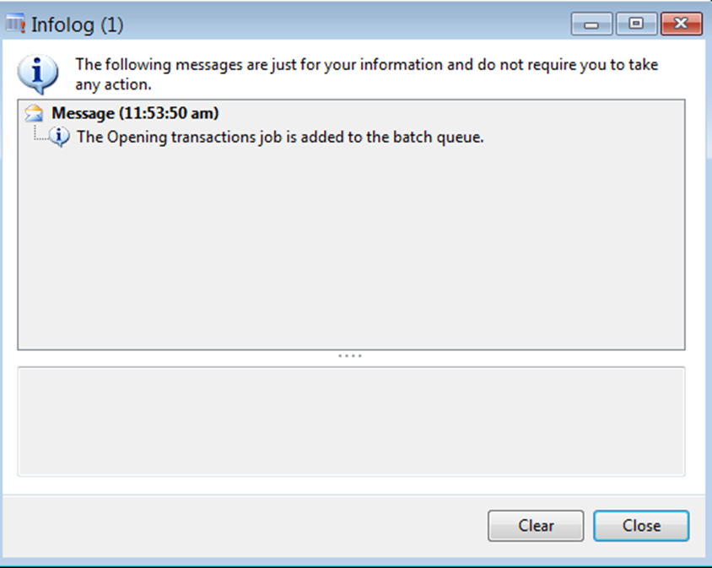
You can check on the status of the batch

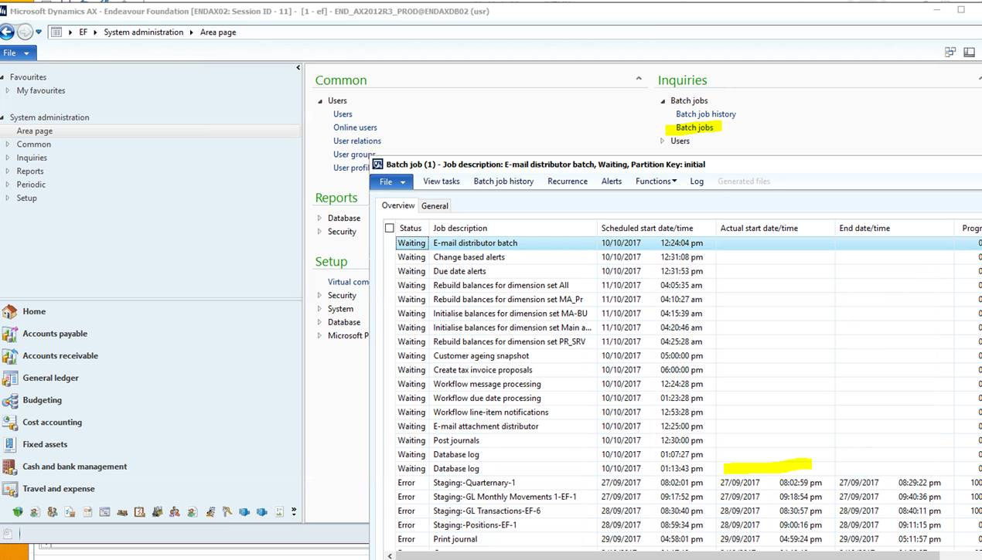

Once complete run the TB for the new financial year and check all the opening balances agree to the closing balances from the previous year

When the Opening transactions job is run – report checking etc can commence. Any adjustments needed can be processed and the Opening transactions job is re-run. (It is recommended that the Voucher number include the Run number as in the example EOY1, the next run would be EOY2)

Reporting & Inquiries

Voucher transactions

General Ledger>>inquiries>>>Voucher Transactions

This is particularly useful if you have a Voucher Number or Journal Number that you wish to search on.

The query form below is presented and the user is able to enter search criteria as required.

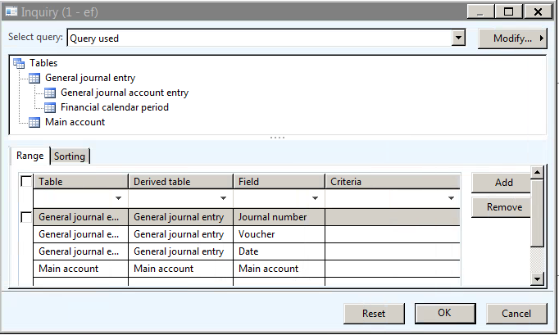

Exporting a Screen to Excel

This functionality allows a user to export any active screen in AX to Excel by holding down the Ctrl Button and T.

The screenshot below shows an excel export of the above screen.
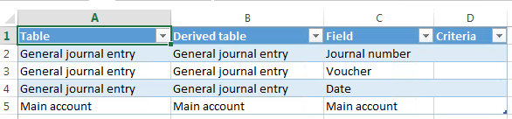

AX Reporting is done via Management Reporter
To access Management Reporter via AX
General ledger>>Reports>>Management Reporter

Depending on the security permission of the user’s current role in AX – one of two screens will be presented when MR opens.

The Viewer or Designer access levels determine what the user is able to see. Below is a screenshot of the Designer View

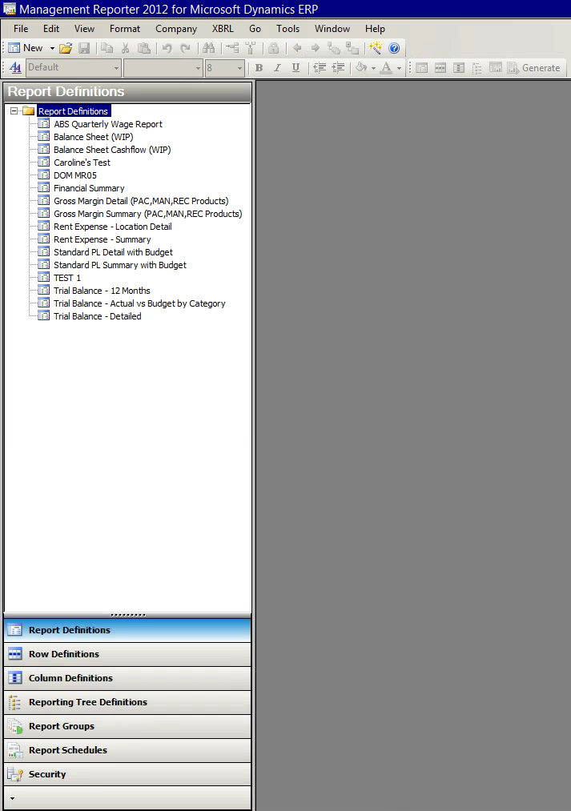

To Access a report
- Double Click on Report Definitions
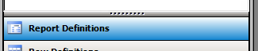
- The list of reports will be presented in the window above
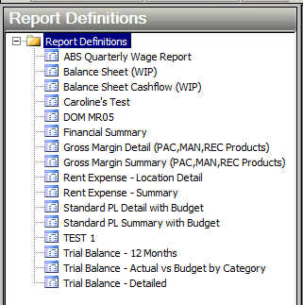
- The report settings form is presented when selecting on a report by double clicking
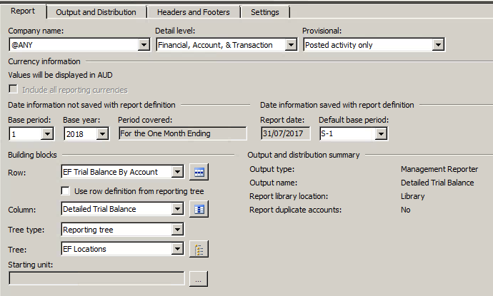
NOTE: THESE REPORTS HAVE BEEN BUILT TO SPECIFICATIONS SO THE OPTIONS PRESENTED ARE STANDARD. IF CHANGING ANY OF THE VIEWING OPTIONS, PLEASE DO NOT SAVE
- Select Generate
If a reporting tree is selected in the report output screen as in the one above the following form will open
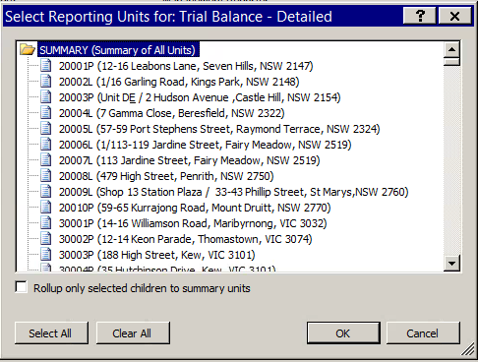
Select a range of dimensions by holding down the shift button while clicking on the first and last dimension in the range
Select individual dimensions by holding down the Ctrl button while clicking on individual dimensions
Or Click on Select All to include every dimension in the report
The Clear All button will deselect all the selections made
- Click on Generate once all the relevant selections are made
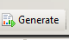
Alternatively the menu button directly beside the Generate button will present previously generated reports which can be selected
- The Management Reporter Web Viewer will present the report. An example of the above chosen report presented in the Web Viewer.
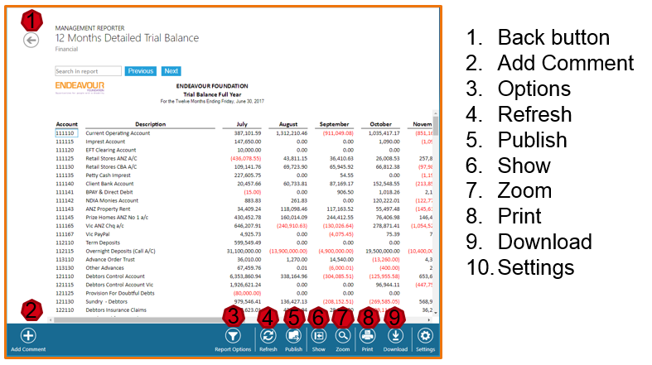

Journal Approval Workflows

The following workflow has been set up for all created GL journals.

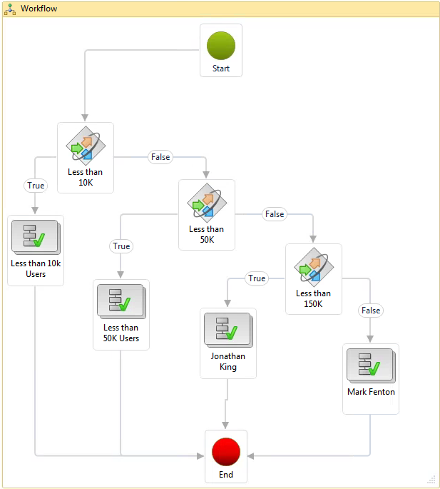

Users have been assigned groups determined by the dollar value of the journal they are creating.

The Groups and assigned users are as follows:

Groups
10K – Matthew Brown
50K – Kirrily Brookes
Dominic Cheung
Angela Colban
Bob Collins
Charles Costigan
Jenny Hutchens
Jessica Parry
Catherine Ung
Karen Wilson
150K – JK
>150K – Mark Fenton

The workflow engine will activate when a Journal Header is created and GL Journal name is selected.
The user will need to complete the journal lines and then go back to the header to submit for approval

In the General Journal form, click on Submit to send the document to workflow. The Submit button turns into Action button.

When all the necessary approvals are actioned – the Submit button changes to Action.

To know who is approving the transaction, click on Action>> View History

Appendix

Appendix 1 – End of Month Checklist

SAMPLE EOM CHECKLIST FOR BUSINESS TO REVIEW AND UPDATE IF REQUIRED

The steps below are suggested action items that could be tailored for EF:
Complete All Financial Processing
- Month End Journals
- Reconciliations
- Process BAS
- Printing Reports
- Processing Adjustments and Corrections
- Closing Period Status
- Printing Final Reports

Appendix II – End of Year Checklist

SAMPLE EOY CHECKLIST FOR BUSINESS TO REVIEW AND UPDATE IF REQUIRED

Microsoft has put together a Fiscal Year closing checklist which can be located at the following link.

The steps below are suggested action items that could be tailored for EF:
- Verify the closing options that you have selected in the General Ledger parameters form.
- Complete the Inventory Closing process.
- Complete month-end and other period closings in all modules other than General Ledger. Some of these may include:
- Post all open journal vouchers for the month in all relevant modules
- Complete any batch posting routines in Accounts Receivable and Accounts Payable
- Post and adjust project transactions
- Complete month-end and other period closings in General Ledger and print financial reports for the month and quarter.
- Ensure Elimination Entries and other entity trial balances are imported and posted in the “Consolidation Company”
- An online consolidation can be done when the subsidiary legal entities are in the same database as the consolidated legal entity. It is recommended that you use Management Reporter to combine the financial results for multiple legal entities in a consolidated format. Management Reporter lets you create consolidated financial reports across legal entities.
- In all modules other than General Ledger, complete year-end activities that might create ledger postings. E.g Process year-end depreciations in Fixed Assets.
- Create the new fiscal year by navigating to General Ledger >> Setup >> Fiscal Calendar
- Have your IT Department process a SQL Backup of your AX Database.
- Process adjustments for year-end.
- Print final Financial Statements.
- At this point, run the Opening Transaction job which will transfer opening balances for each account to a new fiscal year and close out your P&L Accounts and transfer those amounts to your Retained Earnings account specified in the Opening Transaction form.
- Run the financial statements or Trial Balance and verify the data. If any adjustment entries are required, post it through a general journal and re-run the opening transaction process with a new voucher number.

Trial Balance Run Error
Trial Balance Run Error as per:
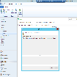

To correct see below:
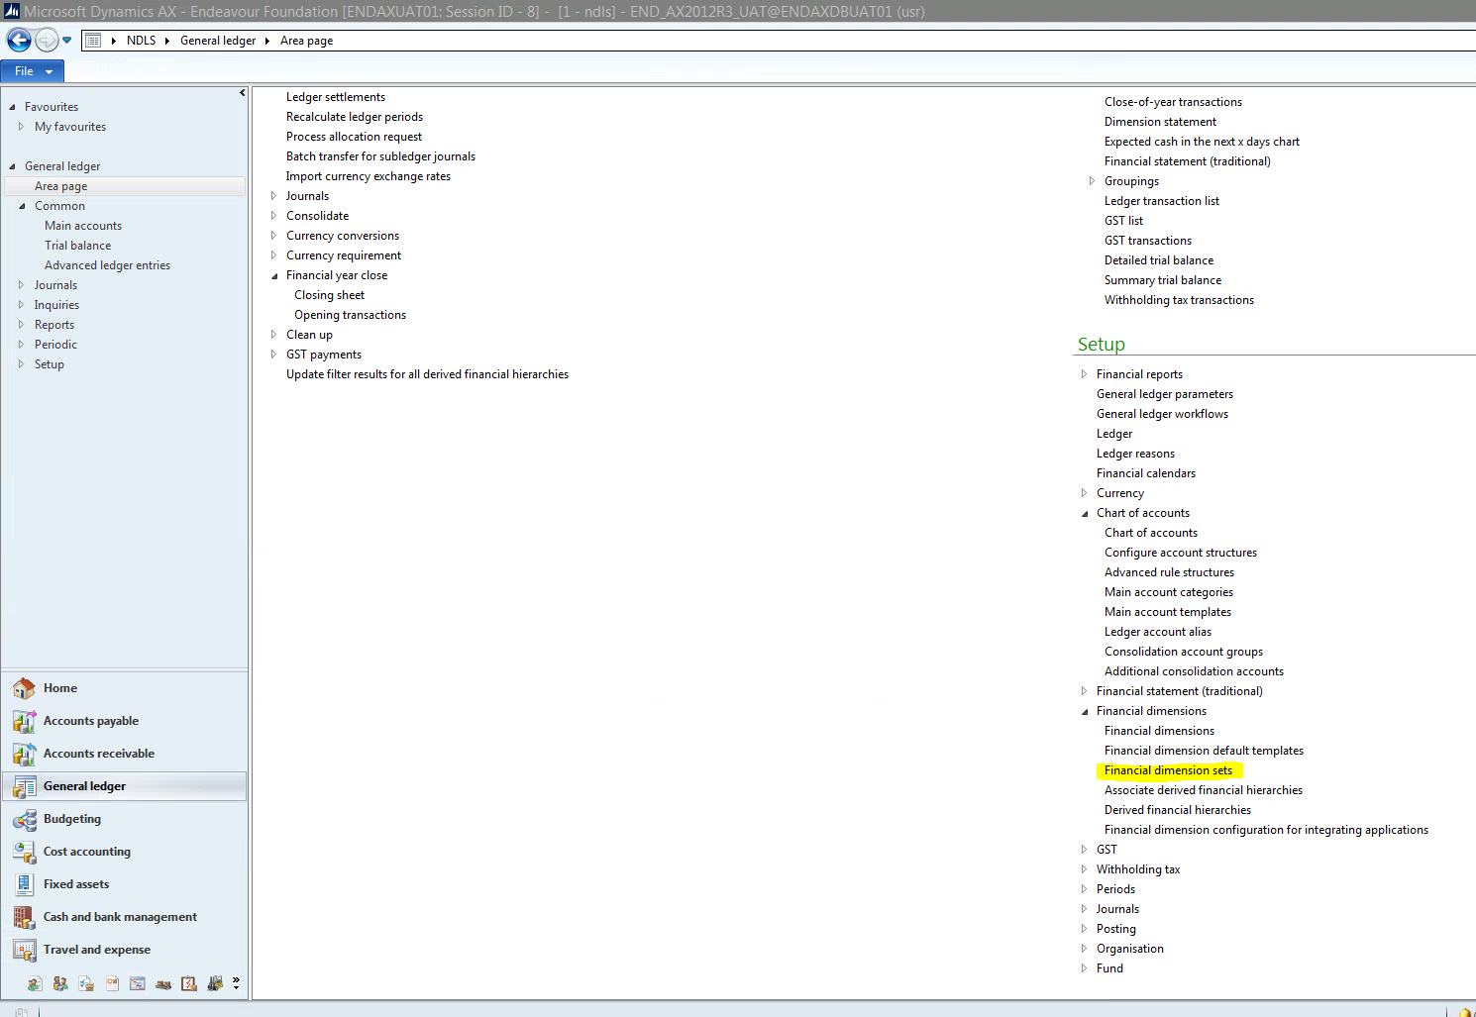
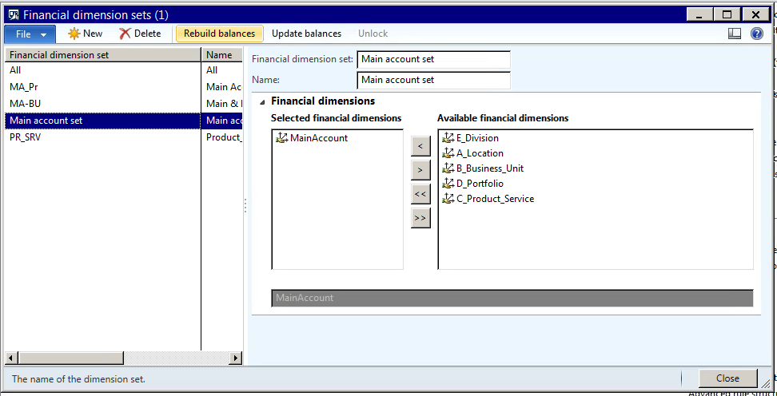
If the balances have not been initialised then will say “Initialise Balances” instead of “Rebuild balances” as shown.
To correct just click the “Initialise Balances” and the TB will be able to be run correctly.

Note: This process should be run daily at 4am as part of a batch, so the error should not occur and if the batch does fail then a notification should be sent.

Error VT_CY on Jnl upload
This can be caused by the format of numbers including the $ sign

