
Empty Pallet Hazards
Safety Toolbox Talk

Toolbox Session
More Learning Choices
04.2017

This Toolbox Talk is to prompt conversations and discuss hazards posed by empty wooden pallets.
An empty wooden pallet can weight up to 43 kg. A range of injuries can occur if not handled or used correctly.
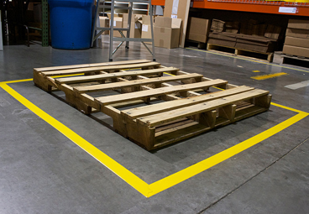
What can cause an injury?
- Damaged pallets may have exposed nails or splinters that can cause lacerations or splinter injuries;
- The use of incorrect postures or techniques when moving or lifting pallets can cause strain/sprain injuries;
- Using pallets as work platforms or standing on them poses trip fall hazards;
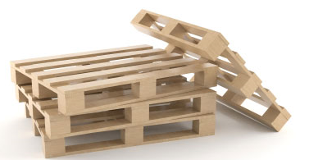
- Handling pallets without appropriate personal protective equipment e.g. safety gloves;
- Storing pallets in an upright position or leaning them on their sides pose strike hazards that can cause injuries from them falling over; and
- Incorrectly stored empty pallets can become trip hazards.

What can we do to prevent an injury?
- Use a pallet jack or a forklift for handling pallets. Ensure you have been trained to use these aids;
- Regularly inspect pallets for damage – loose or rotten sections and exposed nails, and remove from use;
- Always wear appropriate PPE to avoid splinter and cut/crush injuries; and
- Store pallets only in designated areas and ensure they do not pose trip hazards or block designated walkways or exits.
Empty Pallet Hazards
Toolbox Talk Record
Note: Safety Toolbox Talk attendance can be captured within team meeting minutes with reference to a specific Toolbox Topic.
The below record sheet can be used for those who were unable to attend the team meeting to demonstrate that they have reviewed the Toolbox Topic separately.
Further Note: The safety toolbox talk is NOT a training tool. It’s designed to raise safety awareness around specific safety topics and assists with encouraging conversation and reinforcing safety knowledge.
Name of Site / Service:

Name | Signature | Date

