
General and First Response Fire
Evacuation Training

Toolbox Session
More Learning Choices
09.2014

The following Toolbox Training has been developed for presentation to all management and team members to enable them to understand the fire and evacuation procedures for the site/service; identify the different types of fire fighting equipment and understand how the equipment is operated/used.

Audience | This Toolbox Training should be presented to all team members, including management, annually in line with the site/service monthly Health and Safety Plan.  This Toolbox Training should also be presented to all team members upon any change to the Site/Service Fire and Evacuation Procedures, Plan or Equipment.

Presentation | It should take approximately 20 – 30 minutes to deliver this Toolbox Training.

Objectives | After hearing this Toolbox Training, team members will:  - Be aware of and understand Emergency Response;  - Understand the site specific Emergency Control Organisation (ECO) and its purpose;  - Understand the characteristics of fire and associated risks;  - Recognise and understand how to operate or utilise different fire fighting equipment;  - Know how to locate fire safety reference points; and  - Understand how to safely evacuate the building in the event of an emergency.

Filing | Ensure an Attendance Register is signed off.  When the Toolbox Training is completed, ensure the Fire Evacuation Instruction Record QF 4200.09 is updated and incorporated into the FSMP.

Equipment Required | - Fire Safety Management Plan.  - If able, have a Fire Extinguisher available to demonstrate symbols and sweeping action.  - If able, have an old Fire Blanket or a towel available to demonstrate how to use a fire blanket.  - If anybody has any questions regarding this training, please contact a WHS Advisor or send your question to whs.support@endeavour.com.au.

Introduction: | Note: | This toolbox training is to be provided by the Site Evacuation Coordinator.
Introduction: | Explain: | “The primary responsibility in times of emergency is the safety of our team members, volunteers, contractors, people we support and visitors.  Team members must NOT subject themselves or any other person to the risk of injury or death in any emergency situation.”

What is an Emergency? | Explain: | An emergency is defined as:  “any event that arises internally or from an external source, which may affect persons or the community in general, and which requires an immediate response.”

What legislation applies? | Explain: | As part of the Qld. Fire Safety laws, all Qld. sites are required to have a written Fire Safety Management Plan. Although this is only a Qld. requirement – we are completing for all sites nationally as ‘good practice’.  Qld. Building Fire Safety Regulations 2008 and associated Development Codes.  WHS Act 2011 and WHS Regulations 2011.

Emergency Control Organisation (ECO) | Explain Structure and Purpose: | Position | Purpose
Emergency Control Organisation (ECO) | Explain Structure and Purpose: | Chief Warden | - Manage Emergencies.
Emergency Control Organisation (ECO) | Explain Structure and Purpose: | Deputy Chief Warden | - Ensure lives are put before assets.
Emergency Control Organisation (ECO) | Explain Structure and Purpose: | Communications Officer | - Assist in getting the business back to normal following an emergency.
Emergency Control Organisation (ECO) | Explain Structure and Purpose: | Area Warden
Emergency Control Organisation (ECO) | Explain Structure and Purpose: | Warden | - Assist in prevention of emergency situations.
Emergency Control Organisation (ECO) | Explain: | - This is a standard Emergency Control Organisation Structure, however is not always suitable for every business or undertaking.  - Point out your ECO team list and explain who is on the team.  - Inform of the different Helmet or Cap colors used by the Wardens e.g. White for Chief, Deputy Chief and Communications Officer, Yellow for Area Wardens and Red for Wardens.

Characteristics of Fire: |  |  | 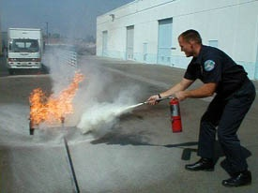
 | Explain: | Fire is a chemical reaction known as ‘combustion’. It is represented by the ‘Triangle of Combustion’. For fire to occur, 3 components must be present:  - Oxygen – Supports Combustion  - Heat – Ignition Source  - Fuel – Combustible Material  Due to the nature of fire, as it gets hotter and more intense, chemical chain  reactions occur to further support this process, therefore the opportunity for rapid intensity and spread, if not controlled.  Fire fighting techniques are based on removing one or more of these elements that combine to make a fire.  Ask participants: What are some ways that you could suppress a fire?  - Smother – remove the oxygen supply – How? Extinguisher, fire blanket, close doors and windows.  - Starve – remove the fuel – How? Turn off a gas stove.  - Cool – remove the heat by cooling down.  - Inhibit the chemical chain reaction – DCP Extinguisher.

Fire Extinguishers: | Explain: | The following extinguishers to be demonstrated are the predominately used extinguishers across Endeavour.  Note: if there is another type used at your site, you will need to provide some information on it e.g.  - Wet Chemical – oatmeal colored band used in kitchens for oils and fat fires.  - Foam – Blue colored band used on flammable liquid fires.
Fire Extinguishers: | Carbon Dioxide (CO2) | Carbon Dioxide (CO₂):  - Red with black band.  - Smothering agent.  - Makes loud roar when discharged.  - Key differentiator (discharge horn).  - Most appropriate for electrical fires.  - Do not handle metal parts during operation – frostbite could occur. | 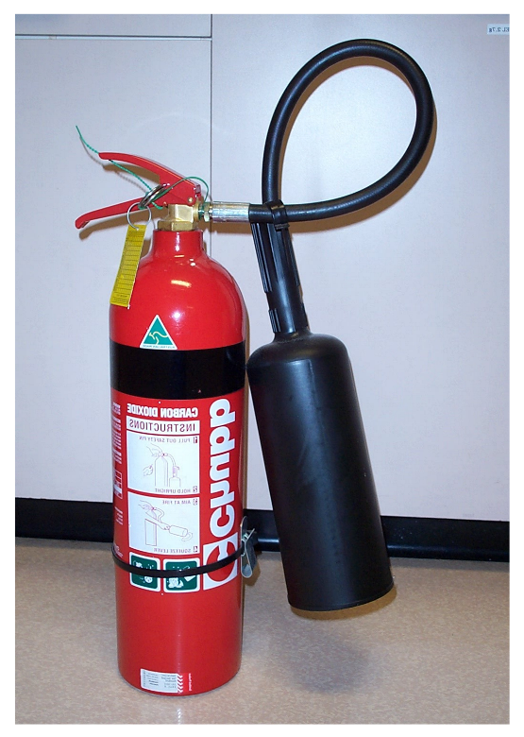
 | Dry Chemical Powder (DCP) | Dry Chemical Powder (DCP):  - Red with white band.  - Most appropriate for electrical and flammable liquid fires.  - Smothering and inhibiting agent.  - Leaves a very large residual mess of powder. | 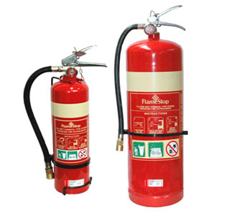
 | Water | Water:  - Red bottle.  - Cooling agent.  - Not to be used on fire involving electrical equipment. | 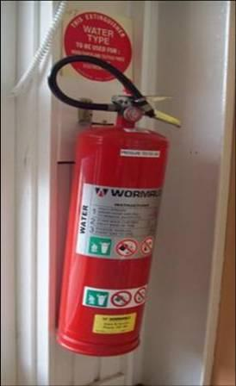

Selecting the Correct Fire Extinguisher: | 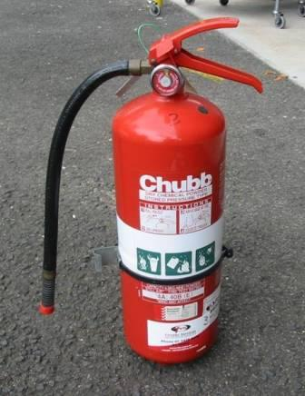  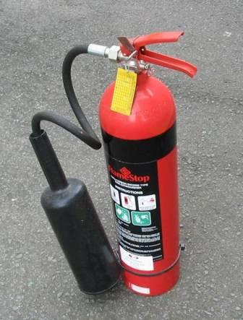
 | Explain and demonstrate: | - You are not expected to remember each class of fire and what they include, however it is good to have an understanding.  - If you are ever required to use an extinguisher, refer to the symbols on the side or front of the extinguisher to assist in determining if it is the correct one to use.  - Have an extinguisher available to point out the symbols.  - The symbols depict what type of fires the extinguisher can be used on.  - Where an extinguisher cannot be used on a certain type of fire, the picture may have a red line through it.  - Extinguishers are located in areas based on the relevant fire hazards e.g. CO2 extinguisher placed outside a Server Room.

Using a Fire Extinguisher:
 | Explain and demonstrate: | - Point out the location of the tamper seal.  - Point out the location of the pin and how you would spin it to break the seal. (Note: You do not have to physically pull the pin to break the seal.)  - Demonstrate how you would aim the nozzle and present a sweeping action towards the base of a fire. (Note: You do not have to operate the extinguisher.)  - Important note regarding ‘sweep’: Liquid fires have a different technique. When fighting a liquid fire with a foam or wet chemical extinguishing agent, aim the extinguishing agent above the fluid, so that the agent floats down onto the fire and prevents splash/spread.  - Test the extinguisher before proceeding to the fire.  - Before starting to fight a fire, you must first consider whether or not it is safe for you to do so.  - Fire extinguishers are only effective against relatively small fires so it may be safer for you to evacuate the building and leave the fire for the fire brigade.

Using a Fire Hose Reel: | Explain: | It would be unlikely for personnel to need use a fire hose to fight a fire, however if you were instructed to grab and run out for someone to operate, remember to turn the tap valve on firstly to charge the hose, then run it out.
- Never use near electrical fires or where electrical equipment is in close vicinity of a fire.

- Never use on flammable liquid fires as it can cause it to spread.

- Valve must be open before attending to the fire.

Using a Fire Blanket: | Explain and demonstrate: | If able, demonstrate how to use the Fire Blanket with an old fire blanket or use a towel to demonstrate the process.  - Place the blanket down and spread out.  - Grab the blanket/towel with both hands about 30 centimeters from the top.  - When you pick up the blanket/towel, flick the 30 centimeters part up over your hands so it protects your hands and wrists as you proceed to the fire.  - Demonstrate a simple placement of the blanket/towel over the fire to cover and smother and walk away.  - Never attempt to throw the blanket to cover as it may knock over and spread the fire.
 | 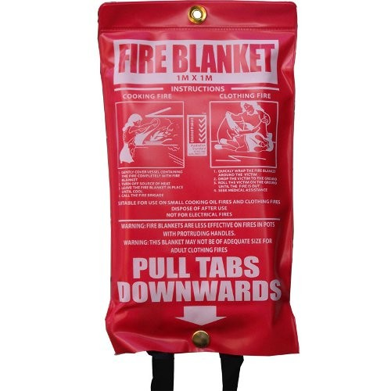 |  | - Used to smother a fire.  - Take release tape in each hand and pull downwards and outwards.  - Protect hands.  - Drape the Fire Blanket over the flames to seal off the oxygen.  - Do not remove the Fire Blanket from the fire.  - If clothing is on fire, wrap in fire blanket.  - If fighting a kitchen fire and safe to do so, turn off the heat source e.g. stove top.  - A Fire Blanket can also be used for protection when moving through a fire affected area e.g. to shield our body.

Locating Fire Reference Points: | Explain and demonstrate: | The details of the Evacuation Diagrams contained in your workplace:  - Must identify ‘you are here’ when looking at the diagram.  - The diagram must be orientated correctly so you can follow the correct directions.  - Thick Green line demonstrates nearest safe exit.  - Dotted Green line, alternate safe exit.  - Location of nearest fire equipment and/or manual call points.  - Location of Evacuation Assembly Area – Explain where your assembly area is located.

Evacuation Procedures: | Explain: | You will need to amend this and the next section to accommodate your site requirements regarding Evacuation procedures/tones etc.
- The <Insert Building Name> has two alarms, an Alert tone and Evacuation tone.
Note: You may need to incorporate different instructions suitable for your own Building/ Site or Service requirements – please remove this statement when determined.

- On hearing the Alert tone:
BEEP BEEP BEEP
- Prepare to evacuate.
- Remain calm and await in the location you are located until either:
  - You are advised to evacuate; or
  - You hear the evacuation tone WHOOP WHOOP WHOOP

- If you are advised to evacuate or hear the evacuation tone:
WHOOP WHOOP WHOOP
- Evacuate the building via the nearest safe exit in a calm and orderly manner.
- Follow directions of Wardens.
- Proceed to the designated Assembly Area (across the road in the vacant park area).
- Await instructions for the fire services or chief warden prior to re-entering the building.

First response to Fire or Smoke: | Explain: | If fire or the presence of smoke is reported to you, immediately take the following action:
- Remain Calm.
- Alert persons nearby and summon assistance by calling out “FIRE! FIRE! FIRE!” in a loud voice.
- Activate the nearest Manual Call Point or Alarm system.
- Notify the fire service by dialling 000.
- Remove people from immediate danger if safe to do so.
- Notify the Chief Warden of the location & size of the fire.
- Attempt to extinguish the fire (if trained and safe to do so).
- Follow directions of the Chief Warden, Area Wardens and Wardens.
- Do not enter a smoke filled space as smoke is TOXIC.
- If confronted by heavy volumes of smoke, crawl to safety, as the air is clearer near the floor.
- Don't gather personal belongings, this will delay your exit from the building and increase your risk of injury or death.

Activating a Manual Call Point? | - Activate in an emergency.  - Push clear cover inwards to activate.  - Sends signal to the Fire Indicator Panel (FIP) and sets off the Alert Tone. |  | 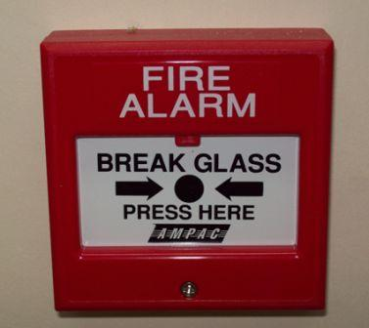
 | Explain: | If you do not have a manual call point, inform that it is still important to know how to operate.

General & First Response Fire Evacuation
Toolbox Training Record
Name of Site / Service:
Print Name of person Conducting Toolbox Training: |  | Signature:
Date: | Start Time: | Finish Time:

Name of Participant | Signature

