
Asbestos Awareness
Toolbox Training
Toolbox Session
More Learning Choices
09.2014

This Toolbox Training has been developed for presentation and discussions with workers to help understand what asbestos is, the hazards associated with asbestos, where asbestos is located at their workplace and how to use the site Asbestos Safety Management Pack.
Audience | This Toolbox Training should be presented every 2 years to all site staff.
Presentation | It should take approximately 30 minutes to deliver this Toolbox Training.
Objectives | After this Toolbox Training, you will:  - Have an awareness of the hazards associated with asbestos;  - Know where asbestos is located in this building;  - Know what the Asbestos Safety Management Pack is and what it’s for;  - Know what “banned” activities are with asbestos containing material;  - Know what to do if work is performed on asbestos containing material; and  - Know what to do if asbestos is damaged.
Filing | Ensure the attendance register is signed off.
Equipment Required | Site Asbestos Safety Management Plan.  If you have any questions that can’t be answered at this session, please contact your WHS Advisor or send your question to whs.support@endeavour.com.au
Introduction | Note: | This session is to be delivered by the Site/Service manager.
Introduction | Discuss | What is asbestos?  “Asbestos is a naturally occurring material found on the earth’s surface and because of its durability, flexibility fire resistance and insulating properties, it was used in building materials from the early 1900’s until the end of 1999.”
Where can asbestos be found? | Discuss | Asbestos is used in more than 3000 products and many building materials include that include:  “fibro or cement sheeting including walls, corrugated roofing, fence panels guttering, vinyl tiles, mastic adhesive, low density fibre board underlay, electrical mounting boards, thermal and acoustic insulation.”  Common locations for asbestos containing materials (ACM) are shown below:
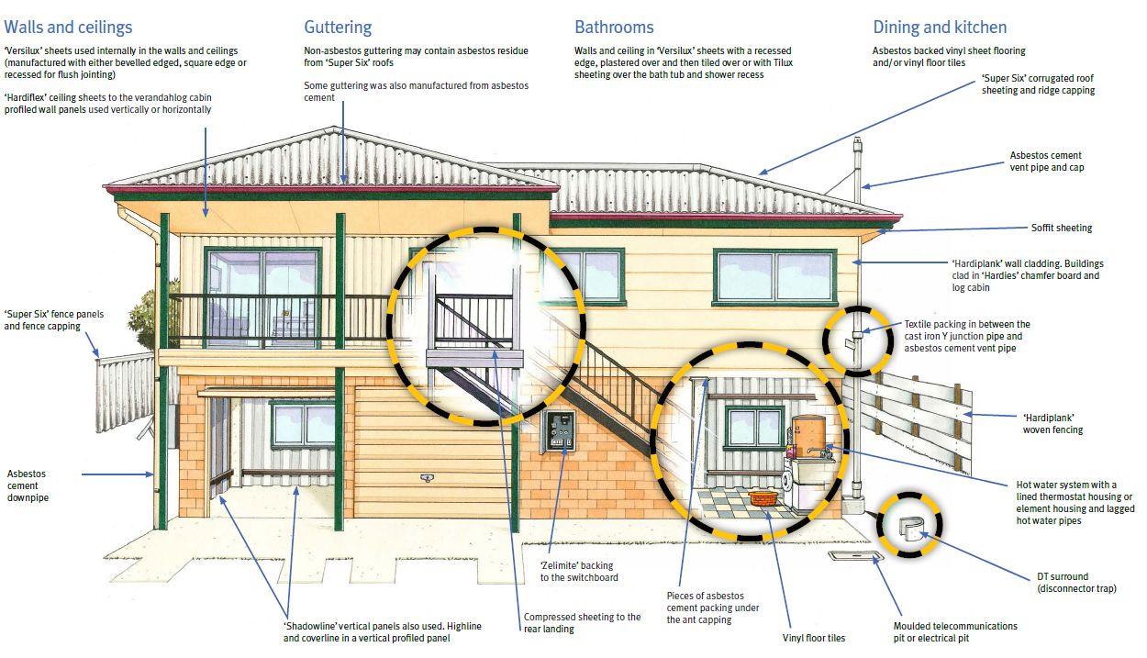
Forms of Asbestos Containment | Bonded Materials | Vinyl tiles and power boards are examples of bonded materials.  If the bonded materials are in good condition the fibres are incorporated in resin materials which prevents fibres from being released. | 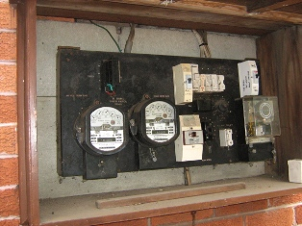
Forms of Asbestos Containment | Sealed Asbestos | Painted fibro sheet ceilings and walls are examples of sealed asbestos materials.  While these materials are well painted and not damaged or broken fibres are prevented from being released. | 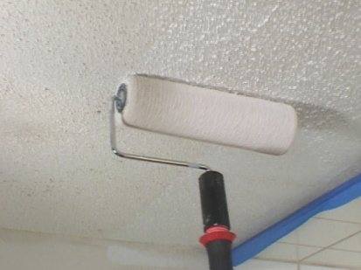
Forms of Asbestos Containment | Encapsulated Asbestos | Surfaces such as floors, walls and ceilings can be encapsulated to contain asbestos materials. This involves covering the original surface with a material such as plaster board or new vinyl.  While the encapsulating materials in good condition fibres are prevented from being released. | 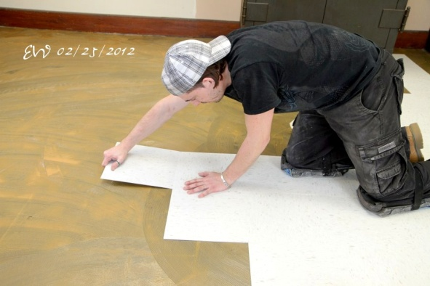
Exposure to Asbestos | Question | How Can You Be Exposed To Asbestos?
Exposure to Asbestos | Discuss | Asbestos can be released into the air whenever it is disturbed, particularly during the following:  - Drilling, boring, cutting especially with power tools, filing, brushing, grinding, sanding, breaking, smashing or blowing with compressed air.  - Pressure cleaning or scrubbing.  - Maintaining or servicing materials containing asbestos from vehicles, equipment or workplaces.  - Renovating or demolishing workplaces.

Is Asbestos Dangerous and can it affect your health? | Question | What are the hazards associated with asbestos?
Is Asbestos Dangerous and can it affect your health? | Discuss: | Asbestos fibres (50 – 200 times thinner than hair) may be released and float in the air during activities that disturb asbestos-containing materials.  The asbestos fibres can then be inhaled without you knowing it and get trapped in the lungs. If swallowed, they can become embedded into the digestive tract.  Asbestos is a known human carcinogen and can cause chronic lung disease or lung and other cancers. Symptoms and/or cancer can take decades to develop following exposure.
Is Asbestos Dangerous and can it affect your health? | Discuss: | Why hasn’t all asbestos been removed from buildings  Asbestos does not present a risk if it is in good condition and well bonded, sealed or encapsulated.  Asbestos can present a greater risk if it is removed than if it is left in place and maintained in good condition.
Asbestos Safety Management Pack | Show | The site Asbestos Safety Management Pack (ASMP). | ` 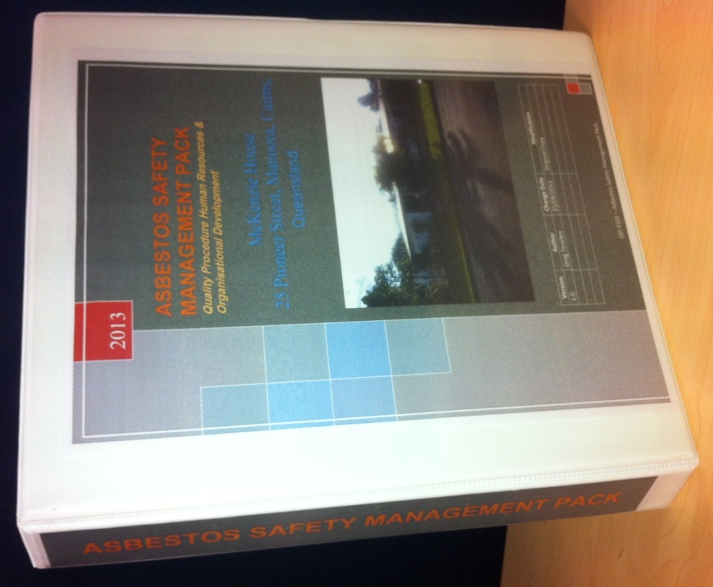
Asbestos Safety Management Pack | Discuss | What you need to do if:  - You need to clean asbestos containing material surfaces.  - You need to drill a hole or hang a picture.  - You are having building work done.  - You notice damage to an area or equipment that may contain asbestos.  - You discover unknown asbestos.  - An emergency situation occurs.  Labelling and signage:  - Locations where signs and labels are required.  Registers:  - Where the register is located.  - What is in the register?  - Who should have access to the register?  Procedures:  - Damage to Asbestos or Assumed ACM.  - Managing Damage to ACM (Endeavour owned building).  - Managing Damage to ACM (Non Endeavour Owned Building).  - Response to Person Being Exposed to Asbestos Dust.
Asbestos Safety Management Pack | Discuss |  | 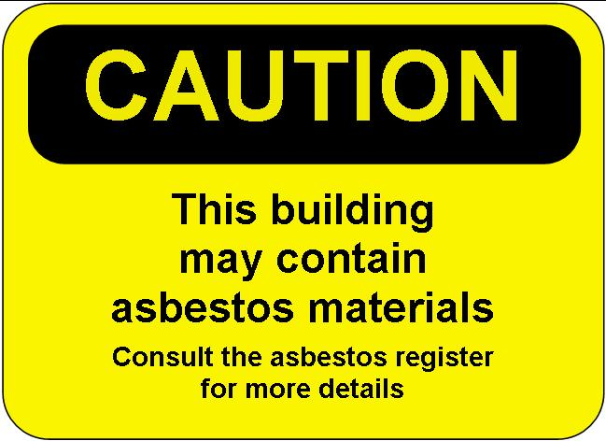  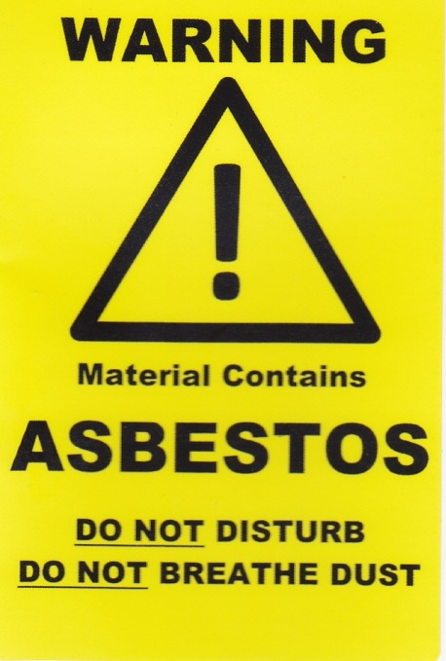
 | Review: | - The hazards associated with Asbestos.  - If sealed and in good condition:  - It presents a low risk.  - It can be left in situ.  - Do not drill, cut, scrub or pressure clean.  - Ensure all staff know:  - Where the register is located.  - Where Asbestos is located.  - What the emergency procedures are.  - Only certified persons may work on Asbestos.

Asbestos Awareness
Toolbox Training Record
Name of Site / Service:
Print Name of person Conducting Toolbox Training: |  | Signature:
Date: | Start Time: | Finish Time:

Name of Participant | Signature

